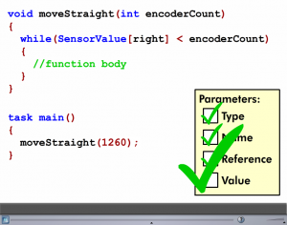
Robotics Programming: Behaviors and Functions. Name:______________

For each section, take notes and answer questions based on the video in Cortex Video Trainer. (1 point/question)
Behaviors and Functions 1:
- What do functions allow you to use?
- _____________________________
- _____________________________
- Name three parts of declaring a function?
  - ____________________________________________
  - ____________________________________________
  - ____________________________________________
Behaviors and Functions 2:
- Where is the call statement located?______________________
- Where are functions located? ______________________________
Parameters Part 1:
- What are the four steps to using parameters? _________________________________________________________________________
- Name four different TYPES of parameters that can be passed? ___________________________________________________________________________
- What rules do Parameter Names have to follow? ___________________________________________________________________________
Parameters Part 2:

Activities:
Remote Control: Turn Buttons
Programming (10 Points = 100%)
___ Header complete with names, description and date (2 points)
___ Program incorporates functions (4 points)
___ Code is properly indented (2 points)
___ Comments in the program describing the code (2 points)
Performance (10 points)
____ Completed

Sensors: Optimizing Code
Programming (10 Points = 100%)
___ Header complete with names, description and date (2 points)
___ Program incorporates functions (4 points)
___ Code is properly indented (2 points)
___ Comments in the program describing the code (2 points)
Performance (10 points)
____ Completed

Sensors: Robo-Dunk 2
Programming (10 Points = 100%)
___ Header complete with names, description and date (2 points)
___ Program incorporates functions (4 points)
___ Code is properly indented (2 points)
___ Comments in the program describing the code (2 points)
Performance (10 points)
____ Completed

