Unified Machine Language (UML) Diagram

What is a UML Diagram?
Suppose you have to design a system. Before implementing a bunch of classes, you’ll want to have a conceptual understanding of the system — that is, what classes do I need? What functionality and information will these classes have? How do they interact with one another? Who can see these classes? And so on.
That’s where class diagrams come in. Class diagrams are a neat way of visualizing the classes in your system before you actually start coding them up. They’re a static representation of your system structure

ClassName
Instance variables
Methods, including constructors
Diagram Parts
Each BOX is a class
+ public
- private
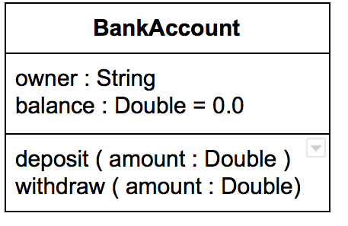
variableName: type
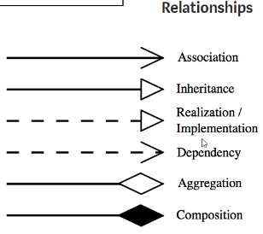
methodName(parameter:type): returnType

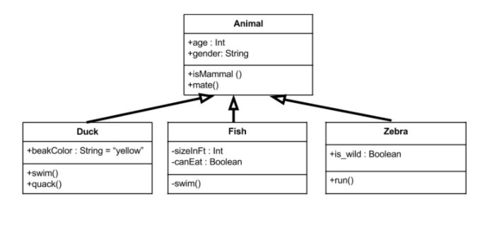
For the problem described on the following pages
- Mark the text
  - Underline variables
  - Put boxes around the methods and associated descriptions
  - Circle the values returned
- Create a UML Diagram for the classes associated with this program

3. Consider the problem of modeling bank accounts. A diagram of the class
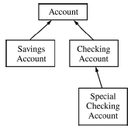
hierarchy used to represent bank accounts is shown below.

The abstract class Account models a bank account with the following data and
operations.

Data
• the identity number for the account (The identity number is never
changed once the account has been constructed.)
• the balance in the account (The balance can change as a result of
some operations.)
Operations
• create an account with a given identity number and initial balance
• return the identity number
• return the current balance
• deposit some positive amount into the account, increasing the balance
• decrease the balance by a specified positive amount, if the amount is
greater than the balance, throw an IllegalArgumentException
• return the monthly interest due

An implementation for this class is shown below.
public abstract class Account
{
private int idNum; // identity number for this account
private double balance; // current balance for this account

/** Creates an Account with identity number idNumber
* and current balance startBal.
* @param idNumber the identity number for the account
* @param startBal the starting balance for the account
* Precondition: startBal ≥ 0.0
*/
public Account(int idNumber, double startBal)
{ /* implementation not shown */ }
/** @return the identity number for this account.
*/
public int idNumber()
{ /* implementation not shown */ }
/** @return the current balance for this account.
*/
public double currentBalance()
{ /* implementation not shown */ }
/** Increases the current balance of this account by amount.
* @param amount the amount to be deposited into the account
* Precondition: amount ≥ 0.0
*/
public void deposit (double amount)
{ /* implementation not shown */ }
/** Decreases the current balance of this account by amount.
* @param amount the amount to be removed from the account
* Precondition: 0 ≤ amount ≤ currentBalance()
*/
public void decreaseBalance (double amount)
{ /* implementation not shown */ }
/** @return the monthly interest due for this account.
*/
public abstract double monthlyInterest();
}

(a) A savings account at a bank “is-a” bank account and is modeled by the class SavingsAccount. A savings account has all the characteristics of a bank account. In addition, a savings account has an interest rate, and the interest due each month is calculated from that interest rate. The operations for a savings account that differ from those specified in the class Account are the following.
• create a new savings account with a given annual interest rate, as well as the parameters required for all accounts
• withdraw a positive amount that does not exceed the current balance, decreasing the balance by the amount withdrawn
• calculate the monthly interest by multiplying the current balance by the annual interest rate divided by twelve

Write the complete definition of the class SavingsAccount, including
the implementation of methods.

(b) A checking account at a bank “is-a” bank account and is modeled by the class CheckingAccount. A checking account has all the characteristics of a bank account. In addition, a checking account can have checks written on it. Each check written decreases the account by the amount of the check plus a per-check charge.
The operations for a checking account that differ from those specified in the class Account are the following.
• create a new checking account with a given per-check charge, as well as the parameters required for all accounts
• clear a check for a given amount by decreasing the balance by the amount of the check plus the per-check charge
• compute and return the monthly interest

A declaration of the class CheckingAccount is shown below.

public class CheckingAccount extends Account
{
private double checkCharge;
public CheckingAccount( int idNumber, double startBal,
double chkCharge)
{
super(idNumber, startBal);
checkCharge = chkCharge;
}
public void clearCheck(double amount)
{
decreaseBalance(amount + checkCharge);
}
public double monthlyInterest()
{ /* implementation not shown */ }
}

A special checking account “is-a” checking account and is modeled by the class SpecialCheckingAccount. A special checking account has all the characteristics of a checking account. In addition, a special checking account has a minimum balance and an annual interest rate. When the balance is above the minimum balance, the per-check charge is not
deducted from the balance when a check is cleared. Otherwise, a check is cleared just as it is for a checking account. In addition, when the balance is above the minimum balance when interest is calculated, interest due is calculated on the current balance. Otherwise, the interest due is the same as for a checking account. The operations for a special checking account that differ from those specified in the class CheckingAccount are the following.

• create a new special checking account with a given minimum balance and interest rate, as well as the parameters required for a checking account
• clear a check for a given amount according to the rules above
• calculate the monthly interest by multiplying current balance by the annual interest rate divided by twelve if the current balance is above the minimum; otherwise, calculate the interest as it is done for a checking account

Write the complete definition of the class SpecialCheckingAccount,
including the implementation of its methods.
(c) Consider the class Bank partially specified below.
public class Bank
{
private ArrayList<Account> accounts;
// all accounts in this bank
// accounts has no null entries
/** For each account in this bank, deposits the monthly interest due into that
* account.
*/
public void postMonthlyInterest()
{
// to be implemented in this part
}
// There may be instance variables, constructors, and methods that are not
// shown.
}

Write the Bank method postMonthlyInterest, which is described as follows.
For each account in this bank, postMonthlyInterest should calculate the
monthly interest and deposit that amount into the account.

In writing postMonthlyInterest, you may use any of the public methods
of class Account or its subclasses. Assume these methods work as specified.
Solutions that reimplement functionality provided by these methods, rather than
invoking these methods, will not receive full credit.

Complete method postMonthlyInterest below.
/** For each account in this bank, deposits the monthly interest due into that
* account.
*/
public void postMonthlyInterest()

