Intro to Engineering Design Practice Final Name: __________________________
Define the following elements of Design
- Point: Has position but no dimension. Used to indicate location.
- Line: Has only length, used for boundary, volume, perspective and depth.
- Color: Includes base color, value and saturation
- Value: Relative lightness or darkness of a color, object or shape.
- Shape: a 2D area enclosed by lines or curves
- Form: A 3d volume or solid
- Space: Areas between and around parts of an image
- Texture: The surface look or feel
Define the following Principles of Design
- Balance: The distribution of elements within a design
- Emphasis: Used to draw attention to one area
- Contrast: The degree of relative difference between elements.
- Rhythm: Repeated use of line, shape, color, texture or pattern
- Proportion: Comparative relationship between elements of a design with respect to size.
- Unity: The consistent use of design elements
- Economy: Use of the bare minimum of elements.

Multiple Choice

- _B__
- _C__
- _C__
- _D__
- _C__
- _A__
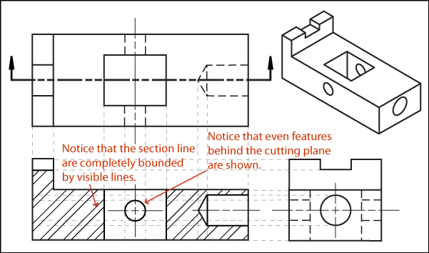
- _C__
- _C__
- _D__
- _A__
- _A, B, C, D__
- _C__
- _B__
- _B__
- _D__
- _A__
- _C__
- _B__
- _C__
- _D__
- _C__
- _B__
- _A__

Line Types
  - _A___________
  - _F___________
  - _B___________
  - _D___________
  - _G___________
Reading Dimensions
2.1 _D___________
2.2 _B____________
2.3 _E___________
2.4 _C__________
2.5 _A____________

Engineering Design (Answers may vary)
1) Defining the problem
a) Constraints: __________________________________________________________________
b) Specifications: _______________________________________________________________
2) Generated Concept:
3) Develop solution
Decision Matrix
Specs/Constraints |  |  |  |  | Totals
Proposals

Selection Proposed and why: ______________________________________________________
______________________________________________________________________________

