Activity 5.7 Instant Challenge: Choremaster

Introduction
There are many ways to solve a problem. Sometimes it is as simple as applying a piece of duct tape. Other times it takes months or years for a product to progress from an idea into full-scale production. In this activity your team will quickly design a product to perform a household chore using the available materials.

In this activity your team must think of a common household chore, then create a gadget to make that chore easier to perform. After the allotted time, your team will present a performance of your chore to the rest of the class.

Equipment
- Ziplock bag of items  - 5 Craft Sticks  - 12” Wire  - 12” masking tape  - 3 paper clips | - 3 paper plates  - 1 plastic pipe  - 1 shoe (supplied by the group)

Procedure
- Divide into teams with direction from your teacher.
- Your team will agree on a common household chore to create a product (2 minutes).
- Your team will define the problem, generate concepts, and develop a solution (12 minutes).
- Your team will construct and test a prototype (12 minutes).
- Your team will present the solution to the class (2 minutes).
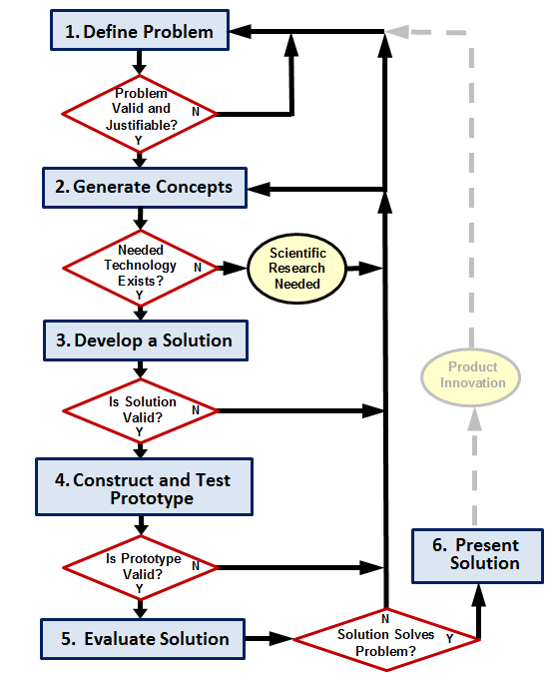

Scoring
Your team may receive points for the following.
- Creativity: Up to 10 points for creativity in the design and use of materials.
- Teamwork: Up to 10 points for how well your team works together.
- Performance: Up to 10 points for how well the product completes the chore.

Conclusion
- What were the major obstacles to selecting a solution?

- How could you improve the effectiveness of your team?

