Getting Started in Java
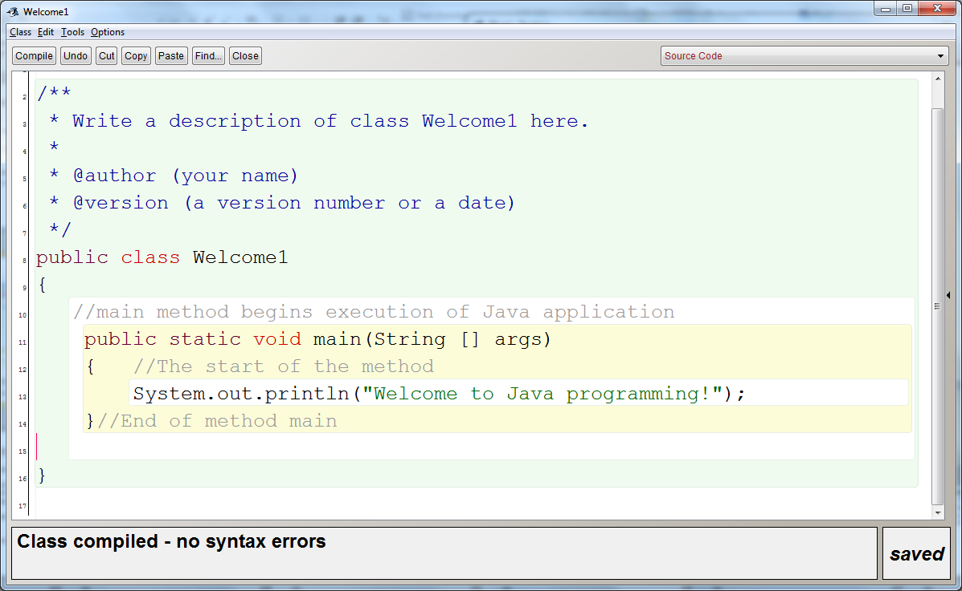

Three errors:
Error Hint from Compiler
_______________ _________________________________________________________________
_______________ _________________________________________________________________
_______________ _________________________________________________________________
Notes:
_______________________________________________________________________________________________________________________________________________________________________________________________________________________________________________________________________________________________________________________________________________________________________________________________________________________________________________________________________________________________________________________________________________________________________________________________________________________________________________________________________________________________________________________________________________________________________________________________________________________________________________________________________________________________________________________________________________________________________

