Game Maker Day 1 Name: ________________________

Sprites: _______________________________________________________________

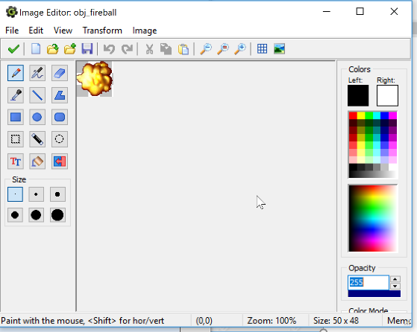
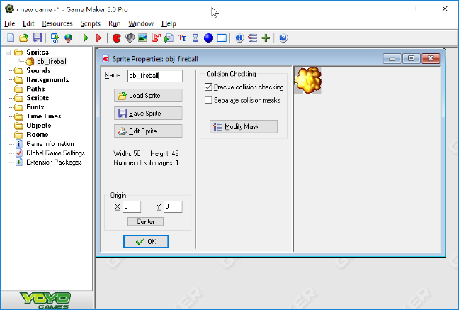

Objects: ______________________________________________________________________
Main Parts
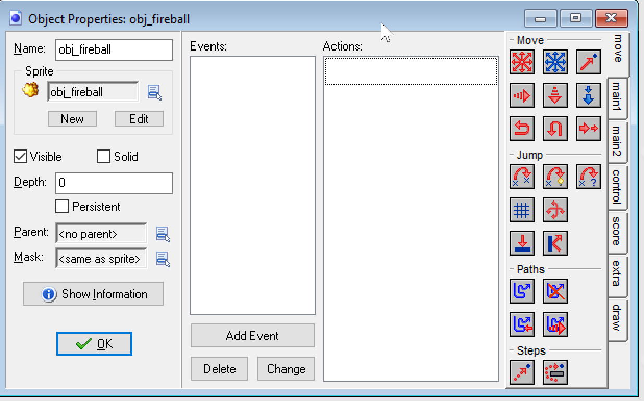
___________

___________

___________

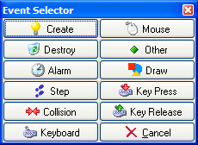

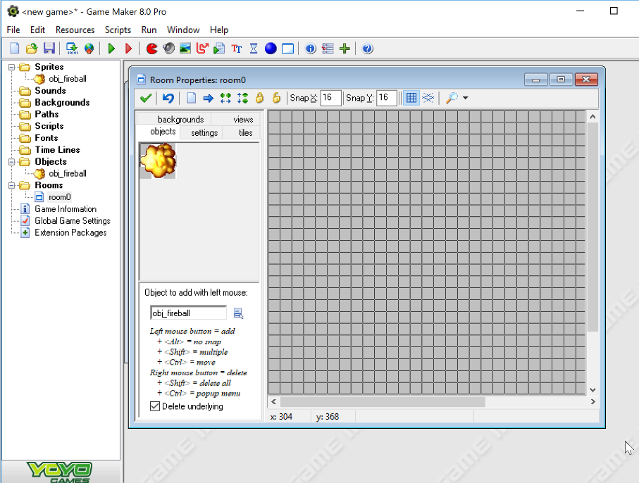
Rooms

Summary:
Sprites:___________________________________________________________________

Objects: ___________________________________________________________________

Rooms: ___________________________________________________________________
First Game: YourNameMaze1
- Create a brick sprite, brick object and use the brick objects to make walls.
- Create collision events so that when the ball hits the wall object it stops horizontal direction
- Create a maze
- Add events and actions needed for the ball to be able to go through the maze.
- Test the ball going through the maze
- Pushes
  - Add features to the game
    - Find other images for sprites. GIFs, Pac man, ..
    - Monsters
    - Secret walls
    - Battles
    - Treasures

