Activity 7.2 Sectional Views

Introduction
Have you ever noticed that some objects have more going on inside than outside? Take an apple, for instance. How would you communicate the intricate details hidden inside an apple’s core? You would have to cut the apple in half in order to show someone that there are spaces inside that house seeds. If you were to make a sketch of the apple, you could show the spaces and the seeds as hidden lines, but too many hidden lines can serve to confuse the issue. Sectional views are another alternative.

The main purpose of a sectional view is to effectively communicate internal information to enhance the viewer’s understanding of the part. There are several different types of section views that engineers use to communicate internal geometry.

In this activity you will visualize and create section views, both by hand sketching and CAD of parts that have interior features not easily documented with orthogonal projections.

Equipment
- Engineering notebook
- Pencil
- Computer with 3D CAD solid modeling software

Procedure
- Study the figure below. Use points and construction lines to lay out a section view on the grid provided. The cutting plane line will tell you where the full section is cut. Delineate the visible edges of the sketch with object lines. Use section lines to indicate which surfaces were cut by the cutting plane. DO NOT ERASE YOUR POINTS AND CONSTRUCTION LINES.

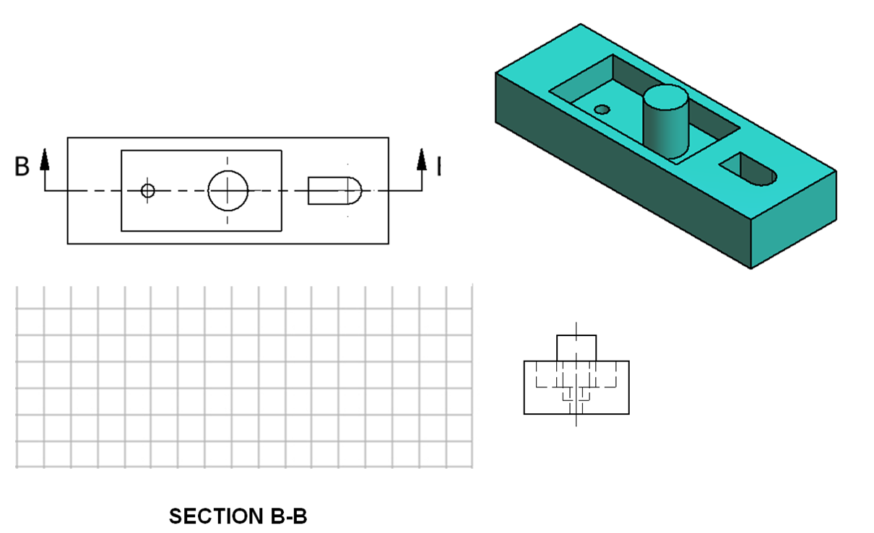

- Study the figure below. Use points and construction lines to lay out a section view on the grid provided. The cutting plane line will tell you where the full section is cut. Delineate the visible edges of the sketch with object lines. Use section lines to indicate which surfaces were cut by the cutting plane. DO NOT ERASE YOUR POINTS AND CONSTRUCTION LINES.
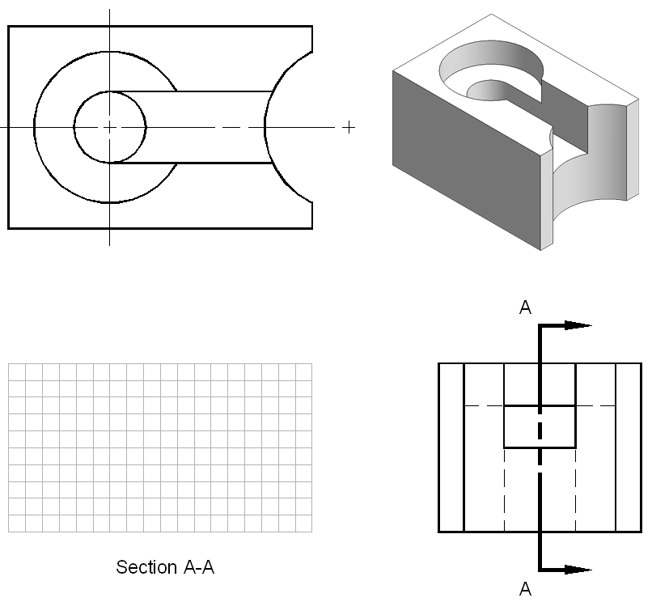

- Study the figures below. Use points and construction lines to lay out a half section view of the object. The cutting plane line will tell you where the section occurs. Delineate the visible edges of the sketch with object lines. Use section lines to indicate which surfaces were cut by the cutting plane. DO NOT ERASE YOUR POINTS AND CONSTRUCTION LINES.
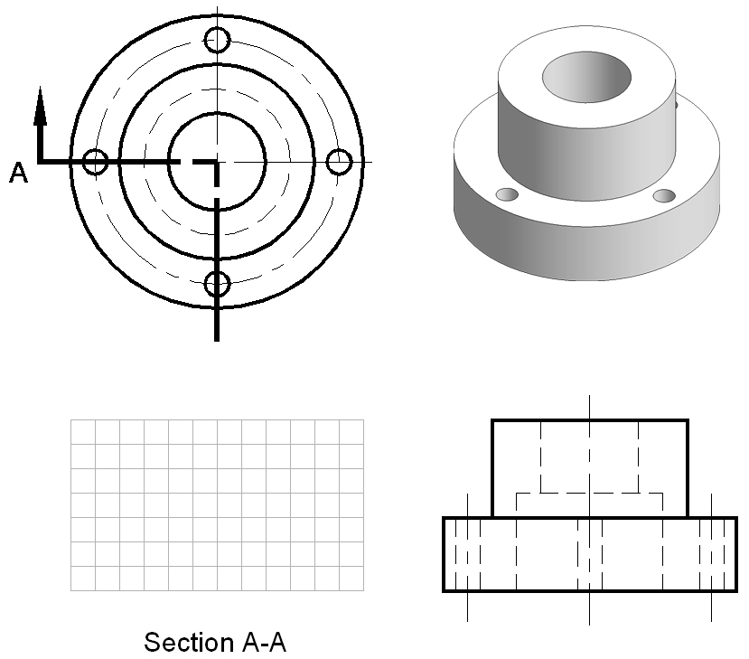

Conclusion
- What do the arrows on a cutting plane line indicate?

- What is the difference between a half and a full section?

- Are hidden lines shown in a section view?

- What conventions are associated with section lines?

