Activity 7.1 a) Part Review

Procedure
Create the following Parts in Inventor.

- The grid spacing is 0.25 inch. Save it as YourName7-1Piece1
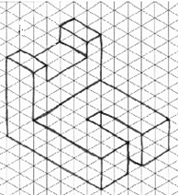

- The grid spacing is 0.25 inch. Save it as YourName7-1Piece2
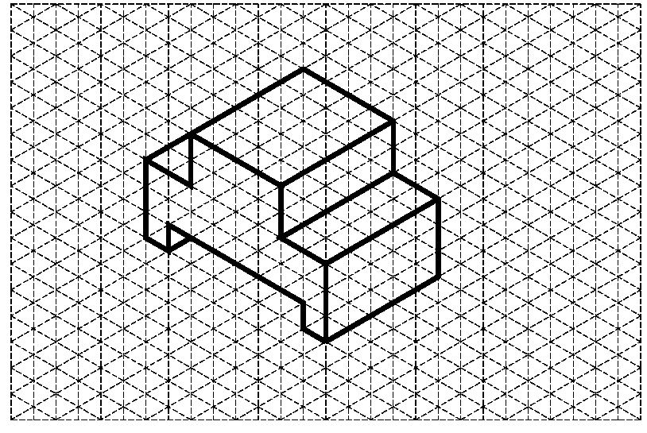

- The grid spacing is 1 centimeter. Save it as YourName7-1Piece3

- The grid spacing for the part is 0.25 inches. Save it as YourName7-1Piece4
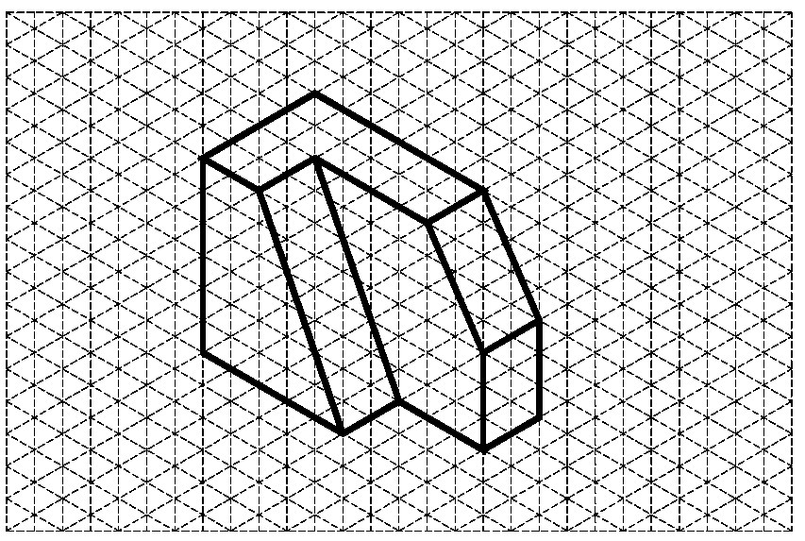

- The grid spacing for the part is 0.25 inches. Save it as YourName7-1Piece5

- Bonus:

Create a computer model of the part shown below using 3D solid modeling software. Note that TYP means “typical” and indicates that the dimension is typical for all similar features. Assume that all holes cut completely through the part. Save the part as YourName7-1Bonus
