Activity 5.2a – Geometric Constraints

Introduction
A CAD model can quickly display an engineer’s ideas in a realistic way. And those models can be used to generate technical drawings that can communicate the information necessary to make the idea a reality. In order to generate a 3D model, designs must start with sketches that are generated within the CAD program. These computer generated sketches will appear resemble hand drawn sketches in geometry (the combination of points, lines, and shapes), but have big advantages over hand drawn sketches. One important difference between a freehand sketch and a CAD sketch is accuracy. The lines of a CAD sketch can be drawn perfectly straight, with start and end points that occur in exact locations in space. By using numeric (dimensional) constraints a line may also be given precise length, placed a specific distance from another sketch feature, or constrained to be oriented at a specific angle from another straight line. By applying geometric constraints a line can be made perfectly horizontal or vertical. If more than one line is being sketched, they can be made perfectly parallel or perpendicular, collinear, or equal in length. Lines can be constrained to be tangent to circles or arcs, and two circles can be constrained to be concentric. In order to precisely model a part, the designer must be able to use dimensional and geometric constraints within the CAD program.

You have already used linear dimensioning in earlier activities. In this activity, you will learn about geometric constraints that are common to most CAD programs and practice applying these constraints to CAD sketches.

Equipment
- Computer with 3D CAD solid modeling program
- CAD files
- Geometric Constraints
Procedure
- Open the file called Geometric Constraints. Read the instructions above each image in the file and use the Geometric Constraint tools to complete each of the 12 exercises. Your completed sheet should look similar to the sheet pictured.
- Make the geometric constraints visible by choosing the Show Constraints tool in the Constrain panel under the Sketch tab.
- Add your name to the bottom right corner of the sheet. You may use the Text tool in the Draw panel under the Sketch tab to add text to a sketch.
- Save the file as a different name, print it out, and submit it along with this activity to your instructor for evaluation.
CAD file name and location:

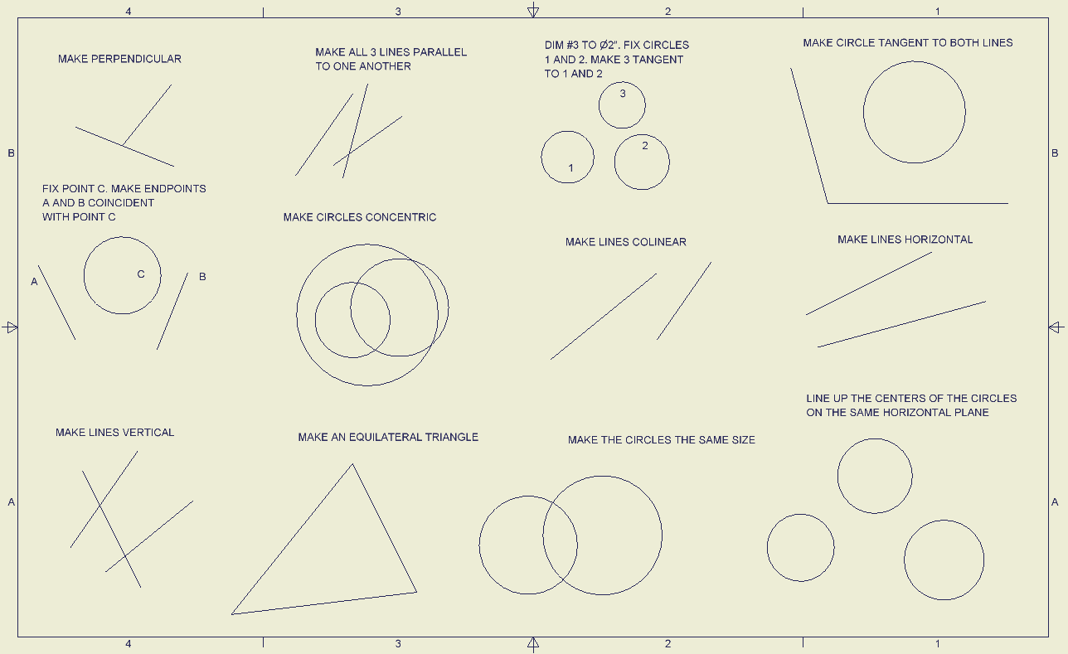
Before

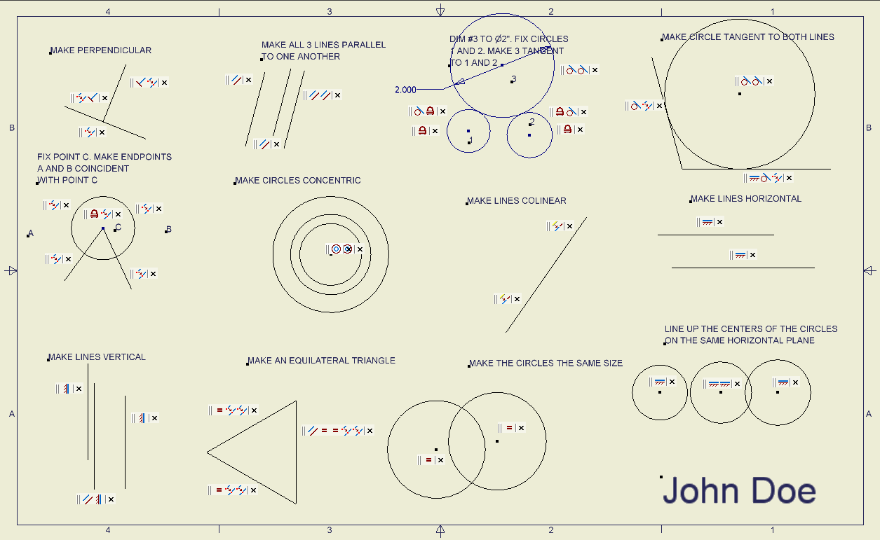
After

Conclusion
- What is a geometric constraint?

- What are the different types of geometric constraints that are applied to sketches, and what are their functions?

- Define “tangent”.

  - Sketch a line tangent to two circles.

  - Sketch three circles such that all circles are tangent to the other two.

- How is a geometric constraint different from a numeric constraint?

