VEXcode Vision Sensor Check off Sheet Name:_________________

(17) ___ Color Tracking coordinates on VEX Brain
(19) ___ Color track graphic in Screen
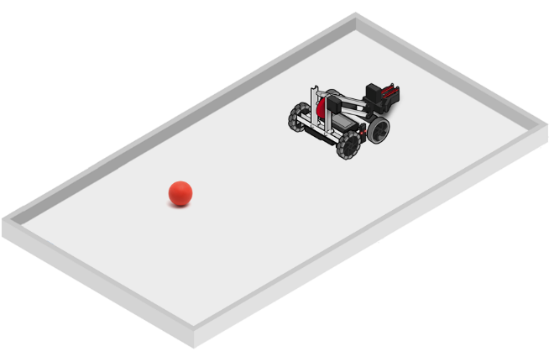
(21) ___ Hide – and – Seek Challenge
Program the robot to scan (turn) until it detects a colored object. Once it detects the object it should stop and drive toward it.

Extra challenge program the robot to automatically pick up the object.
Feel free to combine multiple sensors in this solution!
Extra! Extra! challenge. After picking up the block, find and stack it onto another block of the same color.

