Game Objectives
This competition is a game of capture the flag! Plain and simple. There will be two alliances of three robots each, randomly drawn from a lottery, who will be responsible for capturing the other team’s flag and placing it in their own base. This is a pretty open-ended game, and participants may attain this objective however they please.
Scoring
Placing the other team’s flag down on your team’s base will yield 1 point. Upon every score, the clock is paused and robot and flag positions are reset. The flag must be outside of the robot and on the surface of the playing field in order for it to count as a point.
Game Rules
Robot Starting Position: Robots will be placed so they are touching the ramp and a floor tile on their side of the field.
Autonomous game: At the start of the match and the start of the second half, there will be a 10 second autonomous period.
Driver game: Robots will be allowed to grab, push, pull, launch, etc. the flag to their own base however they like, as long as their robots meet specifications. There will be a timer for 90 seconds, but every time a team scores, the timer is paused and robot and flag positions are reset. Robots are allowed to play defense, but are not allowed to latch on or grab other robots.
Robot Specifications
● Max size fully expanded: 13”x13”x13” as determined by the sizing cube.
● Any robot appendages or secondary functions (i.e. Claws, flippers, springs, pneumatics,
etc) must not be capable of critically damaging other robots
● Mechanisms designed to enclose the flag inside the robot are allowed, but remember that scoring is only possible if the flag is outside of the robot and contacting the surface
● Flammable or explosive materials are not allowed.

Game Rules
- Defense is allowed
- Pinning <= 5 seconds. Penalty: Robot must back up 2 feet and cannot drive for 5 seconds
- No grabbing, grasping, … other team. Penalty: Warning, off the field for 1 minute or the rest of the period whichever is longer,
- A team is not allowed on their base or the ramp to their base.
- A team may push their own flag but not grab it.
- An alliance my not trap their flag for more than 5 seconds.

Field details:
● 12 ft by 12 ft
● Walls around field
● Inclined areas are up to 10 inches off the ground
● Walls are 11+ inches
● Flags are 3-inch cubes
● The hill-elements can be positioned in any way; are separate from the base

Field top view:
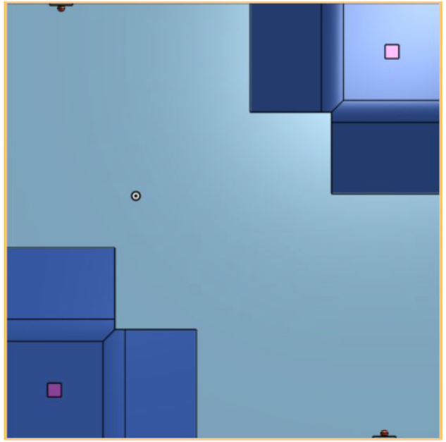
Field angled view:
