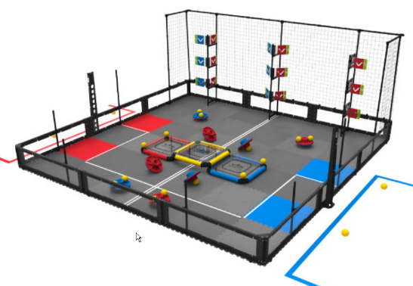
Robotics Projects Final 2018: Turning Point
You will be developing a design proposal for the VEX 2018-2019 ‘Turning Point’ Competition. Record your work in a PowerPoint labeled YourNameRoboticsProjectsFinal.

Part 1: Coding. (10 points)
Starting from the closest red starting tile, turn the first two flags. You may use the following two commands to have your robot go forward to hit one flag (straight forward for 2 seconds works), then back up one second, turn right 90 degress, go forward 1 second, turn left 90 degrees and go forward one second. wait1Msec() and motor[leftorRightMotor] = … Assume the robot turns 90 degrees if motors are going full power in opposite directions for 0.9 seconds. Include your program on the last slide of the Final PowerPoint. (+ 2 Bonus if you demonstrate score the flags in the Virtual World Use the Huge Table where the flags would be 9 small squares apart). Note: Turning in the Virtual World may, or may not, be the same as the assumption for this problem.)
Part 2: (60 Points)
Start by watching the ‘Turning Point’ YouTube video on the class Website in the ‘In The Zone’ unit.
- Title Slide: Include your name and a picture of a robot or device related to your design selected. (3 pts) Add the picture after completing the design selection process.
- Game Strategy/Problem Definition Slide: (6 pts)
  - Include: Title, Problem Statement
  - Open the TurningPoint_strategiess.docx from the class website and evaluate the different strategies for their potential success.
  - You will select the top three strategies you would like to implement for your Turning Point robot. At least one of the strategies selected needs to be an original idea. At least one strategy needs to be an original idea.
  - Use your selected strategies to create a 3-5 sentence problem statement to describe what you feel a successful robot will be able to do.
- Constraints Slide (6 pts)
  - Include: Title, list of constraints
  - Skim over the Turning Point game manual. There is a link on the website.
  - From the manual, select at least three constraints that you feel are important considerations for your robot design.
- Design Brainstorm Slide: (6 pts)
  - Include: Title, A list of potentially successful brainstorm ideas: 3+ original brainstorm ideas, 1+ idea from the internet, 1+ idea from ‘build_strategies’ document,
  - Watch some YouTube videos of Turning Point designs. There are several videos on this page.
  - Brainstorm design strategies for the best Turning Point design
    - List at least three original ideas on Brainstorm slide
  - Find at least one robot or idea for a robot on the internet and post a picture on this slide

- Decision/priority Matrix (12 pts)
  - Select at least three potential designs from the previous slide and include them in the left column
    - At least one has to be an original idea
    - At least one has to come from the ‘Potential_build_strategies’ document
    - At least one has to come from research on the internet
  - Put your strategies and constraints as column headers
  - Evaluate the ideas from the brainstorm slide on how well they meet the game strategy and constraints. ( 1- Low, 5 – High)
 | Strategies (Specifications) | … | … | Constraints | .. | … | Total
Potential Designs Column
…
..

- First Design proposal ( 10 pts)
  - Using the results of the decision matrix and what you understand about the Turning Point challenge select a design proposal.
  - Include:
    - Title
    - 3-5 sentences describing why this design direction was selected
    - Sketch of your proposal. This can be done by hand or using the computer: TinkerCAD, Autodesk Inventor, Paint, … (If you do not have a camera to put a copy into your PowerPoint, put your name, Robotics Projects Final, and Title and turn it into the Macintosh.)
- Predict your performance (6 points)
  - Predict how your final design would compete in a match
  - Include
    - Title
    - What your autonomous program would do
    - How many flags, discs you will score.
    - What you would do in the last 30 seconds of the match
- Effort and creativity (12 pts)
  - This is not a separate slide, but they are reflected in your final work.
  - Looking for how well developed your strategies, design and thoughts were presented.
  - How well this presentation could be used to sell your idea to potential sponsors.

