Table of Contents
Meeting 9/12/2011 1
Meeting 9/13/2011 5
Meeting 9/14/2011 8
Meeting 9/15/2011 10
Meeting 9/16/2011 18
Meeting 9/19/2011 24
Meeting 9/20/2011 30
Meeting 9/22/2011 32
Meeting 9/23/2011 34
Meeting 9/26/2011 37
Meeting 9/27/2011 42
Meeting 9/28/2011 44
Meeting 9/29/2011 49
Meeting 9/30/2011 54
Meeting 10/3/2011 60
Meeting 10/4/2011 64
Meeting 10/5/2011 67
Meeting 10/6/2011 71
Meeting 10/7/2011 73
Meeting 10/10/2011 75
Meeting 10/17/2011 76
Meeting 10/18/2011 77
Meeting 10/19/2011 78
Meeting 10/20/2011 79
Meeting 10/25/2011 85
Meeting 10/26/2011 87
Meeting 10/28/2011 88
Meeting 11/2/2011 93
Meeting 11/7/2011 94
Meeting 11/8/2011 97
Meeting 11/14/2011 100
Meeting 1/4/2012 108
Meeting 1/5/2012 110
Meeting 1/6/2012 111
Meeting 1/10/2012 113
Meeting 1/11/2012 114
Meeting 1/17/2012 115
Meeting 1/19/2012 116
Meeting 1/23/2012 118
Meeting 1/26/2012 121
Meeting 1/27/2012 122

List of Figures
Figure 1 - Engineering Design Process Slide 2
Figure 2 - Drivetrain Slide 2
Figure 3 – Key-chains 4
Figure 4 - 1st design 5
Figure 5 - "Pocket patch” design 5
Figure 6 - Art's protobot (left) & the model (right) 6
Figure 7 - Geared-wheel assembly on robot 8
Figure 8 - Katie's robot with light sensor 9
Figure 9 - Code for Basic Line Following 14
Figure 10 - Proportional Line Follow 15
Figure 11 - Graphical Explanation of P control 15
Figure 12 - Protobot with idler gear 18
Figure 13 - New Chop Saw 21
Figure 14 - Explanation of Stacking Mechanism 22
Figure 15 - "Fork" Prototype Mechanism 25
Figure 16 - Chain Deployment Idea 25
Figure 17 - Parallelogram Claw Concept 26
Figure 18 - Explanation of lift 27
Figure 19 - Aluminum Tubing 28
Figure 20 – Field 29
Figure 21 - New Crate "Forks" 30
Figure 22 - Hook Mechanism Idea 30
Figure 23 - Cut Tubing 31
Figure 24 - Aluminum Tubing Chassis 31
Figure 25 – Chassis 32
Figure 26 - Design Layout 33
Figure 27 - Holes for Chassis 34
Figure 28 - Curved Capper 35
Figure 29 - Final T-Shirt Design 35
Figure 30 - Joystick Control 39
Figure 31 - Post on Chiefdelphi 41
Figure 32 – Logo 42
Figure 33 - FLL team 43
Figure 34 - DC Motor Specs 44
Figure 35 - Speed Chart 45
Figure 36 – Drivetrain 47
Figure 37 - Chain Diagram 48
Figure 38 - Kydex Mount 48
Figure 39 - 2nd motor mount 49
Figure 40 - Basic drive code 50
Figure 41 – Tensioner 51
Figure 42 - Drive chassis 51
Figure 43 - Ball Gathering Prototype 54
Figure 44 - Scenario 1 55
Figure 45 - Scenario 2 56
Figure 46 - Vertical bar 58
Figure 47 - New Battery Holder 61
Figure 48 - Old Installation 61
Figure 49 - New Installation 62
Figure 50 - Mount Diagram 62
Figure 51 - Structure Diagram 63
Figure 52 - Riveted Base Plate 64
Figure 53 - New Tire Setup 65
Figure 54 - NXT Holder 71
Figure 55 - Collecting Mechanism Prototype 72
Figure 56 – Prototype 73
Figure 57 - Aluminum slider 81
Figure 58 - Collecting Mechanism 82
Figure 59- Robot with Collecting Mechanism & Crate 83
Figure 60 - Robot Chassis 84
Figure 61 - Smiley Face 91
Figure 62 - FTC 3237 92
Figure 63 - Angle Structure 94
Figure 64 - Collecting Wheel 95
Figure 65 - Prototype Collecting Wheel 96
Figure 66 - Chain Route 98
Figure 67 - Crate Collecting Mechanism 103
Figure 68 – Blueprint 103
Figure 69 – Arcs 104
Figure 70 - Goal Setting 106
Figure 71 - Scouting Sheet 108
Figure 72 - Collecting Mechanism 112
Figure 73 - PVC Pipe 114
Figure 74 - Crate Flipper 115
Figure 75 - Back Rollers 116
Figure 76 - Front Roller 117
Figure 77 - Servo Opener 117
Figure 78 – Accelerator 118
Figure 79 - Lift Assemblies 119
Figure 80 - Flipper Stopper 119
Figure 81 - NXT Platform 120
Figure 82 - Back of robot (Stacker & Lifter) 122
Figure 83 – Numbers 123
Figure 84 - Electrical Board 123
Figure 85 - PVC Pipe 124

Meeting 9/12/2011
Task list:
- Engineering Process / Drivetrain Training
- Brainstorming
- Fundraising
- Assign manual sections
- Plastic injection machine

Not everyone on the team is in the same period of robotics, which is a setback because it will be hard to have a meeting with the whole team. However, that allows more people to be in the team and more flexibility.
Period 1: Henry
Period 2: Henry, Art
Period 3: Henry, Erik, John, Katie
Period 7: Henry, Erik, Kim (Katie)
After School: Emanuel, Brenton?
Currently there are 7 team members officially on the team. Brenton is interested in doing robotics but might not have the time.

-Engineering Process / Drivetrain Training
Most people on the team are new to robotics, and since the challenge was announced yesterday, it was important for them to know how the engineering process works, before the team starts building the robots. Henry made a PowerPoint for Engineering Design Process and Drivetrain. Also, Erik took John through the parts for FTC so he can be familiar with the TETRIX system. The slides for the PowerPoint are in the next page.
The PowerPoint was very beneficial to the team because it allows the team to settle down and not get too excited after seeing the new challenge. It’s nice to have the excitement and ready to start building but before the team starts that, it’s important to see the whole picture. We need to figure out “WHAT TO DO” before “HOW TO DO IT”. As for the slide for the drivetrain, it informed the rookies of what to look for when building a drivetrain and how it needs to be fit for the competition.
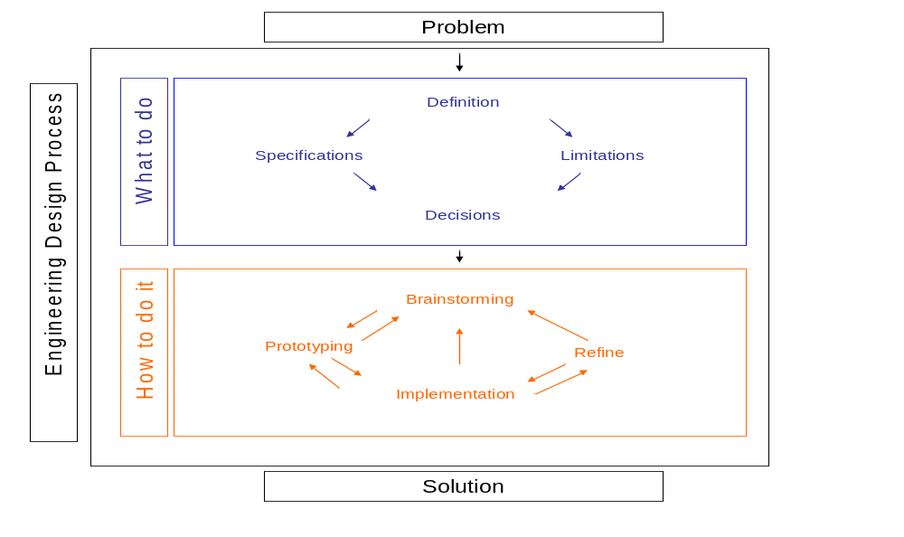
Figure 1 - Engineering Design Process Slide

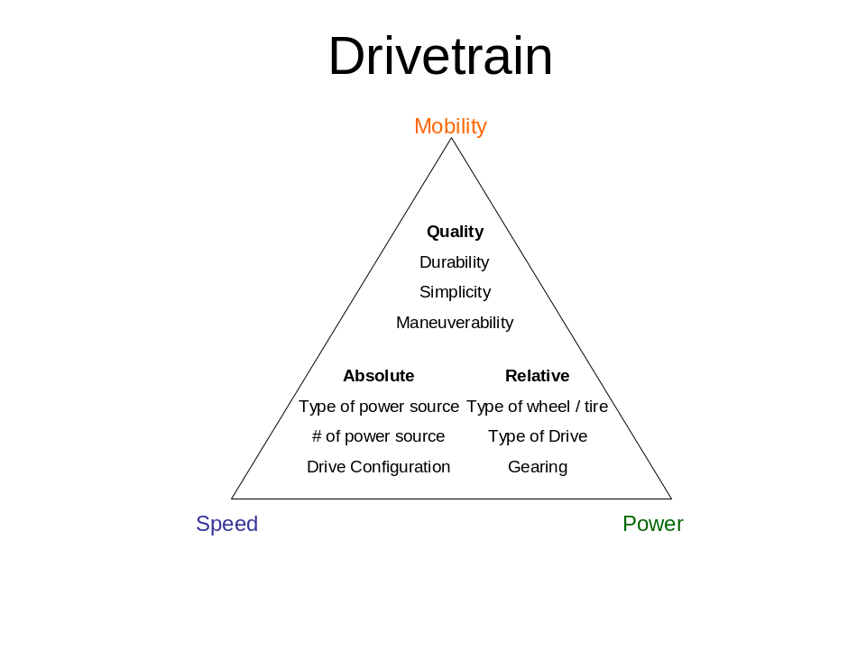
Figure 2 - Drivetrain Slide

-Brainstorming
During 7th period, Henry and Erik brainstormed about the challenge. Instead of getting to the nitty-gritty details, they brainstormed how the world championship final is going to be like.
-Autonomous
-Robot & Bowling ball parked at corners
-Collect at least 2 crates & collect balls
-Tele-Op
-Stack in safezone
-Scoring magnetic racquet ball
-Defensive maneuvers (Blocking / Pinning)
-Endgame
-Bowling ball scored
-Defense
-Raising crates
The above list is the list that was formulated during the brainstorming and the alliances will be able to do all those things.
Then we hypothesize if an alliance is going against another alliance that has the exact same robots & strategy, what factors will determine the result of the match, if luck is not involved. Here’s the list we came up with:
-Driving / Execution
-Efficiency of mechanisms
-Strategic placement
Analysis:
Since there’s a limit of holding only 15 balls, capacity is not as important as processing speed, or efficiency of the system. That will be the main quality of the robot that we will look for.
Here’s the generic task list for the robot based on the brainstorming:
-Collect racquet balls
-Crates (Stack, move)
-Score magnetic
-Bowling ball manipulation
Henry and Erik also watched a video that talks about a company called Resource Furniture to think about how to maximize the space of the robot. Some things they learned from the lessons are one mechanism can have multiple purposes and if two mechanisms won’t be used at the same time, it can be in each other’s way when they’re deployed. Also surgical tubing will help ease the load on motors.

-Fundraising
Kim is contacting a local bowling alley for the possibility of hosting a fundraising event since the challenge is related to bowling. However when she called the manager wasn’t there and it will be followed up during the next meeting.

-Assign manual sections
Since the manual is more than 50 pages long, each person was assigned sections to divide and conquer the manual.
Katie – Penalties
Erik – Extra Materials
Art – Basic Components
John & Emanuel – Game
Kim – Awards
There are many penalties this year and it will be worth the time to have someone dedicate themselves so we will have a better understanding of them.
Another note to a major change is the expand of usage of extra materials:
-Plastic (unlimited)
-Aluminum tubing, channel, angles, flat bar (unlimited)
-Surgical tubing (unlimited)

-Plastic Injection Machine
Erik learned how to use the injection molding machine in the lab. He and Henry will be working on making a mold for a new keychain to hand out to teams. It’s going to be a challenging task since it will have to be made by a CNC mill.
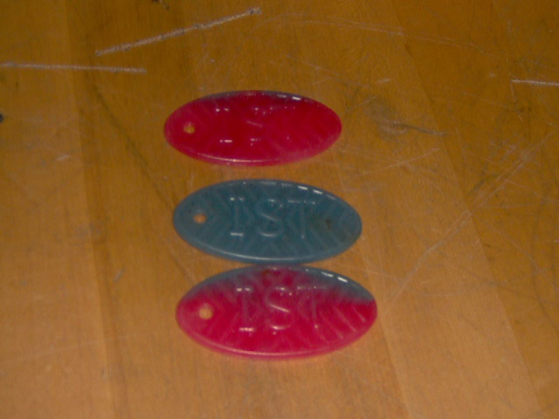
Figure 3 – Key-chains

Meeting 9/13/2011
Task list:
-T-shirt Design
-Training / Building Protobot
-Discussion about Challenge
-Lift Research
-Drivetrain

-T-shirt Design
Katie worked on several T-shirt designs during class for the robotics club. The initial design was tools that made up the words robotics. Then she changed design to include titan robotics, and West Salem High School, Salem Oregon since that will let other people know where the team is from. After Coach Smith reviewed the design, he said it’d be beneficial to have a generic logo as a pocket patch so different teams in the club can put their team name and number below it.
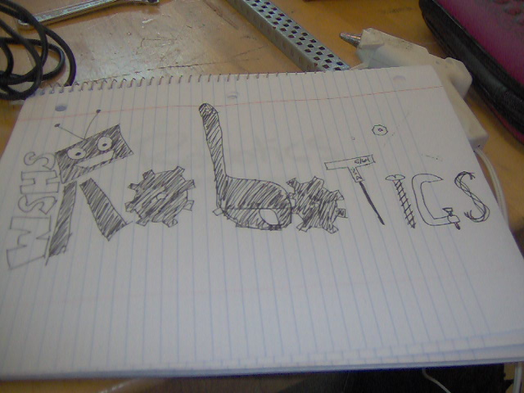
Figure 4 - 1st design
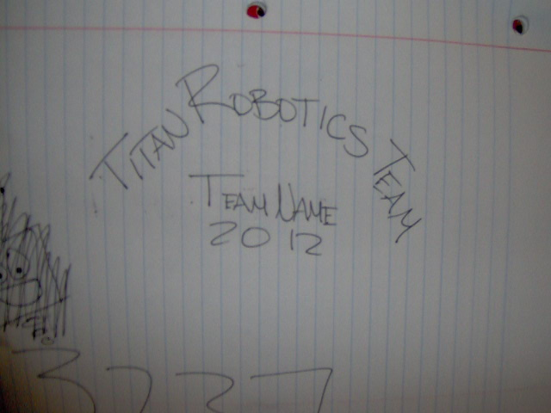
Figure 5 - "Pocket patch” design

Also the T-shirts will have a design in the back with iron on team numbers.
-Training / Building Protobot
Art started building a protobot our coach designed during the conference at OSU during the summer. Here are the reflections:
-It takes a lot of time to take things apart and start building all over again.
-It’s easier to build if you know what you’re building.
-Center of gravity makes a difference.
Just like building the robot for competition, building will move much faster if there was research done beforehand and if we know what we will be building. This approach will be more time-efficient.
Art didn’t finish building the robot but he’s catching on and learning really fast. Also he’s going to switch to the 3rd period class to be with the rest of the team.
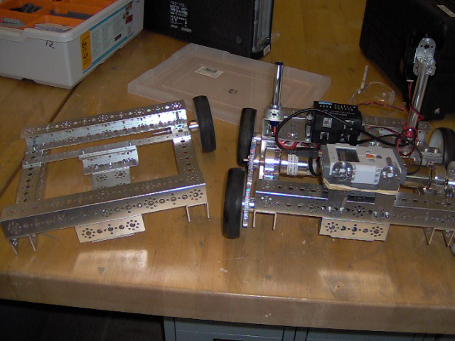
Figure 6 - Art's protobot (left) & the model (right)

-Discussion about Challenge
Katie, Erik, John and Henry discussed about the challenge for a bit during the meeting. However, since most are not completely familiar with the challenge yet, it was kind of slow because we’re not sure what to think about. However, some great ideas still came through.

-Autonomous
Offensive Actions Defensive Actions Other Actions
Upright crate Prevent opponent to score Get crate to safezone
Parking Collect balls & store them

We broke the game into three sections, autonomous, tele-op and endgame because what happens in autonomous will dictate or change what happens in tele-op, which will affect the end game. It’s important to have a clear strategy & backup strategy & counter-strategy throughout all three parts of the game to adapt to different robots and alliances that we might face.
If we have the lead after autonomous, it puts us in a better position because we don’t have to play catch up and the other team is being pushed to be on the defensive. Autonomous is going to be CRITICAL since there are so many ways to score.
We stopped because we ran out of time and we need to start off without boundaries to limit our thinking. It will be continued next meeting.

-Lift Research
Erik did some research on lifting mechanisms to figure out how to lift the crates as high as possible. There’s the “cherry lift” which has a telescoping arm. This is an interesting design because it can extend really far but the challenge will be designing a custom telescoping mechanism using TETRIX and the custom materials that are allowed.
He also learned about another kind of linear actuator that uses a screw to extend / retract. This will be quiet possible since we are allowed to use unlimited length bolts up to 3/8 in. on our robot.
The last mechanism he learned about is the lift for forklifts, which runs on chains. The obstacle to apply it to TETRIX will be how to mount it onto the chain.

-Drivetrain
Henry and Erik also discussed briefly about different possibility of drivetrain. Six-wheel drive seems like the way to go. However, the six wheels can either be evenly spaced, like our robot for HotShot!, or the two sets of rear wheels closer to the back, like last year’s robot. Before actual testing for now the rear two sets of wheels will be where the weight is, to get the maximum traction.
Chain-drive seems like it will work since it saves weight and space. It will also allow more flexibility in the placing of motors. However, the possible obstacles of running a chain-drive will be putting a tensioner on (this is a must), and transferring power to all three sets of wheels.

Meeting 9/14/2011
Task list:
-Training Protobot
-Programming Training
-Grant Submission

-Training Protobot
Art continued working on building the protobot today. However during the middle of the meeting the protobot was taken away because coach suggested team 3115 to take it apart and build it again, for practice. However, Art was still able to finish the geared-wheel assembly. Here are some of the issues that he came into today:
-There two kinds of long screws
-One side of the wheels are deformed because they were the “outside” side when they were on the last robot, and this makes putting the screws in more difficult
-A correct gear assembly is: wheel – spacer – gear – collar
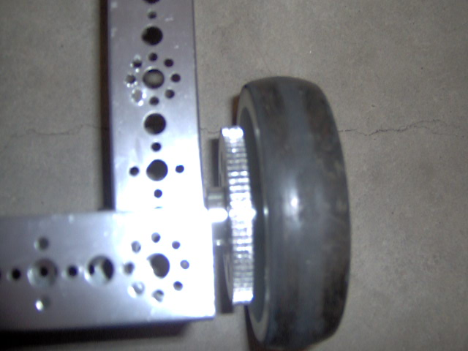
Figure 7 - Geared-wheel assembly on robot
Also Henry and Art discussed about what competitive robotics is like. All the other teams had started building their robots and our team hasn’t started yet. The reason behind it is we need to figure out “what to do” before “how to do it”. It’s definitely tempting to jump right in and start building but thinking through the challenge earlier in the season now will benefit us in the long run. The team will do a game analysis, then formulate a strategy, then determine what the robot will do, then build a robot.

-Programming Training
Katie worked on more programming with Henry to get used to RobotC and the basic concepts / functions that are used in FTC.
-Motor / Sensor Set up
This is very easy because there’s a setup wizard build-in in RobotC
-Include joystick driver
The line #include joystickdriver.c needs to be in the program if any of the functions in the joystick is called.
-getJoystickSettings(joystick)
This is used to update the value of joystick. The values of joystick must be updated constantly so it must be in a while(true) loop
-joystick.joy(1/2)_(x1,x2,y1,y2)
This is used to call the respective controllers and the joysticks on them. X being horizontal measurement and Y being vertical measurement.
-joy(1/2)btn(1-9)
This returns 0 or 1 depending on whether the button on the joystick is pressed or not.
-SensorValue(name of sensor)
This is used to call the value of a sensor, analogue or digital.
Katie was able to drive the LEGO robot through Bluetooth and make the robot do a right turn off button 1.
Katie also put a light sensor on so she can work on line following tomorrow.
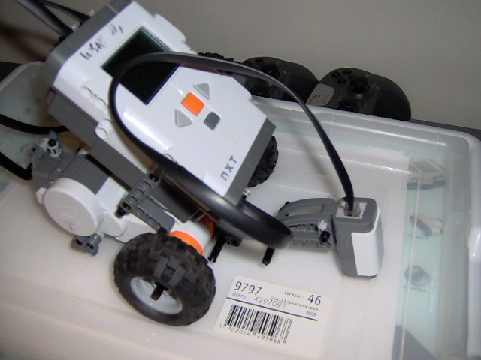
Figure 8 - Katie's robot with light sensor

-Grant Submission
The Oregon Department of Education has a $1000 grant for FTC teams. Henry filled out partial of the grant and John will finish the rest. The reason why Coach Smith is having us to do the grant ourselves is so we know what responsibilities the commit itself to. Also, it will make all the people in the club appreciate the work that the coach does for us and the fact that fundraising and money is part of the robotics program also.

Meeting 9/15/2011
Task List:
-Game Analysis & Brainstorming
-Training Protobot
-Line Following
-Grant Submission
-Fundraising

-Game Analysis & Brainstorming
Today Henry analyzed the game and brainstormed about the basic level of the game, ways to score, then tasks to accomplish that, etc. This will be used to determine what a successful strategy will be, and what our robot will be able to do and what we tasks we can leave to our partner.

Ways to score Ways to prevent scoring
Autonomous
Park bowling ball block
Parking robot block
Upright crate block
Tele-Op
Low goal deny access to goal / ball
Crates deny access to goal / ball
Magnetic deny access to goal / ball
Stacking crates deny access to crate
Endgame
Parking bowling ball block
Elevate crate deny access to crate

From the list above, it’s obvious that blocking is an effective strategy to prevent the other team scoring and is significantly easier than almost all the other ones. This explains why at competitions there are robots that are more defensive than offensive because it’s easier and usually more effective if they don’t have a really efficient scoring system.
While we’re making our strategy, we’ll need to put this into account, both offensively and defensively, meaning we should have a robot that can push / block other robots when we need to and have a drivetrain to push other robots out of the way.
Also, another effective way to prevent scoring is denying access to resources, and goals, whether it’s bowling ball, racquet ball, or a crate. If our alliance keeps collecting racquetball, there will be less of them for the other alliance, which decreases their chance of scoring them, and more importantly the magnetic ones. Bowling balls and crates are color coded but if they’re somewhere they other alliances’ robot can’t get to, it will effectively stop them from trying to score utilizing those elements.

Basic Strategy
Autonomous Tele-Op Endgame
Push bowling ball Gather ball / crate Defense – block
Grab 1 crate Defense – robot / goal / resource Push bowling ball
Collect while parking Score ball Elevate crate
Prepare bowling ball

Chokehold Strategy (guarantee winning if executed)
Defensive Chokehold
Denial of ALL resource / block: this will only guarantee not losing because it does not involve scoring, and it’s nearly impossible because there’s 1 bowling ball, 2 robots, 6 crates, and 100 racquet balls to defend.
Offensive Chokehold
Collect all racquetball and score them in low goal / 1 crate: especially hard since there’s a 15-ball limit on the robot and 1 crate can only carry roughly 20 of the balls.

After thinking about chokehold strategies, it was obvious that the game is well balanced and the Game Design Committee did a fantastic job to make sure there’s no reasonable chokehold strategy.

Generic Tasks:
-Drive
-Collect racquetball
-Score racquetball
-low goal
-crate
-magnetic
-Manipulate crate
-Manipulate bowling ball
-Elevate crate
-Defense

Cost-Benefit Analysis

Task Difficulty Benefit Merge
Drive 8 10 2
Collect 5 10 5
Score-crate 5 10 5
Score-low goal 5 5 0
Score-magnetic 10 10 0
Manipulate crates 7.5 15 7.5
Manipulate bowling ball 5 10 5
Elevate crates 10 20 10
Defense 4 10 6

Task Numeric Sort Defense / Offense
Elevate crate 10 O
Manipulate crate 7.5 DO
Defense 6 D
Manipulate bowling ball 5 DO
Collect 5 DO
Score-crate 2.5 O
Score-low goal 0 O
Score-magnetic 0 DO

The numeric list shows which tasks are relatively the easiest but also benefit the game the most. Driving was not in there because this is a mandatory task that’s fundamental to the game.
The list matches the 1st impressions of the game because elevating crates give out the most points, hence the reason for being on top of the list. And manipulating crate goes hand in hand with elevating crate(s). Defense is No.3 because it’s relatively easy. The reason why scoring magnetic is at the bottom of the list is even though it gives big points, it’s hard to do efficiently with a large system (space & implementation), and there’s also the “luck” involved. If there’s a controlled way to accomplish the task, it will be bumped up the list.
Also, from the Defense / Offense categorization it shows many seemingly offensive tasks can also be defensive because it takes opportunity away from the other team. “The best defense is offense”, or in plain words, score a lot and that will be have the same effect as defending the opposing alliance.

Prioritization
Desired robot qualities
Robust
Automatic
Desire functionality
Defense
Collect racquetball
Manipulate crate
Manipulate bowling ball
Elevate crate(s)
How
Robust
Good drivetrain
Low center of gravity
Strong chassis
Automatic
Conveyor
Sensor
“Error” tolerance
Defense
Maneuverable
Drivetrain
Collect Racquetball
Conveyor / controlled system
Score crate / magnetic
Sensor
Multiple storage / exit
Manipulate crate
Mechanism in the back / center of the robot
Manipulate bowling ball
Same mechanism as collector / front of the robot
Elevate crate
Out of the way of everything else / center of robot

The analysis today was only based on alliances, not robot. We will determine what we will have to do to be a good robot & have a good strategy by itself, but also a complimentary robot to all the other kinds of robot out there.

-Training Protobot
There was not much work done on the robot because of the limited time we had. However, the highlight of the day was when Art realized there was no more medium gears for us to put on the motor shaft, we decided to put a small gear instead.
The problem with that is from where the motor is mounted on the original robot, the gears won’t mesh because the small gear is too far away from the medium gear on the wheel. So Art improvised and suggested to put a idler gear towards the front of the robot that meshes with the medium gear, and the small gear will mesh with that gear instead.

-Line Following
Katie started programming the LEGO robot for line following today. Henry explained the basic concept of how to make a robot to follow the line with 1 light sensor.
The common misconception with basic line following is the light sensor doesn’t really follow the line; instead it follows the EDGE of the line. We decided to make the robot follow the left edge of a black line, so when the reading is low (black), it has to turn left and when the reading is high (white), it has to turn right.
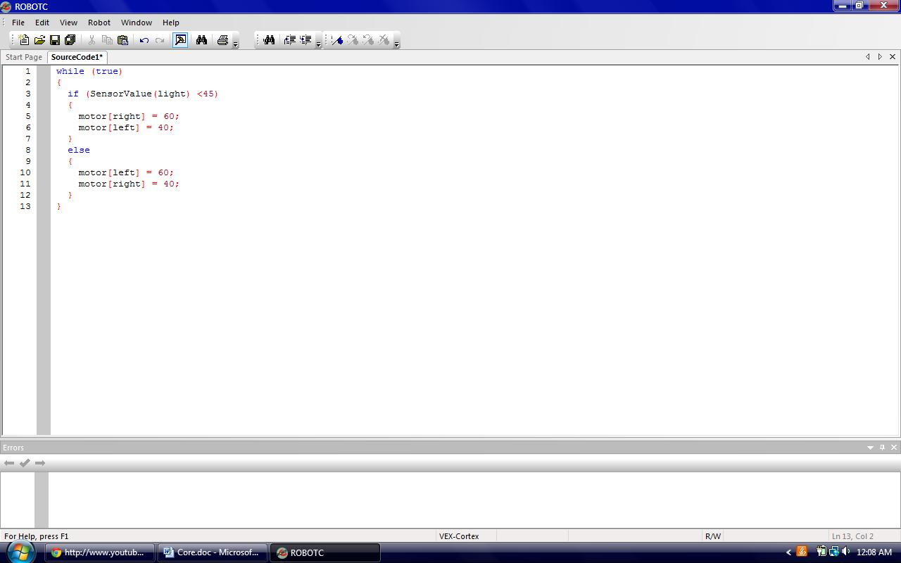
Figure 9 - Code for Basic Line Following

After testing the code, Henry started teaching Katie about PID control. He explained the basic principles of PID control using a scenario and analogy.
If a person is hungry and running to a restaurant,
P stands for how far away he’s from the restaurant
I stands for how long he has been running
D stands for how fast he is approaching the restaurant
Katie added Proportional control into the line following program and now it follows the edge of the line much better without the zig-zag movement. However it still strays off the line when the curves are too sharp or there are consecutive curves. Katie added the Derivative control into the program also but she will tune it tomorrow.

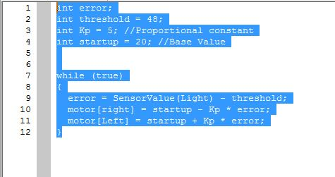
Figure 10 - Proportional Line Follow

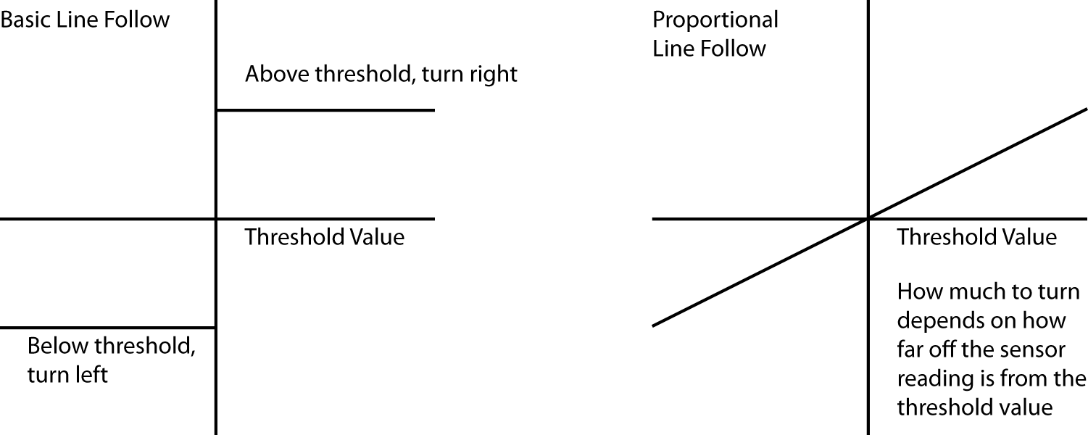
Figure 11 - Graphical Explanation of P control

-Grant Submission
John finished his part of the grant today, and Henry finished the budget part of the grant.
John’s part was prompt 1 one of the grant, which asks:
Describe how participation in FIRST Robotics will contribute to helping students meet local or national standards in STEM as well as align o Oregon Skill Sets.

1. Goal 1: Participate in the FIRST Tech Challlange competition for the 2011-2012
school year.

2. Goal 2: Inspire students to consider careers in computer science and
engineering.

3. Goal 3: Provide opportunities for students to think critically and problem solve as
a team while designing, building and programming their robot.

Goal 4: Encourage students to reach out to younger students and promote applying
science, technology, engineering, and math to robotics.

--Related Salem Keizer School District Goals--

Local Standard 1: Read and communicate effectively: Students continually read and
communicate through documentation and discussion groups to become experts on the
rules of this game. Students will also document the design process in the engineering
notebook and present their robot in the technical interview portion of the FTC Robotics
Competition.

Local Standard 2: Think critically and solve problems: From brainstorming to
competition, students will be solving problems that have a direct impact on their robots
performance. Students work together in discussion groups to continually think through
the engineering design process of understanding the challenge problem with all its
specifications, decisions, and limitations and applying the methods of finding a solution
through brainstorming, prototyping, implementing ideas, and refining a solution.

Local Standard 3: Work effectively in groups as well as individuals: The size and
scope of this challenge requires that the team works together effectively in order to
complete the robot. The team will break down tasks, assign roles and work together
throughout the course of the season.

Local Standard 4: Exhibit technological literacy: Students will apply technology in
designing, building, programming and improving their robots.

**Related Oregon Standards**

Science Content Area: Engineering Design Standard

Oregon Standard 1: H.4D.1: Formulate Problem Statement: Upon reading and
understanding this years’ competition, students will define the problem and specify
criteria for a solution. They will then set constraints, generate potential solutions and
use a selection process to determine their design direction. This will be documented in

the team’s engineering notebook.

Oregon Standard 2: H.4D.2: Create and Test Solutions: After determining the
design direction, students will build a robot and test their proposal. Based on the
results of the testing, students will make modifications to the robot and help make it as
competitive as possible. This will be documented in the team’s engineering notebook.

Oregon Standard 3: H.4D.3: Analyze and display data: While cycling through robot
design improvements, students will document robot performance in the engineering
notebook and determine how to use this information to make a more competitive robot.

Oregon Standard 4: H.4D.4: Recommend a Proposed Solution: After brainstorming
different design options, students will use discussion method to pick and propose a
solution. This will be documented in the team’s engineering notebook.

Expected expense Subgrant Funds
Registration for FIRST $275
Custom materials (Plastic, aluminum tubing, sheet metal) $200
Batteries $200
Motor & motor wires $150
Custom sensors (Hall, limit, LEDs, reed switches, etc.) $100
Event Registration $75
Total $1000

-Fundraising
Kim had written out a possible fundraising plan for the bowling alley. We will plan a “bowl-a-thon” event at a local bowling alley to not only fundraise for our club, but also to promote FIRST and STEM.
For now the members of the club are thinking about hosting the event next month, possibly on a non-school day. This should give us enough time to get the word out so more people can come and have fun.
After everything is finalized, we will send the announcement to the leadership class in our school so they can broadcast it during announcements during school. This should be the most effective way to get the word out. We will also post notice of the event in local markets or businesses where there are lots of people going in and out.

Meeting 9/16/2011
Task List:
-Grant submission
-Training Protobot
-Game / Robot Analysis
-Field Construction
-Parts List for Order
-Stacking Mechanism Research
-Sensor Research
-Sponsorship

-Grant Submission
Henry finished the grant for Oregon Department of Education today and submitted it to Coach Smith for signature from the superintendent and principle.
Fingers crossed!

-Training Protobot
Today is the last day of Art working on the protobot because after he put the motor and the idler gear on the chassis, there was no spare motor controller for him to put on the robot. However, the purpose of building the protobot was to get him to be familiar with the kit and the goal is accomplished. Starting from the next meeting, he will start working on prototyping for the actual robot.
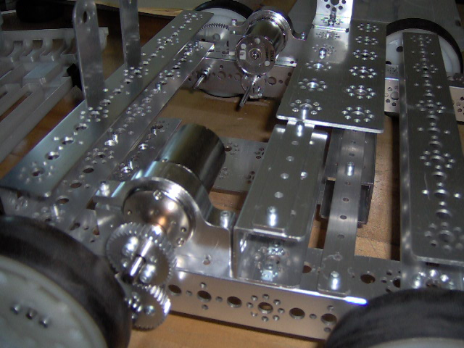
Figure 12 - Protobot with idler gear
-Game / Robot Analysis
Katie, John and Erik did an initial overall general design for the robot while Henry was finishing up the grant. They thought about drivetrain and how each of the components will fit on the robot.
List of task the robot must perform:
-Collect racquetball
-Score crate / magnetic
-Manipulate crate
-Manipulate bowling ball
-Elevate crate(s)
Since racquetballs are critical to the game (crates must have racquetballs to get height bonus), we decided it’s the task that must be completed. Then the big question for the racquetball would be: how much do we need to hold?
The first response of the team members is 15 since it’s the maximum limit. However, after further thinking and analyzing the game, it was deemed unnecessary.
The robot will be much more effective in scoring racquetball / moving crates if two are done at the same time. So the basic conclusion draw from it is: the robot needs to carry a crate around the field. This will make it much more effective and efficient since the robot doesn’t need to traverse around the field to pick up racquetball, then to line up and score in a crate.
Then the next question is, if the robot is carrying a crate, does it really need to hold 15 balls since all of them (except for the magnetic ones) will be scored in the crate?
The team decided the answer is no because it’s going to be scored anyway, so the robot only needs to hold around 8 – 10 (including magnetic racquetballs) to be successful in executing the strategy. This will not only save space on the robot for other mechanisms, it will also make the process much faster.
Our initial strategy of the robot will be:
Autonomous
-Get off ramp from the cliff side (To avoid traffic)
-Push bowling ball to back corner
-Control / setup to control 1 crate
-Park robot to front corner
-Collect while doing all of the above
Tele-Op
-Control crate if not already
-Collect until the robot detect magnetic racquetball(s), score the rest in crate
-Go back to ramp to drop-off crate & score magnetic
-Repeat until end game
-Push bowling ball onto ramp
-Elevate crate(s)
The Tele-Op strategy is formulated based on the number of game elements on the field. There are 88 regular racquetballs and 12 magnetic ones, which means roughly 1 out of 8 is magnetic. So during a match, statistically speaking 1 out of the 8 balls the robot collect will be magnetic, so theoretically, there will be 7 balls in the crate and 1 magnetic one waiting to score. If the robot is capable of stacking & carrying stacks, it will continue to do so until it reaches its crate capacity. This would be the best possible outcome but there are two alternative ways to play the game:
-Keep collecting until crate is full, and then drop it off at the ramp
Pro: less trips back and forth
Con: vulnerable to be blocked; “all eggs in one basket”, less crates on top of the ramp (worth 10 pts each without stacking / elevating)
-Collect until a magnetic ball is found, then drop the crate off at the ramp
Pro: less vulnerable to be blocked (multiple trips), more crates on the ramp
Con: more trips moving back and forth
As stated above, the “perfect” solution would be collect a reasonable amount or until magnetic ball, then stack the crate, then continue to do so and drop multiple crates off at once.
The strategy above takes the pro of both sides (less trips & multiple crates on ramp) but rather it will be possible or not will be determined by whether we will successfully have a stacking mechanism on the robot.
The strategy will be refined and finalized early next week so the team will start prototyping mechanisms.

-Field Construction
Coach Smith brought in some plywood pieces and Erik started to put the field together. The pieces of plywood are 3/4 in. thick instead of 3/8 in. like it says in the building instructions. However, it doesn’t matter because it only specifies the ramp need to be 8 in. tall total. In fact this plywood is better because it will be stronger and less bendable than the 3/8 in. Also, we will then only have to cut 4 legs instead of 6 legs on the instructions because the plywood will be strong enough.
For cutting the legs, we used the brand new chop saw that’s in the lab. It’s a very nice tool!!!
We only finished fabricating the legs because we didn’t have any piano hinges to connect the two pieces of plywood together. However we did attempt to cut the circle for the bowling ball out but the saw was having issues and the blade kept wouldn’t stay in.
We will continue building the field and hopefully it will be done by the end of next week.
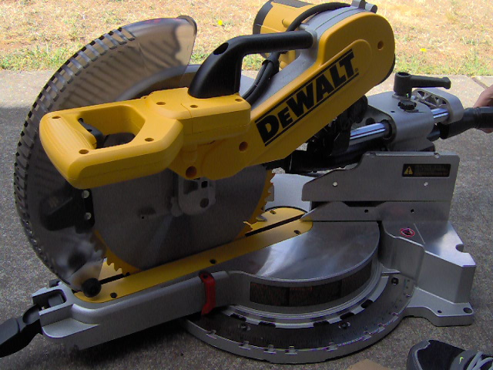
Figure 13 - New Chop Saw

-Parts List for Order
Coach Smith told all the teams in the club to put together a list of parts needed and he will review and put the purchase in next week.
Here’s the list we came up with:
-2 x 12V Battery (at least)
-2 x NXT Battery
-Tank Tread Kit
-? x Motors
-? x Fuse Motor wires
There is not much structural products put in the list because we still haven’t took our robot from last season apart. However, batteries are needed because the batteries we have are 3 seasons old already and they aren’t capable of storing the same amount of power as the new ones. Tank tread kit is needed for the processing system for the racquetballs. There’re 7 motors on our robot currently but most of them have broken gears inside because of last year. They’re still usable but they’re not in perfect condition. As for the fuse motor wires, that’s to prevent motors burning out during prototyping / practice to save the motors.

-Stacking Mechanism Research
Henry looked at videos of the 2003 FRC challenge, Stack Attack, to research about stacking mechanisms since that challenge involves stacking bins up. One of the robots he found that has an effective stacking mechanism is the robot from 1114 Simbotics. Then he further found some more detailed CAD drawing and pictures of the mechanism on their website. From there he learned there are three additional components to the whole manipulating system other than the lifter. The robot has the “paw”, which applies pressure to the top of the stack to secure the stack; it also has a “flipper”, which rights the bins that had fallen over; and finally it has a “whacker” to orient the bins so they fit in the stacker. All three mechanisms are useful in this challenge and Henry will present the robot to the team next week to further explore this mechanisms.
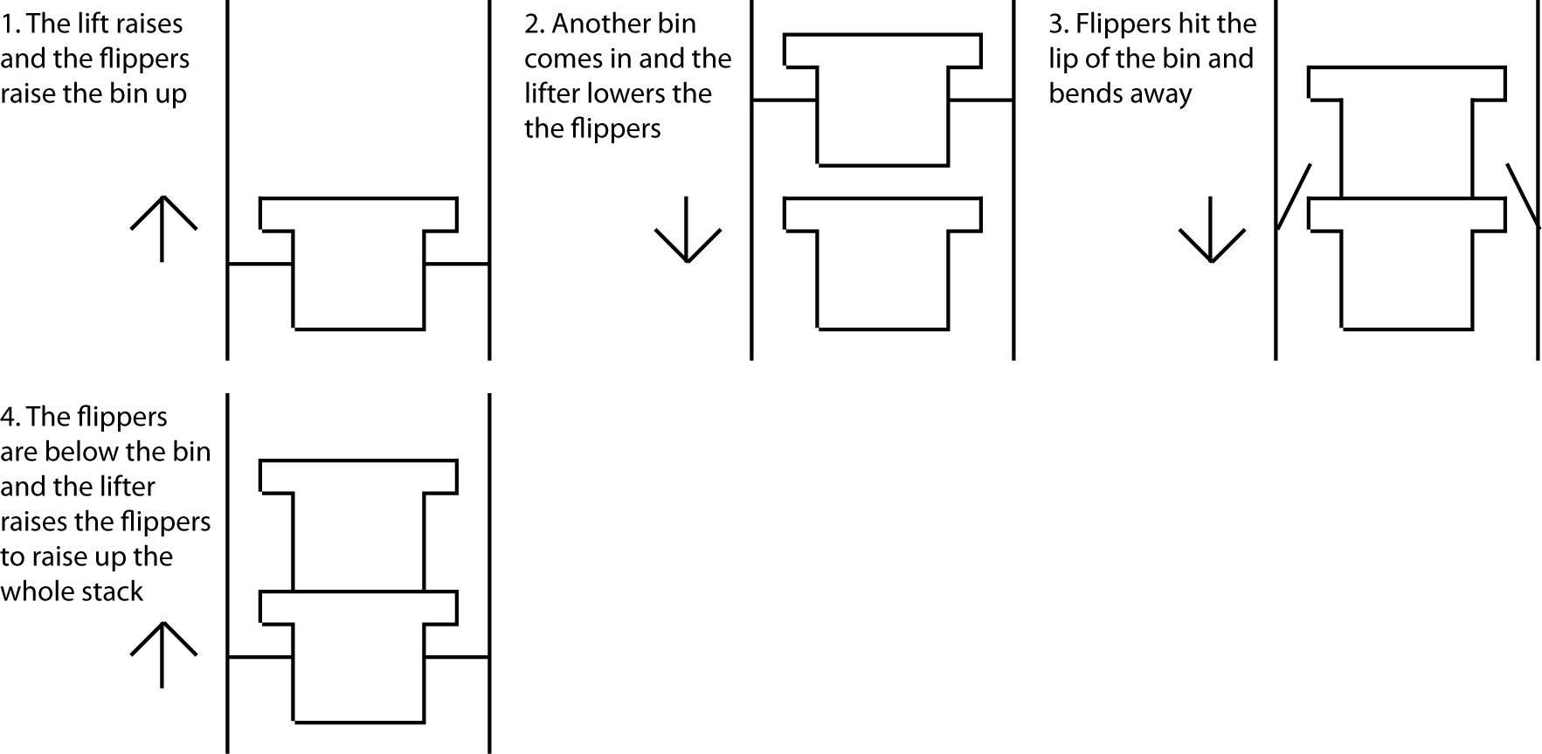
Figure 14 - Explanation of Stacking Mechanism

-Sensor Research
Coach Smith got this Arduino magazine and inside there was a version of Arduino that operates on very small power. He showed it to Henry to think about possibility of utilizing that on the proto-board. This microprocessor will be useful because instead of wiring multiple limit sensors to the Digital I/O on the proto-board for the same system, it will be wired to the microprocessor and the microprocessor will send out signal to the analog port depending on what condition it is.
For example, if there was a system to check how many crates there are in the stack in the robot, instead of wiring 6 (maximum) limit switches to the proto-board testing each height, it will be wired to the microprocessor and it will send out a signal (1 – 6) depending on the height.
However, the only problem is analogue outputs are only possible on sensors, such as ultrasonic sensor (distance), hall-effect (magnetic field), etc. Outputs on the microprocessor are only digital. After doing some research on the topic, Henry found out the way microprocessors accomplish the task of outputting different values is by PWM, or Pulse-Width Modulation. This is how the servos know what angle they need to go to in the TETRIX kits. Depending on the frequency of the signal, it will be interpret as different values. Henry will ask our mentor Dale Jordan to further research and learn about the topic.
-Sponsorship
Brenton replied saying he’s too busy as of right now to participate in robotics. Unless he has time in the future, he won’t be able to participate. However, he will continue work on the scouting program he has been working on when he has time. The scouting program will incorporate videos of each different robots and it will be a significant help to scouting. It’s similar to thebluealliance.net for FRC where a person can search by robot or event and it will show the respective videos.
Since he won’t be able to join the team, we will have to go to Hanard Machinery (own by his dad, Loren Paulsen) for the possibility of them sponsoring us with custom materials such as sheet aluminum and tubing. Also his dad is an engineer and we will be able to talk about the challenge and find out some more new ideas that we didn’t have.
We will also visit West Salem Machinery in the future to talk with the engineers in the shop, and for the possibility of them sponsoring us with custom materials.

Meeting 9/19/2011
Task List
-Timeline
-Prototype
-Order List
-Custom Parts
-Field Construction

-Timeline
Henry put together a list of tasks the robot has to accomplish and set a deadline on them based on priority / importance:

Bowling Ball Crate Racquetball
Control -1 Collect -1 Collect -1
Launch -1 Flip -1 Process / Sort -1
Store -1 Store -1
Stack -2/3 Score Crate -1
Elevate -1/2 Score magnetic -1/2

- Before Christmas
- Before State (TBD)
- Before World Championship (TBD)

Henry put the list together so members from different periods of the team will be able to know what other teammates are working on to avoid confusions or working on the same tasks.
Drive was not on the list because that’s an absolute requirement and everything else is not. The reason for the level 1 tasks to be done before Christmas is so the programmers will have time to program autonomous and implement sensors on the robot to make it more efficient and the drivers will have time to drive and debug what might go wrong on the field.

-Prototype
Art started prototyping mechanisms to possibly lift up the crates or to stack the crates. He quickly put together a “fork” and it lifted up the crate and has a very good hold on it. Also, he thought about mounting the mechanism on a chain loop that’s powered so in the beginning of the match, it’s inside the robot on top but it folds out when we need to use it.
However, the tubes that were used as forks had a diameter of .75 in. and the holes were only 1 in. big. If the mechanism is deployed, the driver must be PERFECTLY dead on with the crate or else the forks are not going to go in.
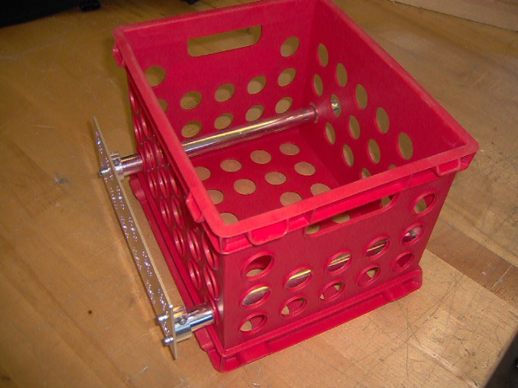
Figure 15 - "Fork" Prototype Mechanism

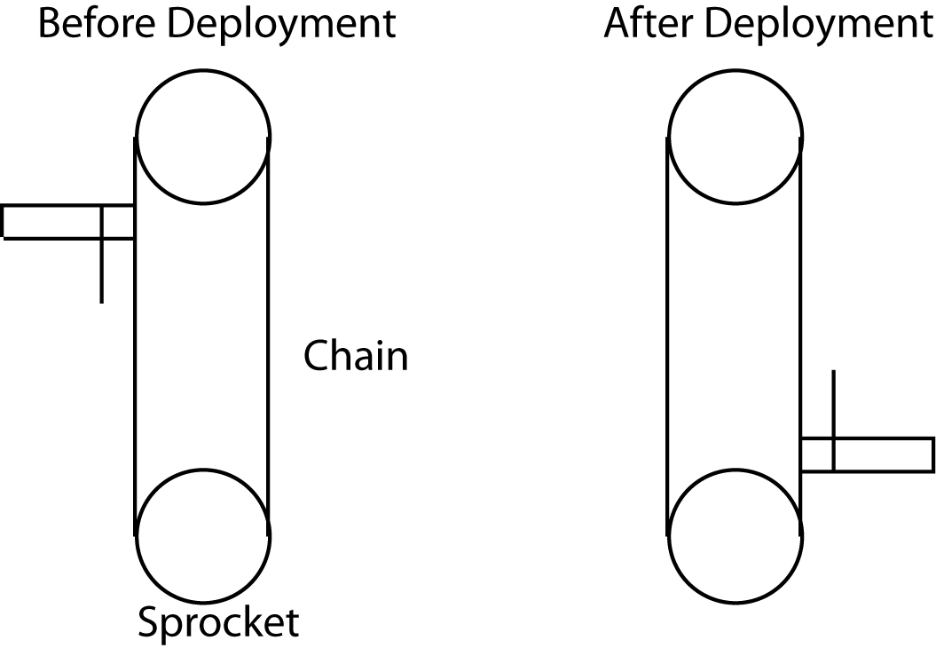
Figure 16 - Chain Deployment Idea

Erik and Katie also brainstormed ideas for lifting the crates up for stacking them. First they thought about having a flipper or plate on both sides to lift the crates by the lip. Since the crates were light there was not so much trouble for doing so. However, the same problem with Art’s fork ideas was also a problem with their idea. Since the plates would not open or close, it still requires precise driving to get the crate in just right because the lip of the crates are very small. If there’s too much variance or tolerance then it won’t support the crate and lift it up.
Henry came up with an idea of using parallelogram grabbers to grab the crate from both sides to secure it. That requires extra space for the linkage and movement for the claw but it’s an active device that can have lots of tolerance so the robot can drive just drive up to it.
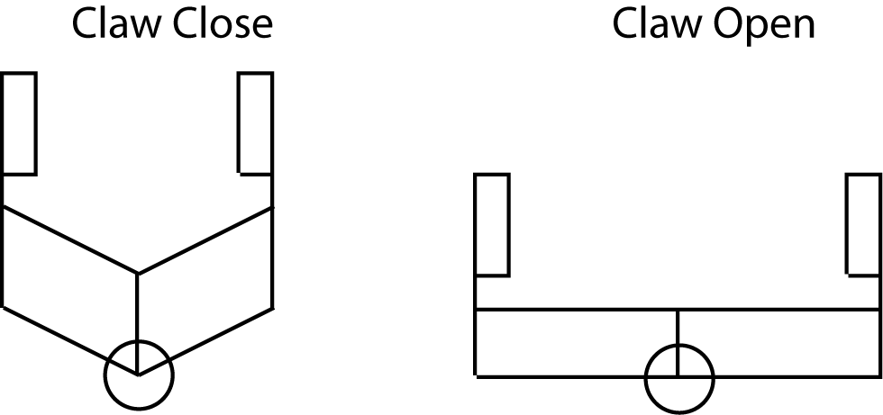
Figure 17 - Parallelogram Claw Concept

The last idea that we have for the crates was to have tank tread belts to suck the crate in, and then have plates / flippers to lift the crate, and so on. This idea was the design we chose to go with because it will not require precise driving. However, this WILL take up extra space on the sides but it should be okay because the tank treads are going to be just offset with the drive chassis around the crate.

As for the lift, Erik and Henry are heading more towards the lift that was on the 1114 Simbotics’ 2003 FRC robot. It’s a continuous lift using either chain with sprocket or rope / wire with pulleys. The lift can be build to be very compact and it can lift higher than scissor lifts, and other lifts because of the space limitation. One component the lift demands is linear slide. However, since TETRIX does not have linear slides we will have to fabricate our own. Erik thought about having just the right sizes of Aluminum C-Channels so they slide within each other. This will be discussed further in the future meetings. The team feels like this is the direction they want to head to because the crates are fairly light (even with racquetballs) and the lift’s height limit depends on how many stage it has.
As for drivetrain, since we have to surround the crate, it has to be compact AND robust. Erik decided to build it so it has support on both sides of the axles of the drive wheels. This will benefit us in a few ways: more robust, and the bars will act as wheel guards so the racquetballs won’t get in the way. Most FTC robots have a drivetrain that’s called “West-Coast Drive” and the axles are only supported on one side of the wheel. However, this will cause bending of the axles in the long run but it’s easier to repair than “regular” drivetrain where it takes much more time to repair the drivetrain. We will also have wheel guards that are pointed towards the center of the robot to make lining up against the war easier because there won’t be any racquetballs in the way.
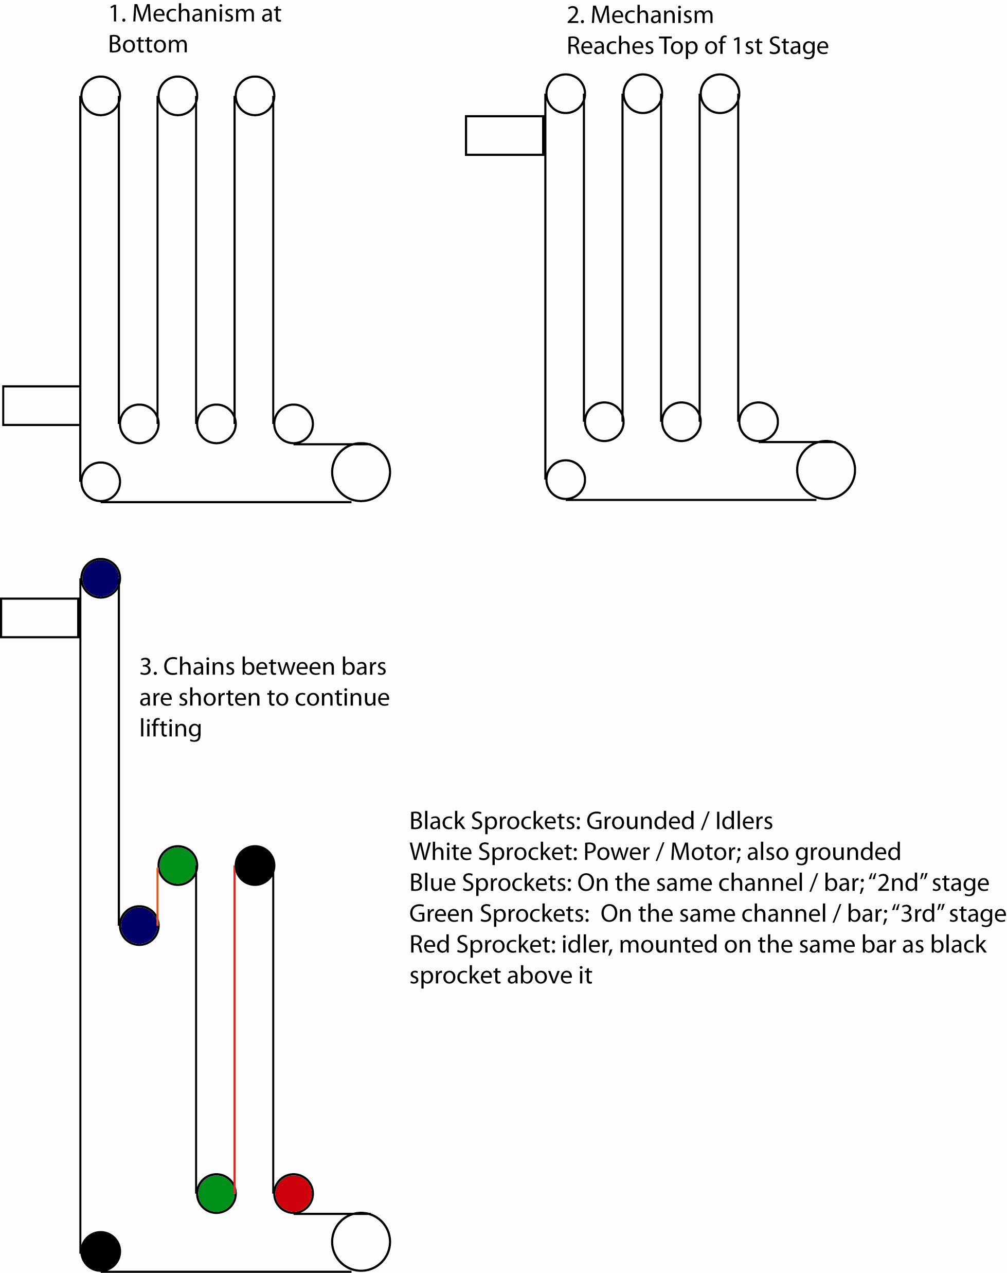
Figure 18 - Explanation of lift
-Order List
Since we have not registered yet, we won’t put in the purchase but here’s the list of items our team is going to purchase:
-2 x DC NXT Battery
-1 x DC Charger
-1 x Gear Pack
-2 x 12V Battery
-1 x Tank Tread Kit
-1 x Rubber Insert Pack
-1 x Bronze Bushing Pack

Since this year we will be heavily relying on custom sensors we will have to purchase the more powerful DC NXT battery. They are 2100 mah and the regular AC ones are 1400 mah. Also, all the batteries (both 12V & NXT) are more than a few years old and they have to be replaced to maximize the powers to motors and also the ensure connection to Samantha is secure.
As for the tank tread kit and inserts, we will need them to collect / process racquetballs and to manipulate the crate.
The Bronze bushing & Gear pack is on the list also because all the gears and bushings we have are all wore out from usage for the past few years. Fresh bushings are needed to make sure everything runs smoothly with the least amount of friction.

-Custom Parts
Today we contacted West Salem Machinery, Hanard Machinery to see if they have any aluminum tubing or sheet aluminum lying around. Neither place has extra pieces but we did get in touch with a local metal supplier, Ram Steel. We purchased 22 ft. of 1 in. square aluminum tubing from them for around $20. They will be used for the chassis of the robot, instead of regular channels to save space, and to make mechanisms more compact and sturdy.
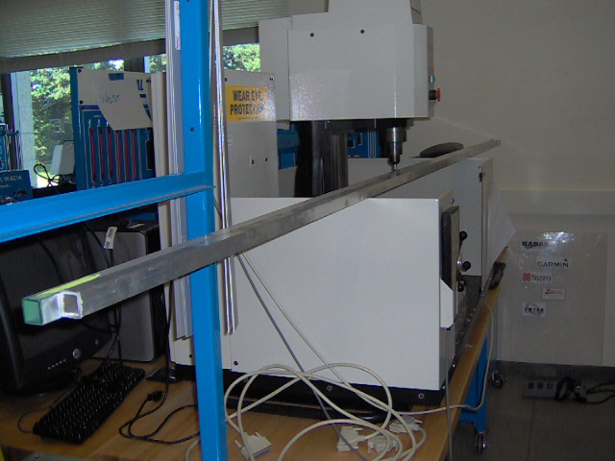
Figure 19 - Aluminum Tubing
-Field Construction
Today Smith brought in the pieces of field that he worked on during the weekend. He also went to Wal-mart and purchased the right crates for the challenge. They are not clear like the official ones but instead they are solid blue / red. He brought in two basketballs similar to the size of the bowling balls for us to prototype with. He finished the magnetic racquetball holding assembly and finished the ramp. The infrared beacon mounting devices are painted and will be here tomorrow.
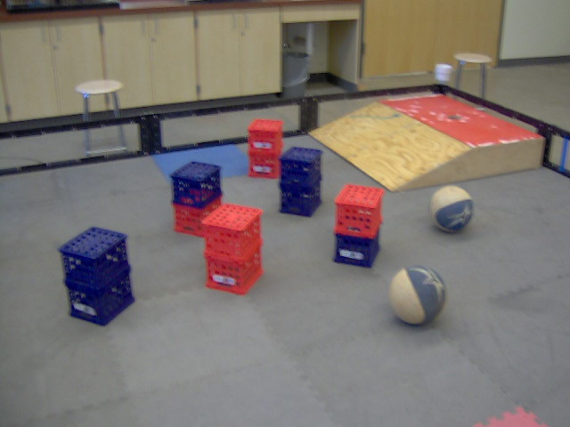
Figure 20 – Field

Meeting 9/20/2011
Task List:
-Prototype Crate Manipulator
-Chassis / Drivetrain

-Prototype Crate Manipulator
Art put together a new “fork” to lift up the crates after hearing ideas from the rest of the team. The new design will be implemented with tank treads, which will bring the crate in and line it up for the “forks”, which will lift them up. This is very similar to the previous one but it won’t require precise driving.
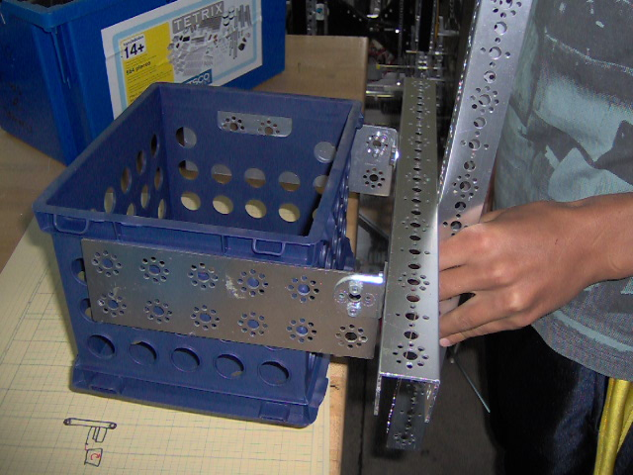
Figure 21 - New Crate "Forks"

Art also thought of a mechanism to flip the crates right side up. Since the crates have lips on all sides, the mechanism is a hook, which will hook on to the lips and the robot will drive back and flip the crates. However, since the crates have 2 different length sides, we will have to find out a way to implement the design so it can handle both scenarios.
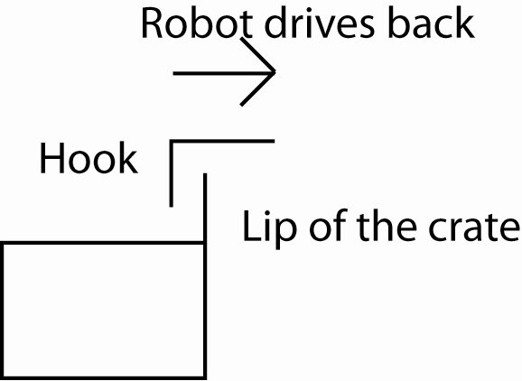
Figure 22 - Hook Mechanism Idea

-Chassis / Drivetrain
Today Erik sketched out the basic chassis for the drivetrain. He cut the aluminum square tubes using the horizontal bandsaw and started putting it together.
The chassis will have square tubing on both sides on the axle, which is different than most FTC robots. This will make the robot more stable and also make sure the racquetballs won’t get in the way for driving.
The lengths for the bars are 17 in. so there will be wiggle room if we need the space for the collecting mechanism for the racquetball.
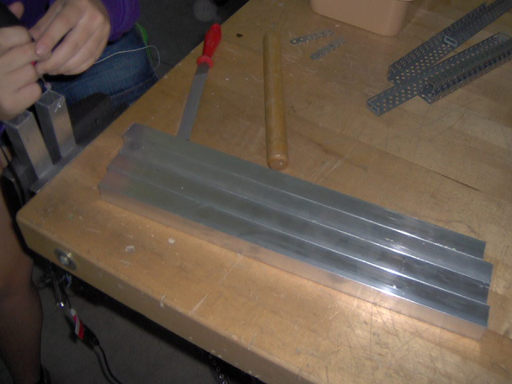
Figure 23 - Cut Tubing

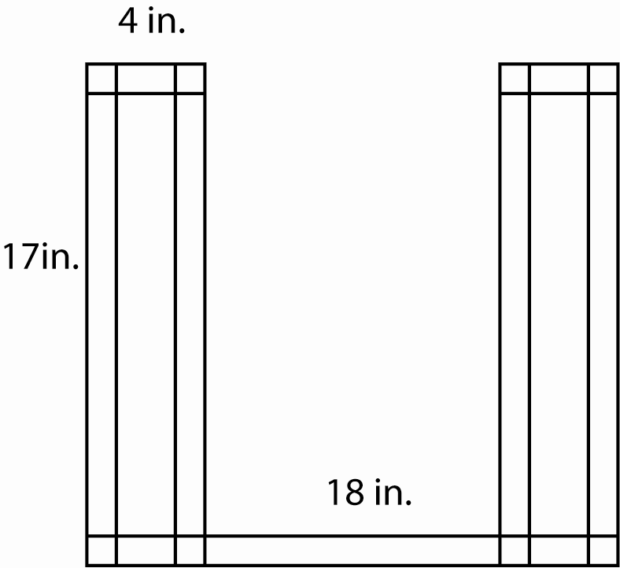
Figure 24 - Aluminum Tubing Chassis

As of right now, we will put the bar going across (width) of the robot all the way to the back but eventually we will change it to where it fits the most and makes the chassis most strong. We will put one more tube towards the center in the future.
Possible problems with the chassis is the wheels won’t be in the front of the robot which means the robot might have problems with jumping off the cliff or going up the ramp because it hits the tubing first. Our solution is to put a wheel / roller in the front so it will roll instead of dragging it across.

Meeting 9/22/2011
Task List:
-Chassis / Design
-Sponsorship
-Mentoring

-Chassis / Design
Today Erik continued to put the aluminum square tubing together for the chassis. The two sides are finished but we were not certain where we should put the cross tubing. We drew out sketches of where all the mechanisms are supposed to go and for now it will be put together between the lift and the ball system.
For the ball collecting / sorting mechanism we will be using a conveyor belt system and it will split the balls into the regular ones that go into the crate and the ones that go up and to the off-field goal.
We will need 2 – 3 tank tread kits total for all the mechanisms.
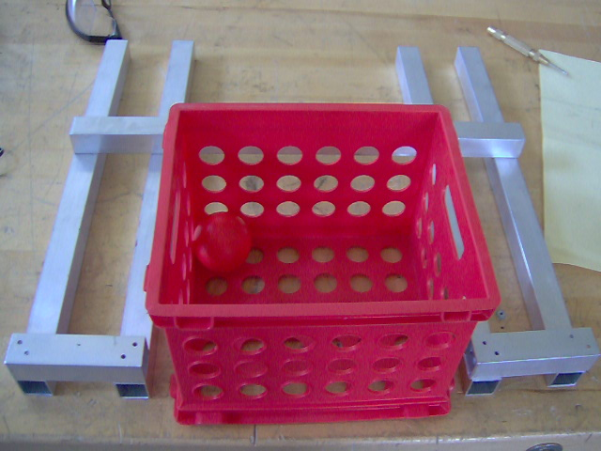
Figure 25 – Chassis

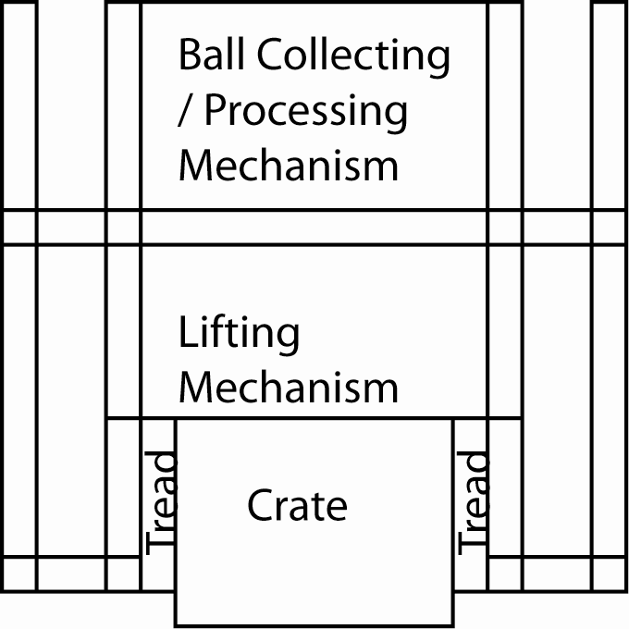
Figure 26 - Design Layout

-Sponsorship
Kim and Katie will be going to a meeting today to talk with the local bowling center personnel for the fundraising event.
Kim’s also found a possible source for the bowling ball. One of her friend’s father from color-guard owns a bowling center and she’s going to contact to see if they’re willing to donate a pair of bowling ball for the field.

-Mentoring
Straub Middle School is having a new FLL team and Henry is going to go down to the middle school to help out / mentor during their meetings. They will be meeting on Tuesdays and Thursdays and tomorrow the teacher / coach will be coming up to the lab to talk with Henry and other mentors.
Another FLL team that Henry will be mentoring is the neighborhood team in West Salem. They have meetings on Friday in the lab.

Meeting 9/23/2011
Task List:
-Chassis
-Bowling Ball Mechanism
-T-Shirt Design
-Mentoring
-Fundraising

-Chassis
Erik continued to work on the aluminum square tube chassis today. He had to re-drill the holes on one side because the vertical bars on both sides were not same distance apart.
After he corrected the issue, he marked the holes for the drive wheels in the back and an extra hole in between them for an idler gear. He also marked the holes for the wheel in the front. The marks were made so the wheel can just clear the corners of the aluminum tube. That will solve the issue of getting caught while we go on / off ramp.
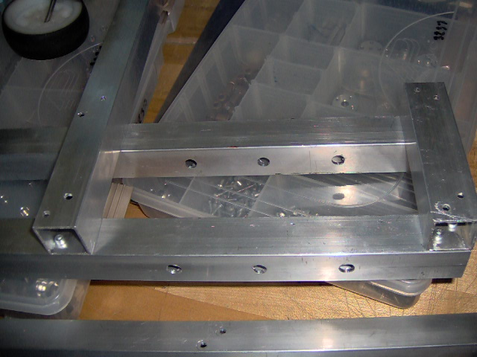
Figure 27 - Holes for Chassis

-Bowling Ball Mechanism
Katie, Art and John brainstormed about mechanisms to control the bowling ball. The mechanism will need to prevent the bowling ball from steering left and right when the robot pushes it onto the ramp and it needs to be able to fold into the robot to prevent damage.
The 1st mechanism they came up with was an X that comes down and caps the ball. The curvature of the X will fit the bowling ball perfectly.
The 2nd mechanism is similar but instead of an X it will be a square, sides will have non-slip pad and this shrinks the size of the mechanism down.
However, both mechanisms have the same kind of motion and next time they will brainstorm more ideas in case the robot doesn’t have space for it.
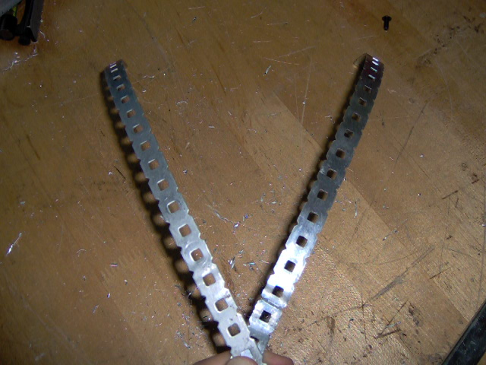
Figure 28 - Curved Capper

-T-Shirt Design
Katie finalized the T-shirt design and will contact to get a quote for the club. The patch will be on all the t-shirts and individual team number / name will be underneath it with iron-on team numbers on the back.
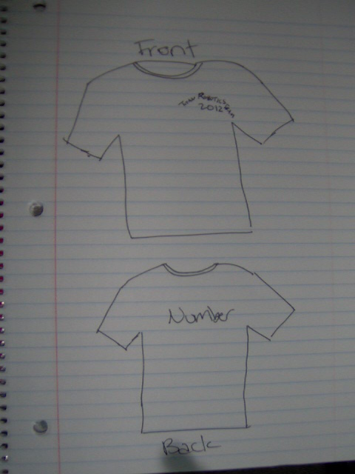
Figure 29 - Final T-Shirt Design
-Mentoring
The middle school teacher came to the lab today and discussed a bit with us for the mentoring. All of the team members were interested and we will start mentoring every Tuesday / Thursday from 3:00 to 4:30 next week.

-Fundraising
Kim had a meeting with the bowling center personnel and we will be having a bowl-a-thon event on Dec. 4th from 1:00 to 5:00. We will try to get sponsors for the lanes and tickets will be $20.00 per person and we will get $11.50 for each person. The representative for the bowling center was very nice and she will help spread the word in local communities and schools close by. We will also send the message in our school and it will be announced in the intercom.
This event will bring some extra funding for the club and it will promote STEM and robotics in Salem.

Meeting 9/26/2011
Task List:
-Chassis
-Lift
-Observation
-T-Shirt
-Custom Materials

-Chassis
Erik, Art and John assembled 4 wheel assemblies to put onto the aluminum tube chassis. The purpose was to test if the chassis is level and whether it curves left or right. However, we were not able to get accurate results since the lab is near a drain, which means the ground isn’t level. However, we did get results while we were testing on the ramp.
When the drivetrain is going up or down the ramp, both the front and the back clear the ramp and the ground without the tubing hitting the foam tile or the ramp, which is what we want. Also the wheels were far enough apart to make sure the robot is as balance as possible.
When the drivetrain was pushed off the cliff, the aluminum tubes clear the ground when the wheels land. This means as of right now, our initial strategy will stay unchanged since we can get off the ramp without problem.
One thing Erik and Henry did notice was the tubes were dragging onto the edge of the ramp when the wheels were in transition from ramp to ground. However, this was only observed in slow motion analysis and it only touches the ramp for a fraction of a second. This won’t be an issue during real testing because the robot will travel at decent speed. Also, another reason why this occurred was because of the fact that the middle pair of wheels were not put on. When they are put on, it will shorten the distance between the wheels and make the contact with the ramp disappear.
Erik also looked into where to mount the super-structure for the ball collecting mechanism, the lift and the tank treads. They will all rely on the bars that will mount the lift and that are what we will have to work on next, in order to work on other parts of the robot. As of right now, the ball collecting mechanism will be a clear PVC tube that goes straight up and down and it will be sorted up top, where the magnetic ones will continue one way, and the normal ones “slide” down to the crate.

-Lift
Erik started thinking about how the lift should be constructed for the lifting mechanism. On all the research photos that he had seen, one thing was common and necessary for the mechanism: a linear slide. However, since TETRIX does not have anything that slides within each other we will have to make our own. The two ways that he thought of was to use square tube that are just smaller than the 1 in. by 1 in. ones that we have and it will slide within the 1 in. square bars.
Another way was to use aluminum sheetmetal to form a bracket to enclose the aluminum tubes on three sides so it will add as the outside layer on the linear slide.
The use of plastic to form the bracket was also discussed but Henry and Erik discarded idea very soon since plastic are not as strong. However, we are allowed to use thicker plastic to that might be an option. It will also decrease the friction in the slides. Plastic to aluminum will have less friction than aluminum to aluminum.

-Observation
Erik and Henry watched the other team in the club test out their drivetrain on the field today. The gear ratio was large to medium with small wheels. When the robot was moving, we felt like it was moving really slow and couldn’t really get to the places where it wanted to as fast. One thing that was especially noticeable was the acceleration. It took more time to accelerate than our last year’s robot.
Erik and Henry discussed what gear / sprocket combination they should use for the drivetrain. After seeing the other team’s robot, we feel like if we stayed the same one, we will have enough speed to traverse around the field to accomplish the tasks. However, it will be a bit more vulnerable to robots that are designed only for defense. Our goal for the robot will be it should handle any kind of defensive maneuver (pinning, blocking, etc.) for any robots that are not designed solely for defensive purposes. The robot shouldn’t lose a pushing match against any robot. With the traction tires we have it should be a fairly simple task. If we feel like the speed is unnecessary and was never used we will revise on the design and change to large to medium sprockets to achieve more torque. Using gears will accomplish the same task but sprockets are smaller than gears.
Another observation was how the software affected the driving ability of the robot. The robot tends to “creep” for a while then brake when the joysticks were back to 0. This made the robot overshoot turns and brakes. The reason behind it is it takes time for the joystick to go back to zero and the inertia of the gears running continues running. It doesn’t brake immediately. The way to fix it software wise would be having a larger dead band cut off. This will not only eliminate errors on the joystick, but also make the braking power (0 in this case) arrive earlier and it will make driving easier.

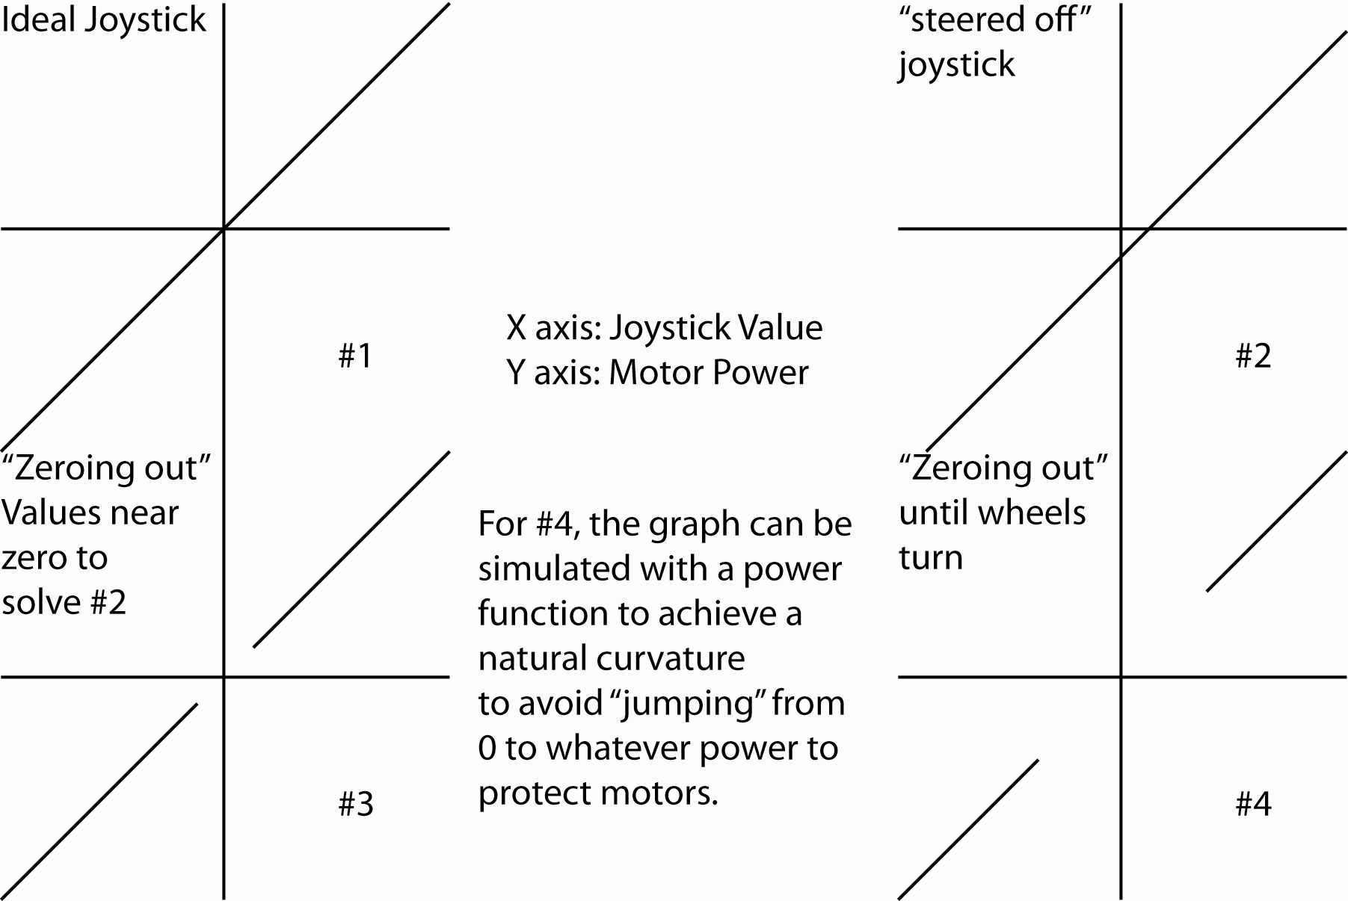
Figure 30 - Joystick Control

Also, the other team’s robot attempted to push the “bowling ball” (we use a basketball as a substitution for now) up the ramp. Two issues came up. 1st one is the robot had to chase the bowling ball around the field for quiet a while until it got the bowling ball in front of the ramp. The 2nd issue was the bowling ball steers left or right when it was going up the ramp, which reaffirms the necessity of a device that prevents it from doing so effectively.
There were crates in front of the ramp which made it difficult because there were obstacles on the way of traverse which means that we need to keep an eye on obstacles on paths that we often travel or places we need access to. There are a lot of obstacles on the ground and this will be an issue.
The last thing Erik and Henry realized was the lift didn’t have to go up really high to score substantially a lot. If the lift only lifts the crates off the ground one height of the crate, it has the potential to score a lot. Even though it doesn’t seem like a lot, but with the stacking mechanism, which will theoretically stack all six crates into one stack, if we have six crates all together, lifting them one crate height off the ground will add 10+points to each crate, which means a total of 60 points altogether. And that’s only one crate height. Our lift will be multi-stage but even if it only had one stage, which is unlikely and probably will be replaced by a simple chain lift, it will still be able to lift 12 in. off the ground at least and adding 20 points for each crate, which will add up to 120 points total. This insight made us realize the stacking mechanism will exponentially increase our points. Along with the height the issue of stability will come up and we will have to dedicate more research into a mechanism to make sure the stack doesn’t tip over or stay very stable.
Erik and Henry decided to have a pin that goes into a hole on the tubes that will be moving up to lock the whole lifting mechanism at the end of the game so when the motors are powered off it will stay up. This will be critical.

-T-Shirt
Katie revised the design for the t-shirts and found out the numbers 2011-2012 didn’t really fit into the patch. We decide to take those numbers off the t-shirts for a few reasons. One being the design conflict, but the main reason is so the shirts will be generic enough for not only this year, but also future years. If a team / individual desires to put the year of the season on the t-shirt they can use the iron-on device to iron them on along with team name, number, etc.

-Custom Materials
Erik and Henry went down to the local Ace hardware store to look for custom materials to use for robotics. Here’s a list of parts that they found that are supposedly legal for competition:
-Sheet metal screw
-Bolt
-Socket head 6-32 thread screws up to 1 in.
-Locknuts 6-32 thread
-Threaded bolt 6-32, 6 in.
-Aluminum channel, angle, and square tube
-Pop rivets
-Compatible washers, etc.
Henry wasn’t completely sure about whether which ones are allowed or not so they only purchased the locknuts. After they were back in the lab Henry found the rule in the manual that talked about fasteners:
<R5> c 18
All mechanical fasteners (nuts, bolts, screws, etc.) of any length, any thread type, up to 0.375 in. diameter. The intend of this rules is to allow teams to use fasteners from any supplier that are substantially the same as TETRIX fasteners. Compatible fasteners are characterized by using the same thread characteristics as TETRIX fasteners. For example, an acceptable substitute for the TETRIX 6-32 thread, 1/2 in. length socket head cap screw is a 6-32 thread, 3/4 in. length, button head cap screw purchased at a local hardware store.
All the materials / parts listed above are either allowed or mechanical fasteners mentioned in the rule. However, none of them are in the TETRIX parts catalogue but technically they are legal by the rule, even though it doesn’t exactly follow the intend of the rule.
To eliminate confusions, Henry wanted to post the question on the official forum however since the team is still not yet registered, we don’t have the login information. Henry posted a thread under the FTC forum in Chiefdelphi to ask the FTC teams in the community to ask the question for him. He asked whether sheet screws / bolt / locknuts / longer 6-32 socket head screws are allowed or not. He also asked a question regarding to the receipt of the purchase of the aluminum square tubes. 1/16 in.’s decimal equivalent is 0.0625 in. which is the maximum thickness for the square tubes. However on the receipt 0.063 was shown instead of 0.0625 because of the rounding up. This happens to be a problem because this would be thicker than the maximum thickness. He wanted to clarify to make sure the receipt would be a legal source indicating we got the 1/16 in. tube since it was a precision issue.

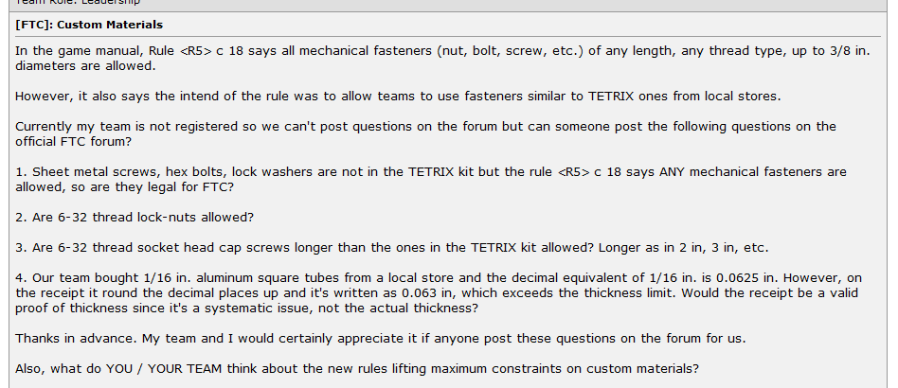
Figure 31 - Post on Chiefdelphi

Meeting 9/27/2011
Task List:
-T-Shirt
-Fundraising
-Mentoring

We didn’t work on the robot much today because we are still not quite sure which fasteners we are allow to use for certain.

-T-Shirt
Today Katie brought in the design for the t-shirts with several kinds of fonts on it. Everyone saw them and voted on which one they like the best. The “counter-strike” font won by a landslide and it has this “robotics” / “cyber” / “futuristic” look on it. That will be the font we’re going to use on the t-shirts.

Figure 32 – Logo

-Fundraising
Kim got the tickets for the bowl-a-thon fundraiser and we will start selling them ASAP after the school broadcast the announcement.

-Mentoring
Henry and other club members went down to Straub Middle School to mentor the FLL team there today. The team had seven 6th graders in them. They all had different levels of background with LEGO / robotics and didn’t quiet know each other.
The task for the day’s meeting was to construct the field elements. By the end, everyone was enthusiastic and knew a little bit more about each other. It was a success in terms of getting them interested and it should be a good season for them.
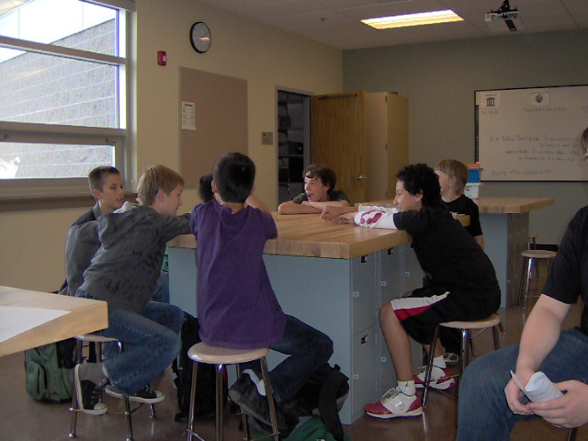
Figure 33 - FLL team

Meeting 9/28/2011
Task List:
-Chassis

-Chassis
Erik, Art, John, and Henry all continued to work on the chassis today. All the holes are drilled in previous meetings and we started on putting together the wheel assembly.
As for the gear ratio, last year’s 1:2 on 3 in. wheels were too fast and caused gears inside DC motors to break and any other ones seem too slow. To prevent swapping out motors constantly, we wanted a slower speed and it would help when we get in a pushing match also.
We found some data that was produced by FRC teams last season because of the mini-bot component of their challenge, and used them to determine whether we should use sprockets / gears with what size wheels.

The official no-load speed of the TETRIX DC motors is 152 rpm and the stall torque is 300 in-oz. However, we won’t be using those numbers to do our calculation since there’s no way we should get any where close to stall torque and it will trip the breaker within a matter of seconds. Instead we will use the ones mentioned above.

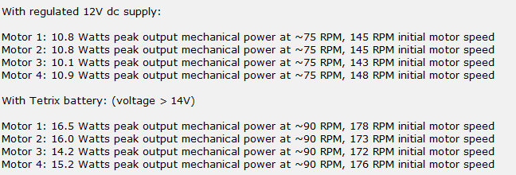
Figure 34 - DC Motor Specs

Since there was no data on amps the motors draw or what the limit is, we won’t be calculating those assuming we won’t trip the breaker of the motor controllers, which is a logical guess because the motor controllers had never failed during matches in our competition. The only time we exceeded the cut-off amps was during a scrimmage / demo at OMSI last year, with a robot that had a 1:3 with 4 in. wheels.

One of the things the team noticed was the difference between a 12 volt regulator power source and the TETRIX battery. This shows the importance of how the motors will perform depending on the voltage of the battery. This is another reminder that we will need to get new batteries and make sure they’re charge for competition.
Since we will be using TETRIX batteries for competition, we will use 90 rpm to do all of our calculations.
We compared a few different gearing options and wheels to see which ones are most fit and how they are compare to previous robots. Also, we didn’t do any calculation for any gear combination that’s slower than 1:1 because we believe they’re inapplicable for the situation. The results are all conservative since we will most likely run the motors at a higher rpm than 90, but it still gave us an idea roughly which combination we should use.
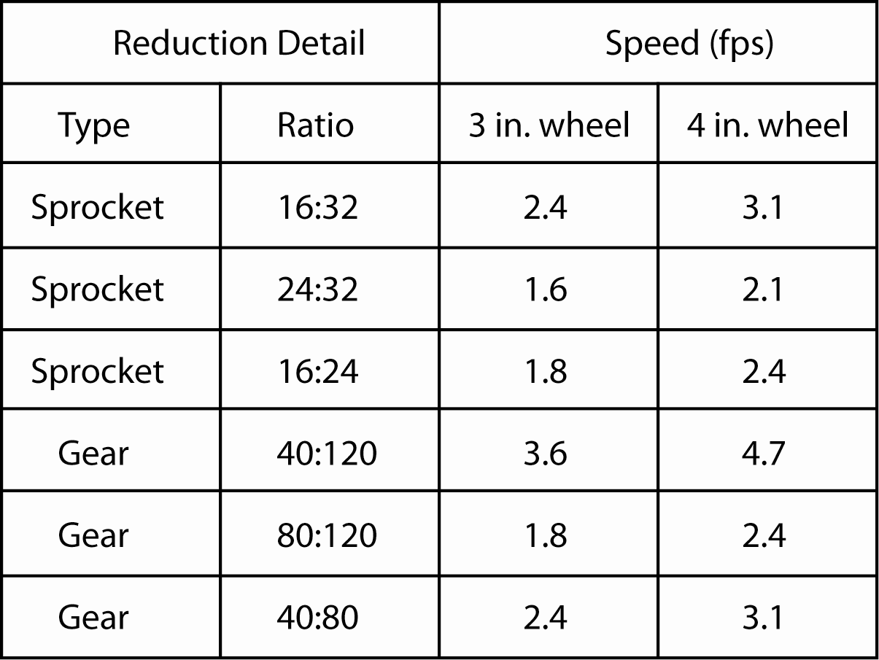
Figure 35 - Speed Chart

The above speed chart by no means is accurate to reality / competition but we have data / footage from previous competitions that timed how fast the robots were traveling.
During the 1st match of the semi-finals at the state competition, our robot covered a distance of roughly 8.75 ft in 3 seconds. However, this is not machine timed but rather by looking at the timer that was by the field and the robot was traveling across the cliff and the corrugated area. The calculated speed from the data would be roughly 2.9 fps and compare it to the 2.4 fps up in the table (the last setup), it gives us the factor of 1.2. So theoretically speaking if we multiply the factor with the speed above it should give us a more accurate speed.

After we determined all the revised speed, we crossed out all the 4 in. wheel options since we will be using 3 in. wheels with the traction tires on them. This will give us two advantages:
-Faster acceleration due to the decrease of torque need to turn the wheel (3 in. vs. 4 in.)
-Higher value of mu
The tires on the regular wheels are fine for regular maneuvering but they prove to be too slippery in pushing matches. The high traction tires were a huge advantage last year and we will utilize them again.

Then the next step was to eliminate the options that had the 120-tooth gear on the drive shaft (motor shaft). The reason for that is the same reason why we decide to use smaller diameter wheels. While one of the other teams was testing their robot today, they observed that there’s a lot of lag between the joystick and the driving. The same problem occurred two years ago when one of the other teams used the same setup (120-tooth to 80-tooth with 3 in. wheels). Our team initially thought the speed was the issue but then it wouldn’t make sense because our team’s robot from last year was significantly faster and yet it had virtually no lag.
Henry then noticed how the motor shaft (the 120-tooth) gear would stall when it’s first powered and how it continues to spin for a bit longer even after it’s no longer powered. He knew the concepts of torque and depending on how far the pivot / arm is, it will be easier / harder to spin / twist something but didn’t realize the effects would be big enough to affect driving.

After eliminating the ones containing the 120-tooth gears, we are left with all the sprocket combinations and 80-tooth to 40-tooth, all with 3 in. wheels. We proceeded to eliminate the 40:80 (gear) and 16:32 (sprocket) because the setup we used last year was 40:80 (gear) and it broke motors, as we mentioned above. The final two options were 16:24 and 24:32, both sprockets. Both combinations have speed that we are familiar with, the 1st one being the combination 3577 used two years ago, and the other one will produce the same speed as the robot two years ago also, except with faster acceleration since the wheels are smaller.

At the end we decided to go with 16:24 sprockets with 3 in. wheels over the other combination for the following reasons:
-Faster acceleration (medium sprocket (24-tooth) vs. large sprocket (32-tooth)
-Smaller sprocket on the wheel
Acceleration is very important not only in achieving top speed, but also in turning, etc. This will allow us to maneuver better. Even though we are sacrificing torque since we chose the combination with faster speed, from the driving practice we had two years ago, neither robot could push the other one head on, which shows the difference of torque between the two was insignificant in that situation. And since this will be a chain drive and due to the nature of the TETRIX parts, we will be able to change ratio easily and not to worry about tension of the chain being too tight or lose because the motors can be twisted inside the mount to adjust accordingly.

We didn’t do any calculation for the torque aspect of the robot because we need to determine an estimate weight for the robot, and more importantly the mu of the high traction tires. The tires will be only used on the four rear wheels to simulate a “drop-center” drivetrain.
Drop-center drivetrain is common in FRC in six-wheel drive robots and its uniqueness is the center wheel is dropped 1/8 in. Even though six-wheel drives have great traction, they don’t turn quite as easy as four-wheel robots. To solve that issue, the center wheel is dropped so there will be only four wheels touching the ground at one time since the robot will either “tip” for ward or backward. This seemingly would decrease the pushing power of the robot in a pushing match but in competition it doesn’t. The front of the robots are usually tilted up during pushing matches and the front wheels are off the ground, not providing any help to the pushing match. The fact that there will only be four wheels touching the ground during a pushing match using a drop-center drive is not a weakness compare to regular six-wheel drive.
The drop-center component will be simulated since the wheels with tires on them will be just a bit thicker than the regular wheels. So when the robot is still, only the four front wheels are full touching the ground and the rear wheels are lifted off the ground just a bit, until the robot is pushing against something and it tilts the other way, utilizing all four traction tires and all the power.
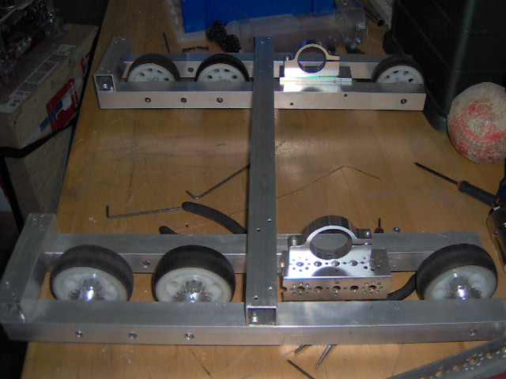
Figure 36 – Drivetrain
After mounting the first set of motor mounts, the team stopped to determine how to chain both motors and all the wheels together. We didn’t want to run two chains because it takes up more space. Due to that restriction, all the sprockets on the wheels will need to be either inside the chain, or outside the chain, in order for them to run the same direction. Here’s a diagram of how the chain will be like:

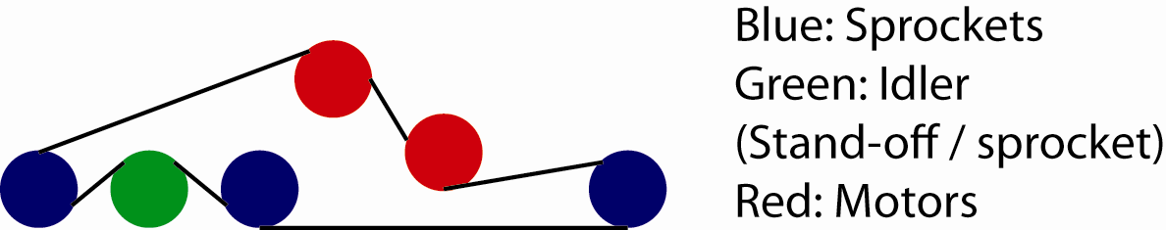
Figure 37 - Chain Diagram

Erik decided to mount the 2nd sets of motors vertically to make sure it’s not in the way of other mechanisms in the future. He and Henry discussed what materials should be used, whether it should be aluminum square, or sheet materials. We decided it should be on aluminum square tube but it should be mounted directly on top of the assisted horizontal one, to save 1 in. space in length and width. Erik fabricated the Kydex pieces needed to do so and he cut them the length of the motor so it will protect the motor from one side also. We didn’t get to mount them on because we have to use pop rivets since we can’t tighten them with screws and nuts.
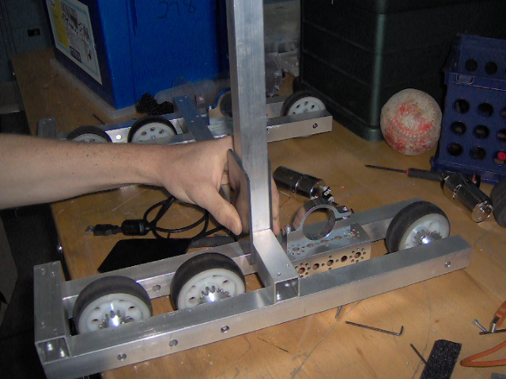
Figure 38 - Kydex Mount

Meeting 9/29/2011
Task List:
-Chassis

-Chassis
Erik continued to work on the chassis today. He drilled the holes in the horizontal bar to mount the Kydex pieces. Then he mounted the motor mounts on there. After we finished mounting it, we put it on the ground and realized the chassis wasn’t level. Turns out the horizontal bar was twisted just a bit for some reason. Erik straightened it out and the problem was resolved.
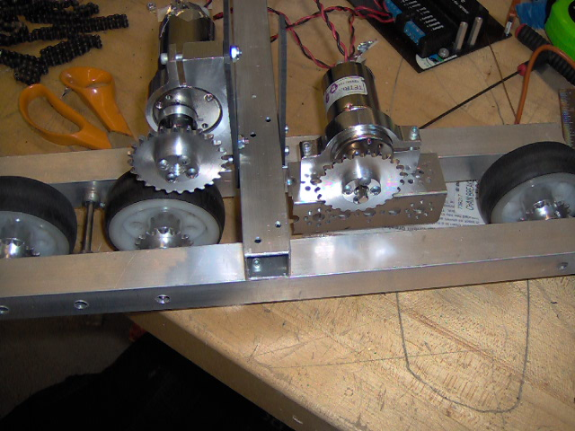
Figure 39 - 2nd motor mount

Then Erik and Henry proceeded to put the motors with the sprockets on. While Erik was wiring the motors to the motor controllers, Henry programmed a basic program for testing the drivetrain.
Wiring the motors reminded us of the Anderson Powerpole connectors that were recommended on the official FIRST site and we told Coach Smith and he sent a order of 50 to the bookkeeper.

The program Henry programmed had three parts:
-Direct joystick drive
-Zoning out values from -20 to +20 (in case of off-center joysticks)
-Reverse (joystick button 5)
Henry also created global variables for motor power instead of directly connecting motor[Left / Right] to the values of the joystick to make future addition to driving code easier.
When he was compiling the code, an error of “this driver is not supported on this platform” showed up. Henry then checked the platform and it was the correct one (NXT & TETRIX); however it still didn’t work. It’s not until later Henry found out there’s another platform option, physical robot or PC-based emulator in the same drop-down menu. It was set on the PC-based emulator so it would explain why the JoystickDriver.c was not supported. He changed it to physical robot and everything works fine.
Also, RobotC 3.0 has many great features refining the program and make editing easier.
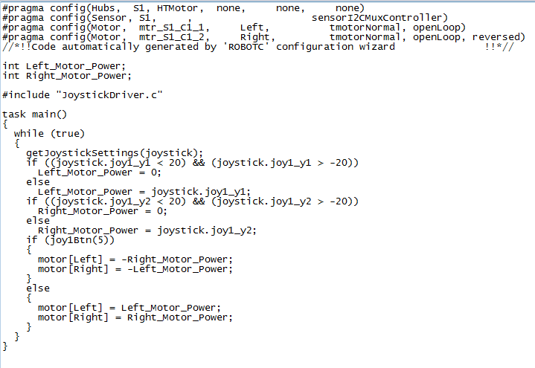
Figure 40 - Basic drive code

After wiring the robot, Erik started to put the chain on the robot. The original route we had for the chain works fine except Erik is worried about the fact there’s not enough contact between the chain and the middle wheel. There is a tensioner on one side but there’s no tensioner on the other. Erik decided to make another tensioner out of plastic and bend the plastic down to make a “loop” for the chain to go through. He used the Kydex plastic to make the bracket and bent it using the head gun. The bent wasn’t as nice as we expect / want it to be but it’s only temporary.
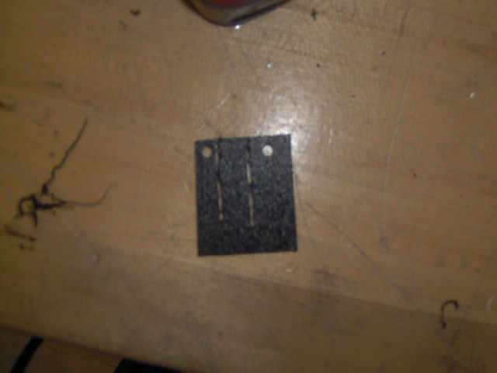
Figure 41 – Tensioner

After we mounted the new tensioner on, we loop the chain through and put the link on them. We twist the motors and they will act as tensioners on top.
We also mount the battery / motor controller / and NXT in the horizontal bar using tape for testing. In one of the suggestion on the FIRST site, the engineers said teams should put a piece of polycarbonate between the motor controller and the aluminum bars to rid of the problem of static-friction affecting the controllers. Coincidentally we used polycarbonate to mount the motor controllers on our robot last year, which works perfectly.
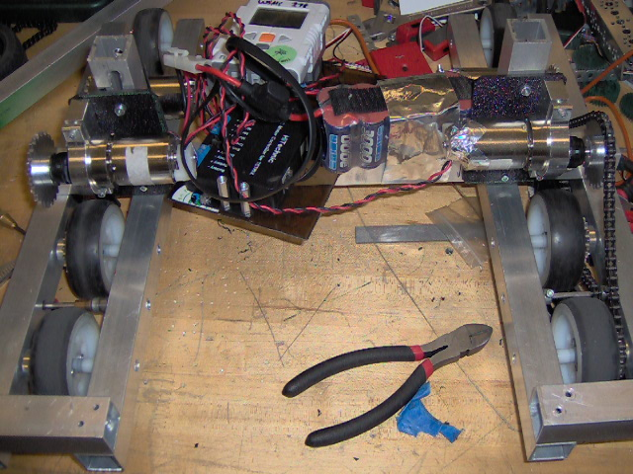
Figure 42 - Drive chassis
When we put it on the field for testing, the robot ran for roughly ten seconds before the chains were off the gear. We expected issues with the chain but didn’t realize it would be that bad. After we put them on again, the chain on the same side failed and the chain actually split where the links were used to put the chain together.
Also, we realized the Kydex mounts for the 2nd pair of motors flex too much when the chain was running, we had to cut out two pieces of 4 in. aluminum square tube and mount the tube between the two pieces of Kydex we put on to prevent it from doing so. After that was done, the Kydex mounts were much more solid, wouldn’t even move at all.
The robot drives very nicely forward. When it’s driving backward, the new Kydex tensioner we put on was bent only one way and it “rubs” on the chains and made the chain “skip”. If the tensioner is improved, it will solve the issue.
Also, when the robot is turning the misalignment in the chain magnifies and the chain would run off the sprockets. The chain was only running off on the right side, where the new tensioner was not as good as the other one. We determined that was the problem after it failing multiple times.

Realizing all those problems, Erik and Henry sat down and thought about other ways to deliver power to the drivetrain if this doesn’t work. Erik believes the issue is running motors on both the outside and the inside of the chain. He and Henry thought about other ways and here’s a list:
-Gear drive
-Split chain drive
-new chain drive

Gear Drive
Pro: no need for tensioners
Con: spacing issue, impossible to be AWD, combinations are hard to work with; either too slow / fast or include the use of large gear, which will make acceleration slower
Split Chain Drive
This means to run two separate solid loops of chains to deliver power. The motor in the front would be chained directly to the front wheel; the two rear wheels will be chained with the rear wheel.
Pro: no need for tensioners (motors act as tensioner); shorter chain; useful variety of combination for speed; faster acceleration; full contact of chain on all sprockets
Con: only utilizing one set of motor (the back set) in a pushing match
New Chain Drive
Both motors would be running the same chain as the front two wheels, and the wheel at the end will be powered by connecting it with the middle wheel by chain and sprockets in a slot in the middle of the aluminum square bar.
Pro: AWD, should be no tension problem (depending on how the front motor is powering the chain), useful combinations of speed; faster acceleration, full contact of chain on the sprockets on the wheel and the rear motor.
Con: very hard to machine (we will have to cut a slot in the square bar); the tension between the two rear wheels have to be perfect (half-links might be needed); might not be enough contact between chain and front motor.

We didn’t decide no which one we will use first during the meeting. In the next meeting we will attempt to fix the problems / improving the drivetrain to see if it’s reliable enough to continue on with the setup.
List of problems for next meeting:
-Fixing possible sprocket misalignment
-New tensioner
-Attempt to add guides / protection along the path of the chain
-Research other setup to “link” both motors together.

Our drivetrain is very similar to FRC drivetrains except for the fact the motors are not “linked” together. All the other idlers are in place just like the FRC robots but one of the things that are near impossible in our case is to have one output sprocket for both motors since it requires another stage of reduction / linking the gears / chain. The output shafts on the motor are not long enough to do so. The advantage of this setup is the fact that the motors are near the center of the robot and out of the way for mechanisms, which is what we want.

Meeting 9/30/2011
Task List:
-Ball Gathering Mechanism
-Chassis
-Disassemble Robot
-Purchase

-Ball Gathering Mechanism
Today Katie built a rough model of the ball gathering mechanism using cardboard pipe and tape.
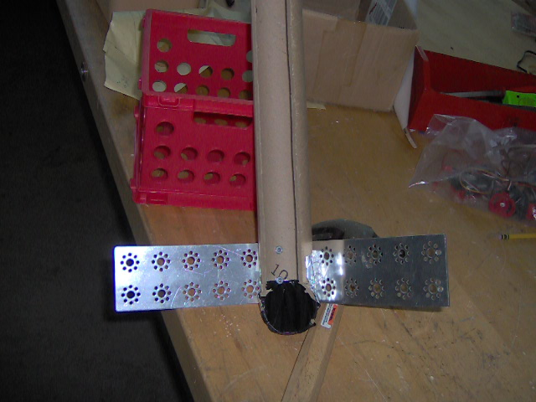
Figure 43 - Ball Gathering Prototype

The prototype currently has two components, one is the pipe that store / transfer the racquetball up to the top of the robot, and the TETRIX plates which will act as a guide to bring a wider range of racquetballs in.
Katie also built a simple LEGO spinner by directly mounting a LEGO wheel to a LEGO motor. They will be place on both sides between the pipe and the TETRIX plates to bring the racquetballs in which then a conveyor belt going up and down will lift the racquetballs up.
For now we will be using LEGO motors but if space / mounting is an issue we will be using CR (continuous rotational) servos instead.

-Chassis
Henry and Erik continued to work on the chassis today.
After the failures they had yesterday, they reflected and reviewed what the possible flaws in the chassis are:
-Tension issues in different sections of the chain
-Misalignment of sprockets
-Excessive friction in idlers
-Improvise idlers not parallel with chain

After generating the list, Henry checked and adjusted the motors on the side that didn’t fail yesterday to further tighten the chains. This was done by first adjusting the motor in the back, then the motor that was mounted on the Kydex.
He also added Nylon spacers onto the axle that’s acting as the idler in between the two rear wheels to reduce friction.
Erik fabricated a new idler and bended it more carefully this time to ensure the bend was parallel with the chassis, so the chain won’t steer off left or right.
The way Henry and Erik checked whether the sprockets were aligned or not was to see whether the chain is steering left / right on the sprocket. When a sprocket is misaligned, the chain that’s coming off the sprocket will “bend” one way.

After fixing all of the issues, Erik put the link back up the chain that fall off yesterday and drove it on the field again. The drivetrain drove very nicely, and there’s no problem turning or driving backwards / forwards.
The robot was also able to drive up the ramp both ways, which is a good thing because the crate side and the bowling-ball side will most likely be on the opposite sides and the robot has to go up both ways. Erik also drove the robot off the cliff and the robot didn’t get stuck as the front wheels hit the tiles first.
Erik then drove a bit more erratically to determine which maneuvers will result in the robots unable to move for the rest of the match. He successfully did so in two ways, one is driving one side of the robot off the ramp and the other one is going off the cliff on the wrong side.
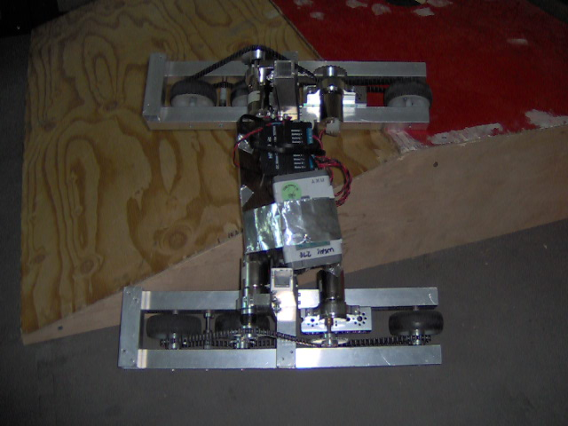
Figure 44 - Scenario 1
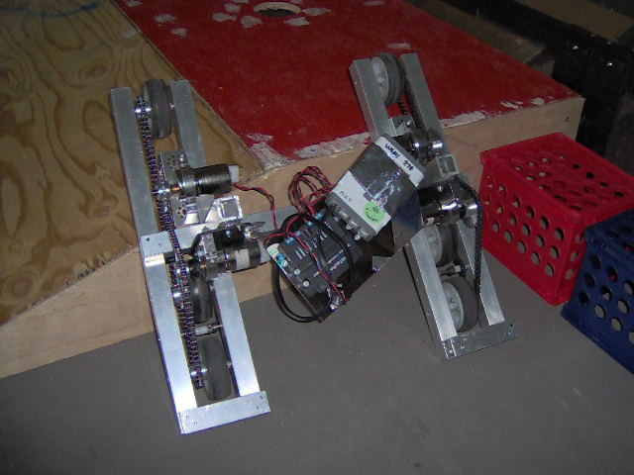
Figure 45 - Scenario 2

In the 1st scenario the robot was stuck due to the fact that none of the wheels were touching the ground because of the aluminum square tubes that were on the outside of the chassis. We kept note of that because this is one of the scenarios we will unlikely to get us out of with an alliance partner because there’s nothing to roll on like previous drivetrains that had the wheels outside. It’s very unlikely a robot will be able to push us all the way off the ramp with the drag the aluminum square tubes have.
However, in the 2nd scenario it’s much easier to get out of and very unlikely to happen since the robot wasn’t design to drive down the ramp that way.

While we were driving on the field doing un-realistic maneuvers, we also experimented with our “bowling ball” and crates. The “U”s in the chassis made it very easy to cover the crate on three sides and drive with in. We were able to manipulate the crates to wherever we want on the field by only pushing it with the chassis. We also found out the lip between the ramp and the tiles made it extremely difficult and impossible to push the crates up the ramp in normal scenarios. Erik successfully pushed one of the crates up the ramp by somehow “flicking” the crate so the side closest to the ramp was off the ground and he pushed it up the ramp.
As for pushing the basketball, it was essentially the same except for the fact that the spherical shape made it very easy to go around in the field, which most likely will change once with all the racquetballs, and it’s not six pounds. It will make it harder to push but also harder to stop. Erik was able to push the bowling ball up without a problem but he had problem stopping it to park it in the designated area on the ramp.

One of the most important thing that came out of the driving practice was Erik’s driving skill is EXCEPTIONAL. Initially Henry was testing the robot to see how easily it can collect crates and push basketball but eventually gave up and Erik took over. He had no problem doing any of the tasks above and that’s without any practice with the chassis and the elements. This will save us time in the future when the whole robot is ready with mechanisms that will make collecting even easier.

After experimenting with the game elements, Erik wanted to see if there’s any possible way the chain could fall off. The only time that occurred was when the robot slid around on the ramp when he was trying to go up to the platform. That was not intentional but we got the result we wanted. Normally it wouldn’t fall off the sprockets but a combination of sliding (horizontal force) + trying to go forward (vertical force) + the chassis wasn’t rectangular (both) made the chain slide off.
The rectangulars on each side of the robot was twisted a bit from all the driving and turned into parallelograms by a fraction of an inch. This resulted in the misalignment of all the sprockets. Even so, it took us quite a while to make the chain fall off, which is a good sign of the reliability of the system.
We will put more structure on the chassis later on to further strength it.

One thing about the drivetrain that Henry and Erik would like to improve is the traction. The wheels spin out extremely easily (comparing to robots from previous years). We don’t know how it’s going to behave in pushing matches as of right now and we will try to conduct the test as soon as possible.
The traction tires we have are a little bit too wide and most likely won’t fit outside the wheels. Erik was creative and put one of the tires on the 3 in. wheels that have no regular tire on them and stuff the sides underneath the ridge. However, that solution is most likely not going to work because the tires are going to come off when we drive / turn the robot since the tires are too lose.

While Henry was brainstorming a solution for the issue above, he thought of using circular pieces that are mounted on both sides of the wheel to prevent the tires from coming out since it will increase the size of the lip on the wheels. The center will be drilled out so axles and sprockets can come out and it will be mounted by screws with spacers that go through the whole wheel. This method can also be used on sprockets and put circular pieces on both sides of the sprockets so prevent them from coming off the chain. The team will explore more about this option in the next meeting.

Another problem we found from the chain drive was the front wheel isn’t straight partially due to the tension from the chain on one side of it but not the other and partially due to the set screws on the collars make the whole sprocket-assembly tilt, which makes it wobbly. TETRIX had came up with new products and one of their products is a delrin bearing that can be mounted on to reinforce axle support. The team thinks it will take up lots of space and hence inapplicable in most scenarios but for the front wheel it should be perfect because it can be mounted on the inside of the tubes, where it’s out of the way.
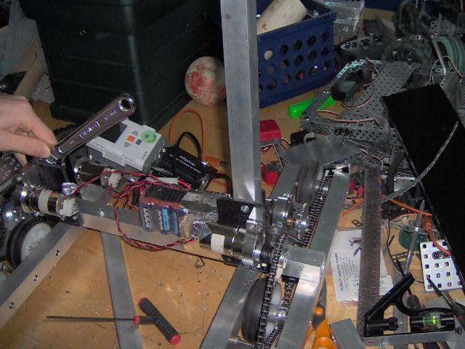
Figure 46 - Vertical bar

At the end of the meeting Erik replaced the temporary square tubes that were connecting the Kydex mounts together with the real fabricated piece. He estimated each stage of the lift will be roughly 12 in. tall and there will be a maximum of 4 stages. Stability will be an issue and we will have to come up with something.
He’s also thinking about other manipulators for collecting the crate since tank treads means we will have to drag the crate on the ground while we are scoring in it.

-Disassemble Robot
Henry officially started to disassemble the team’s last year’s robot. Previously he took off the front and back pairs of wheel assemblies for the 3 in. wheels, one of the collectors, and the whole lifting mechanism for sprockets. He took off the idler gear between the front and rear set of wheels, the cover on both sides, all the collectors, the clear PVC assembly, the aligners for the collectors, and the cover for the IR sensor.
Henry took off most of the things the team might need for building mechanisms such as custom materials and long axles.
A few things that stood out in his mind that was not recorded in last year’s journal:
-Cut axles
-Collars in the drivetrain were under tremendous amount of stress
-Very clean assembly in collectors
-Two axle collars were mounted together to link axles together
-Clamp collars were drilled out and cut to use as bushings
-A servo horn was tabbed and threaded to connect an aluminum piece on it
-Covers for everything
-EXTREMELY ROBUST

This will save us time in the future in case we have to utilize one of the knowledge above to solve issues.

-Purchase
The order of 5 x 24 racquetballs and the magnets came in roughly two days ago and each team in the club was given 2 racquetballs with their team numbers written on them. This will prevent people messing with the racquetballs and if they do then they will know which team is responsible.
Henry also compiled a long list of parts / materials Erik want through the past two weeks. We will finalize all of them altogether to avoid spending time to purchase multiple times.
-Aluminum C Channel
-Aluminum Flatbar
-Aluminum Angle
-Pop Rivets (Purchased)
-Pop Rivet Gun
-Grinding wheel
-Plastic
-3 in. wheels
-Locknuts (Purchased)
-Sheet Aluminum 1/16 in.
-Plastic
-Threaded Beam
-Delrin Bearing
-Aluminum Square Tube (smaller sizes)

Sheet metal screws were also on the list but they were announced illegal by the Game Design Committee.
The sheet metal and flatbars will be used as mounting parts to make brackets to hold the whole chassis together. The Kydex mounts on the chassis will be replaced by them. Erik will be bending the flatbars around the structures and use pop rivets to connect them together to increase its robustness.

Meeting 10/3/2011
Task List:
-Tire
-Battery Holder
-Chassis
-Purchase
-Software Brainstorming

-Tire
Henry did some research on other possible rubber LEGO tires that would be smaller than the high traction ones we have currently since they seemed too big to fit on the drivetrain.
The dimension of the ones he purchased originally were 81.6 x 36 (in mm) and the closest ones he found that are still available on BrickLink was 81.6 x 34. They were mostly available in Europe and there were not enough for a set of four and they are all used. However, there is a set of 4 available in the USA and they were $14.00 per piece. He showed Coach Smith the tire and it is smaller and we will put it in the list of things we might purchase. The part number is 32196.
Henry also found the tires he purchased last year were available again and there’s this store in the USA that had 8 of them that are all brand new for $7.00 per piece. This will let the team have new tires for this year and plenty of spare sets. The part number is x1825.
Henry found the information on the tires on a site that had catalogue of almost all LEGO tires and matching rims. Here’s the website:
http://isodomos.com/Visual-Parts-Helper/Lego-Wheel.html

-Battery Holder
Erik and Katie worked on a new battery holder since the one from last year was not as elegant. Katie first sketch the layout on the Kydex then Erik used the vertical bandsaw to cut the pieces out.
Turns out the sketch was too big and Erik had to improvise and cut the extra length on the sides off to make it fit.
Also, a minor issue we had was when we were using a heat gun to bend the plastic, due to the plastic’s thickness; the bend’s curvature actually was large enough to change the dimensions a bit.
The last thing we found out was the dry-erase marks on the plastic don’t come off when the plastic is heated.
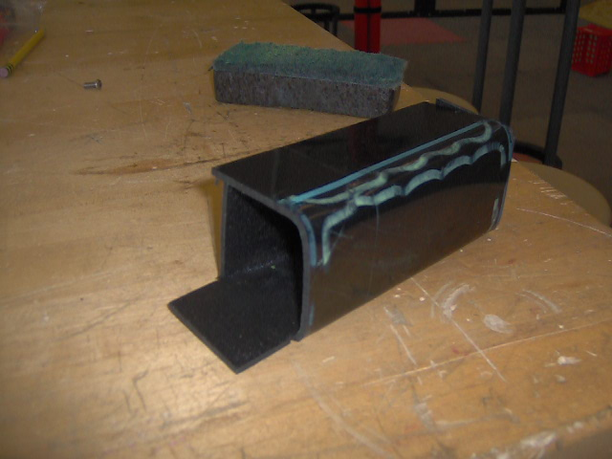
Figure 47 - New Battery Holder

-Chassis
Henry and Erik tested whether the tires would fit on the 3 in. wheels today. It was quite obvious that if we put them on like last year, it would rub on the side and the chain. However, Erik stuffed the sides of the tire inside and made it fit. It looked promising but we had to test to see whether it actually works or not.
We put the tires on the front wheel for testing purposes only. There was a significant difference in turning since the tires created more drag on the ground. The good news is they didn’t fall of or have any signs of that either.
A recurring issue that happened while we were driving on the field was after the robot rammed into the wall, the chassis became twisted and the chain link on one side started to fall off again. Erik and Henry realized the issue had to be fixed and Erik decided to put Kydex underneath the rectangles binding them to prevent twisting.
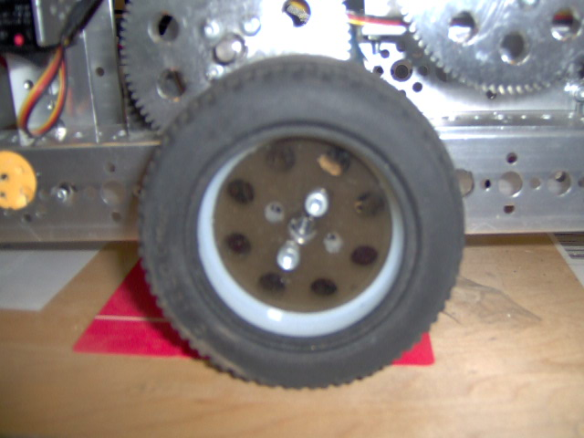
Figure 48 - Old Installation
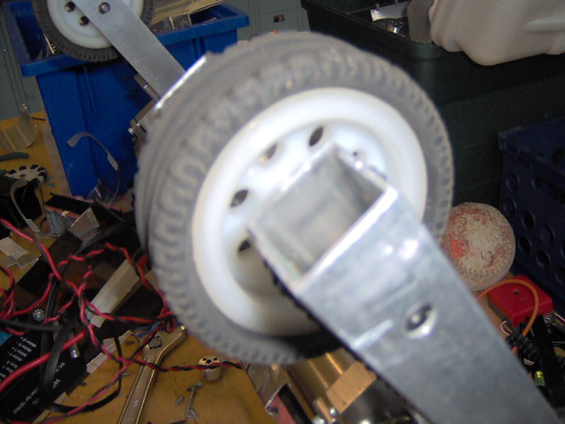
Figure 49 - New Installation

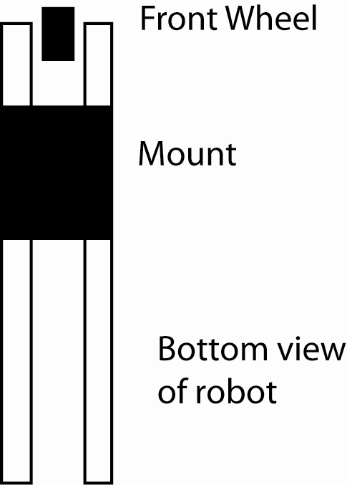
Figure 50 - Mount Diagram

However, Erik couldn’t install the mounts during the meeting because it required the use of pop rivets and we didn’t have a pop rivet gun in the lab. We will install the mounts tomorrow. The mounts will not only increase stability but also prevent the chains from catching to stuff on the ground in case of unknown situations.
Also, Coach Smith suggested Erik to use triangles to make the towers more robust and he liked the idea a lot because it would save more space than using a rectangular structure.
The hypotenuse of the triangle will be placed right on top of the motors on both sides attaching the tower and the front end of the rectangular square tubes.
Erik will be using gussets made out of flatbars to attach the triangles. He will also cut the hypotenuse at 45 degree angles to make it flesh with the tube.
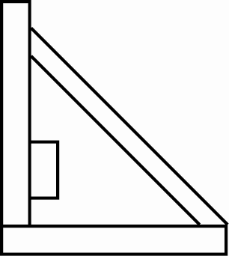
Figure 51 - Structure Diagram

-Purchase
Henry added the list of items onto the purchasing list:
-Limit Switches
-Magnetic Sensor (Hall Effect)
-Surgical Tubing
We will be hearing about the Oregon Department of Education grant early this week.

-Software Brainstorming
Henry researched more about PWM and he was correct about how to simulate analog output using digital I/O. He was confused before because he was looking at Digital I/O to AC control, which are since curves. AC is much more complicated and the pulse width isn’t consistent through out; instead it gets longer or shorter depending on which section of the curve it’s trying to modulate. For basic control, different lengths for different levels will be enough; it won’t need changing pulse widths for one level.
He also stumbled upon digital filters and he will research more after he attempts to collect data on the NXT and plot the csv file on a graph to see whether smoothing out spikes will help the control of the motors since the motor controller update frequency will most likely be slower than the joystick values.
Henry also thought about the idea of making a program that records during driving control and use if for autonomous. He had thought of the ideas before however didn’t think it was quite possible until he read in the book The New Cool featuring FRC team 1717 in 2009 and the programmer successfully implemented it.
He also thought about two other programs that will increase the robot’s abilities: traction control & brake. Brake is simple PID with the target of 0 so when someone’s pushing the robot it automatically fights back, this will work in most circumstances unless the wheels slide. Traction control will be implemented by calculating slip of the wheels by finding the difference of velocity of a powered wheel against unpowered wheel or an accelerometer to find out actual velocity. We will more likely to use the unpowered idler wheel method since the LEGO accelerometer is unreliable and it needs to measure little differences for the traction control to be effective.

Meeting 10/4/2011
Task List:
-T-Shirt
-Chassis
-Purchase
-Mentoring

-T-Shirt
Katie contacted the local t-shirt store and she emailed back a few detail questions regarding the shirts. We’ve decided the shirts will be dark-green (school color) with white letters. The color blue will be incorporated somehow in our outfits another way during competition. The lady also asked whether the shirts will be 100% cotton and we agreed on yes since there’s not really a preference. She said the shirts will be roughly $7-8 since we are ordering 50 of them at least. We will wait for her response to finalize the order.

-Chassis
Katie made a new tensioner to substitute that broke off. While she was bending the piece, Erik adjusted the rectangles on the drivetrain to be square and clamped them down to drill the holes for the rivet.
The rivets are very solid. Now the whole thing does not twist but during testing on the field the chain on the same side fall off again. We don’t know what’s causing the problem and it took the robot 4 seconds to drive a distance of 10.5 ft, so roughly 2.6 fps.
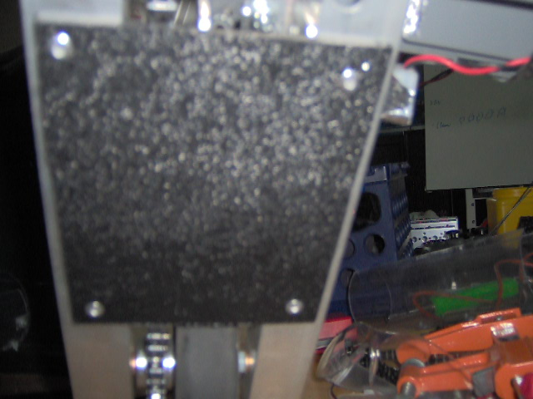
Figure 52 - Riveted Base Plate

The battery switch we had was loose and sometimes the robot would be disconnected but Erik found out what the problem was and fixed it.
Erik put a improvised tensioner on the C-Channel where the motor was mounted by riveting a piece of plastic that props the chain up above the square tube. This increased the tension but then it’s too much and one side is driving faster than the other one significantly.
The robot hast the tendency to curve left since the right side’s assembly is cleaner for some reason. It will get better as the components wear out because there will be less friction.
Henry and Erik replaced the front wheel with the middle wheel to see how it drives. The front wheel is always lifted up when pushing against another robot so it won’t be contributing. The original plan was to put the tire on the two back sets of wheels but turns out the extra thickness would make the tire rub on the chassis on the back.
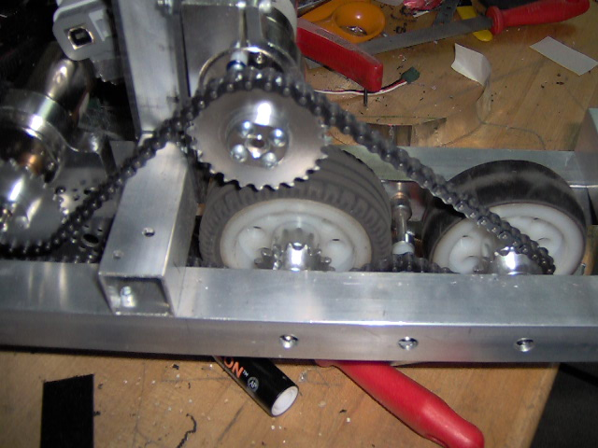
Figure 53 - New Tire Setup

The new chassis turns much faster than the last setup however there didn’t seem to be a significant increase in pushing power since the tires slip. We need to have an actual robot to push against to test the drivetrain.
Another thing we found out is only the edges of the tires are against the ground since the center is hollow and sinks down just a bit. Erik suggested to put either anti-slip pad or something else to “puff” it up to increase traction.
Also, due to the fact the front wheels are outside of the frame, it “climbs” whatever objects is trying to push and then it slips. This wouldn’t be a good thing since it would “climb” up a robot and might not be able to push anything.
We might try putting the tires on the front wheels to see how it drives compare to this since there’s a bit “wobble” front and back wise since it has a drop center drivetrain. With the setup above it will be able to use 2 sets of high traction tires to push objects without climbing on them which is what we want.
-Purchase
Erik found out Home Depot sells aluminum angle and c-channels that are the right size for the competition. They also have rivet gun and rivets. We put an order together to give to the bookkeeper so they can approve it before we purchase them.
Erik will also bring in non-slip pad that he has in his house.
Another club member from another team, Alex’s dad has works in the plastic industry and last year he nicely donated the Kydex to us and we told Alex what would be the materials and sizes for the competition and he will see whether it’s possible for him to donate the plastic to the club.
We still haven’t heard about the ODE grant yet but we should hear about it tomorrow.

-Mentoring
Henry and Erik went down to the middle school to mentor the kids again. The team was split into two groups and each had a new NXT kit to work with.
Erik and Henry went through all the electrical components (brick and sensors) with them and they started building the basic robot that’s on the booklet that came with the kit. They finished the drivetrain and will add the sensors next time.
Henry also explained to them how the challenge would work during competition. He explained that two people will be allowed by the field and they would complete their challenge then switch off with other teammates.
At the end they watched the project video for the challenge since they finished building the field. They seemed excited about it and it should be a good season.

Meeting 10/5/2011
Task List:
-Driving Practice
-Mechanism Brainstorming

-Driving Practice
Today Erik, Henry, John and Art did some testing of the drivetrain on the field. Henry borrowed one of the other team’s robot in the club to participate also.
The 1st test we did was pushing test between the two robots. They have the same amount of motor and the same speed which is almost ideal for testing, except for the difference kinds of tire on the wheels. We will conduct another testing in the future. However, almost none of the teams other than the ones in the club know about the high traction tires, it shouldn’t be that big of a problem in competition.
During the tests neither robot used a fully charged battery but the battery should be around the same voltage.
Test A: 3237 forward vs. 3577 forward
Our robot (3237) pushed 3577 across the field without any issues except the front wheels almost climbed the robot. The issue disappeared when the robots weren’t square and 3237 pushed 3577 diagonally.
Test B: 3237 forward vs. 3577 backward
The resistance of 3577 was less this time due to the fact its powered wheels are lifted up and the unpowered omni-wheels are the wheels that are touching the ground the most.
Test C: 3237 backward vs. 3577 forward
3237 was still able to push 3577 easily. This is surprising because the front wheels of our robot that are farthest away are in the back. The robot did not climb onto 3577 which was a good thing.
Test D: 3237 backward vs. 3577 backward
Results of B & C combined, most ideal scenario.

The results above showed what our robot was capable of relatively comparing to the other robots for now. When we were testing against the wall, the wheels always spin out. We were afraid the robot might not be able to push anyone but the test showed our robot will be fine in most cases.

The tests also tell us how we should deal with other robots in pushing matches. If there’s a robot trying to defend us, we should push them so their un-powered wheels are on the ground and the powered wheels off the ground, and push them with the backside of our robot. Since most robots won’t be AWD this insight would be helpful in most cases.

Then we used the two robots to practice driving drills. At first Erik participated as one of the two drivers but then he let John / Art substitute him so they can practice against each other.
The drill was to have one robot start a half tile early and try to get to a designate spot that Henry points out and the other robot’s objective was to stop them.
As soon as John and Art started driving, they noticed the control difference between our robot and 3577’s. There was a noticeable amount of lag and it made driving much more difficult.
Both of them had fun practicing and during practice, here’s a list of things Henry pointed out that will apply in the competition:
-If you’re around a robot that tipped / entangled / damaged, you will be DQed
-Drive both ways, not just forward
-Overturn – get caught on things waste a lot of time
-Pin for 5 second & back up 3 ft / 1.5 tiles
-Secure battery & NXT
The list above are subtle things people don’t fully take advantage / aren’t aware of and that usually causes them matches. Considering the fact there’s only 5 qualifying matches in most tournaments, minimizing mistakes and taking full advantage of these things will help us out in the long run.
Neither side’s chain fall off after the highly interactive driving drills, which is fantastic because reliability and consistency will be a key.

Henry and Erik also looked at tapes of the 2011 FRC challenge Logomotion for driving training / practice. The team they shadowed / watched was 111 Wildstang. They were the 1st pick of the World Champion Alliance and there were tapes of all of their matches from regional to championship online. Henry and Erik watched the videos chronologically and here’s a list of the things they learned:
-Continuous improvement
-Effective use of the mechanism
-Minimizing errors
-Minimize head to head matchups
-Secure resources
-Robot / Field management
-Initiative
The 1st and 3rd things listed above were very obvious throughout the tapes. The scoring of their game elements on the racks was much faster at world championship than regionals.
As for No.4 on the list, we were surprised to notice that because we know they have a very good drivetrain. However, instead of trying to push the robots that are in 111’s way out of the way, they simply drive around it. Often times they used a combination of both pushing & driving around. This is implemented by not pushing them fully on the side (perpendicular with the other robot); instead they push their corners to make them turn around much easier and half force / half drive their way in. This is a valuable skill that we need to master since it will help us very much. Our robot is capable of pushing but most times there probably will be a faster way to get out of defense.
No.2 on the list was a combination of how well the mechanism works & partially driving. 111’s drive team knew the limit of what angles they can grab the pieces from and they take full advantage of that instead of grabbing the game element straight on each time.
No.5 was relatively not as much driving as strategy. In one of the tapes we saw 111 instead of using its claw to pick up the piece; it applied pressure on top and just dragged the piece to their scoring zone. This was a smart play because they didn’t waste time trying to pick it up under defense, since it will probably cost them five to ten more seconds since they were pinned into a tight spot, and they still accomplish their task of collecting the piece. This strategy applies very much into the FTC challenge since there’s the safe-zone this year that the opposing alliance can’t come in. So if our robot is under defense in the open field, we can do the same thing to save time.
As for No.6, this is a very, very subtle pattern Henry noticed. The FRC field is split into two halves (Red / Blue) by the imaginary center line. How much space the robots have is closely related to how much robot is in that region. In the elimination videos we saw, 254 (Chessy Poofs), & 111 were on their side of the field scoring & their partner 973 (Greybots) along with the opposing alliance were all on the other side of the field. This made it much harder for the other team to score and much easier for 254 & 111 to score, partially due to the defense 973 put against the opposing alliance but also due to how much space they had to drive.
This will be critical since there are so much game objects our robot will purposely avoid the “crowded” areas and collect in the “isolated” area and it will be much easier.
Last thing Henry and Erik notice was how the opposing alliance is trying to work against 254, 111 & 973’s strategy, not the other way around. This is because 254’s alliance can score much faster and this gave them the initiative. The opposing alliance’s strategy must have a component that limit their scoring otherwise they’d lose because they can’t outscore 254’s alliance. This is a huge factor in how we want to design our robot this year because this is a much better place to be in than being in the defensive side. We were able to convert a few wins when we were under those situations previously (HotShot! State Finals) but our goal will be building the best offensive robot so other teams have to work around us.

-Mechanism Brainstorming
Coach Smith gave Erik the idea of instead of using a straight PVC tube to collect the racquetballs, we can have a system that goes back and forth sideways, powered by spinning wheels pushing against side walls to collect / store racquetballs. This would increase the capacity and it would look much cooler. However the downside is the complexity since all the wheels have to be powered and the structures the system needs to mount everything.
Erik seemed to like the idea a lot and would like to try it and we will have the original idea as the back up in case the new one doesn’t work.

Erik also brainstormed about the mechanism that makes the crates upright with Henry. They started with laying out all the different ways it might be on the field and tried to find the difference between the non-upright ones with the upright one.
The only thing the non-upright ones have in common that the upright one doesn’t have is the fact it has a side on top.
We weren’t able to think of a mechanism that can flip all the scenarios upright yet. But Henry thought of a way of using possibly spinning wheels attached on a spring loaded / elastic mechanism to have the spinners “roll up” or “roll down” on the crates and flip them to the upright position by gliding along the surface of the crates instead of pushing them across the field like the stationary wheels would do. However, the only flaw in the system is it won’t be able to deal with the crate when the bottom of it is up unless it catches on the small lips.
We will continue to brainstorm about mechanisms next meeting.

Meeting 10/6/2011
Task List:
-NXT Holder
-Update
-Collecting Mechanism
-Mentoring

-NXT Holder
Katie built a holder for the NXT to hold it better onto the frame of the robot than Velcro.
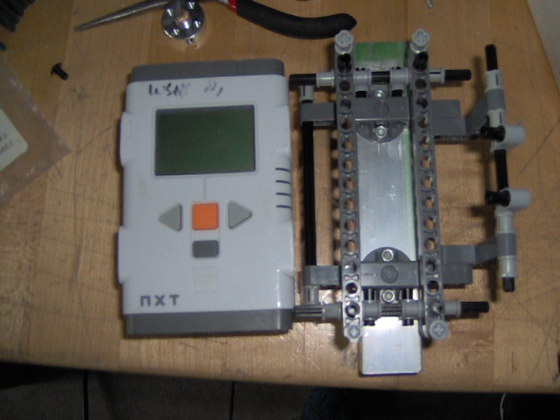
Figure 54 - NXT Holder

The holder secures the NXT quite well and we will put it onto the robots in the future to see how it’d work and what needs to be improved.

-Update
-The Home Depot order has been placed online and the products will arrive within 3 – 5 business days.
-3 out of the 4 teams in the club got the Oregon Department of Education grant. Each grant is $900 each but we don’t know which teams got the grants. Coach Smith sent an email asking the director and we should find out soon.
-The T-shirts are finalized and should be ready to order within a week.
-Erik brought in the non-slip pad
-One of the club members will bring in sheet plastic

-Collecting Mechanism
Erik and Henry built a prototype of the new collecting mechanism out of cardboard and other parts:
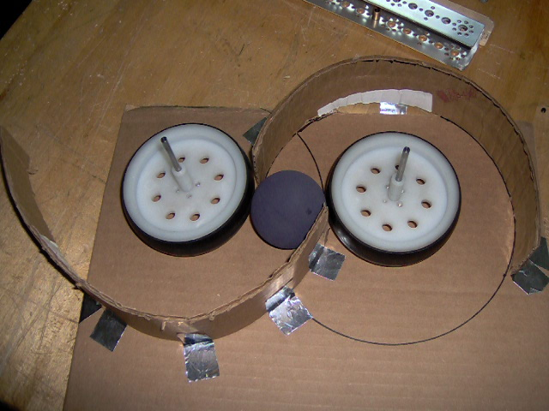
Figure 55 - Collecting Mechanism Prototype

The cardboards will be substitute with clear plastics, most likely polycarbonate. The wheels push the racquetball against the curve wall forcing the balls to go up. The wheels will be powered by chains that will be mounted on a square tube most likely (for stability). When Erik was doing the testing he had another piece of cardboard on top of the whole assembly.
The whole assembly is roughly 12 in. tall and it leaves decent amount of room for other mechanisms of the robot. It also has a larger capacity than the tube idea and it looks much cooler. The design looks promising.

-Mentoring
Erik and Henry went down to mentor the FLL team again. After they finished building the robot, they discussed what their team name is going to be. The name that won the vote was “Z” against “Xtreme Yodeling Zebras”. The kids had ideas of costumes of green and silver (school color) with bee hats and whenever they enter competition / judging they would buzz “z”.
The kids are all excited and next meeting we will start officially introducing the missions to them and teach them the basics of Mindstorm.

Meeting 10/7/2011
Task List:
-Update
-Collecting Mechanism
-Mentoring

-Update
The $2700 ODE grant will be split between the 4 teams in the club like this:
-Registration for all teams (FIRST & Qualifier)
-Must need parts
-Prototyping parts / materials
For the last one, how much a team is allowed to spend depends on how much time they put in.
All the team captains and Coach Smith were happy with the result because it gets every team started and extra stuff if they earn it.
Henry is also going to Dallas tomorrow for a scrimmage but he won’t bring the robot since he’s only there for scouting other teams.
The HomeDepot order will be coming in on Thursday next week.

-Collecting Mechanism
Erik built a plastic prototype of the collecting mechanism today to work out the details. The plastic we used were the scrap pieces from the lab and we will build an official one when we have the new plastic.
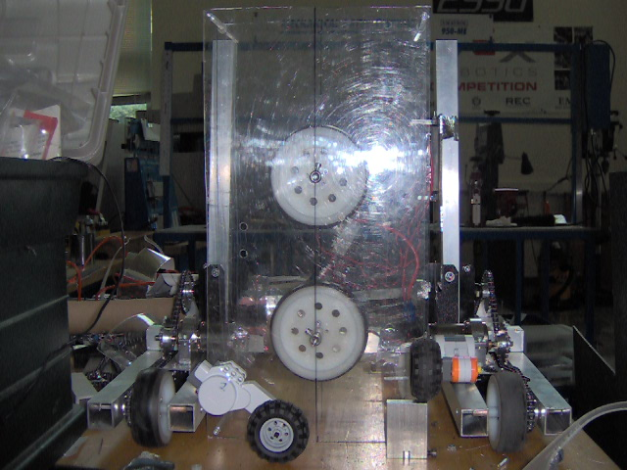
Figure 56 – Prototype

The distance between the mounting holes for the bushings are 4 in. & 10 in. We had to figure out how many spacers to put in between the axles and the combination that works best is a large spacer on the side with the collar & a large spacer and two small ones on the side without. One large spacer is equivalent to three small ones.
We put a 2 in. standoff between the two pieces of sheet plastics but it pushes onto the racquetball too much so we put two small spacers to extend the width.
In the picture it also shows where the LEGO motors will be to funnel the balls into the mechanism.
So far we have enough space to fit everything without much trouble. The motor will most likely be mounted below the horizontal bar to save space and have a low center of gravity.

-Mentoring
Henry mentored the other West Salem FLL team at the lab today. He watched the mission video with the team and they are starting to brainstorm about drivetrains.
The team didn’t get to finish a drivetrain but they wanted a slim drivetrain with the NXT on its side so it can traverse around the map easier. They will continue next meeting to build the drivetrain.

Meeting 10/10/2011
Task List:
-Briefing

-Briefing
Nothing much was done today since it’s the end of a six week and Henry wanted to give everyone more time for their other commitments.
Henry told everyone about the Dallas Scrimmage he attended. There were lots of rookie teams and there wasn’t much scouting for other teams.
However, the Short Circuits was there and their robot had a manipulator that turns the crates over. The contact mechanism was a sprocket with a loose tire outside. Their drivetrain had six motors and the back wheels had their own special tires on them. The gear ratio is medium to small with 4 in. wheels. Two motors on the rear wheel and one in the front on each side. They also had a collecting mechanism but it didn’t work so good since the distance from the contact to the ground was more than 2 in.
Henry calculated the speed of their robot by and it has a theoretical speed of 4 fps. However it’d take time to accelerate, it’s harder to control and it tremendously increases the chance of breaking the internal gears of the DC motors.

After briefing about the Dallas scrimmage, Henry told everyone about how speed & torque of a motor is related to each other and how to get the maximum power out of the motors. This is done so by finding the midway point of the line that’s formed by connecting the stall torque and free speed. Theoretically the optimal speed that will produce maximum power for the TETRIX DC motors is roughly 76 rpm.

The team also talked about how the ranking system works. They learned about the basic terms such as ranking points, qualifying matches, etc. The new add-on this year is if the opposing team occurred a penalty, your alliance would get your own score as the tie-breaking points. This is significant since there are many penalties, large and small, in this year’s game. The team also came to the conclusion of the ranking system ranks the offensive strength of the teams and it doesn’t favor teams that have defense capabilities.
Everyone also discussed about scouting by going around in pits and by watching matches. So far seems like everyone prefers watching matches than visiting pits. We will formally assign roles & what to look for during scouting in the future.

Meeting 10/17/2011
Task List:
-Structure
-Fundraising
-T-shirt

-Structure
The aluminum channels and angles from Home Depot finally came in! Erik took off the vertical square tubes on the robot and mounted angles on its side to prevent it from going left and right. They will also substitute the Kydex mounts that hold the square tubes together originally and the motors will be mounted on the angles.
We also thought about ways to reinforce the horizontal bar that’s holding the two side driving assemblies together. Due to the fact that the rivet gun would not reach into the tubing (too deep), we decided to mount a 2 in. vertical angle on the outside corner between the horizontal and driving assembly bars. This will reinforce the structure and the holes will be easy to access. We also decided to cut the top of the ends of the square tubes off, right on top of the mounting holes to use a rivet gun to hold the tubes together tight.

-Fundraising
Erik heard from the community Burger King is looking for organization to sponsor. The team will look more into.

-T-Shirt
We decided to put our high school’s logo beside the patch because everyone on the team and Coach Smith thinks most people won’t pay attention to words as much to pictures and it should make us more recognizable. We also decided to put some consistent sponsors for the past seasons on the back of the t-shirt to recognize them for their significant support.
List of sponsors:
-Meyer Orchard and Nursery (Tree sell fundraiser)
-Whitman Farms (Financial support)
-Les Schwab (Financial support)
-Oregon Department of Education (Financial grant)

Meeting 10/18/2011
Task List:
-Chassis
-Mentoring

-Chassis
Erik installed the rivets on to the designated place that were marked yesterday however the results weren’t what we expected. There was still a lot of wiggle room, even more than before the rivets were installed. We are planning on mounting additional angle on accessible places to reinforce the structure.

-Mentoring
Henry went down to the middle school to mentor the FLL team briefly. The FLL team started on two missions, collecting the yellow truck and the trailer. The kids successfully reached their target but didn’t have an arm to retrieve either object. However, the route was successful since they aimed it directly at the targets. Next meeting we will discuss programming a bit more and use sensors instead of timing to improve the consistency.

Meeting 10/19/2011
Task List:
-Chassis
-CAD

-Chassis
Erik finished riveting the other side of the chassis and He cut two 1 in. flat aluminum bars to replace the Kydex to mount the tower. He also cut two 3 in. c-channels to mount on the other side to reinforce the motor. The team is very happy with the result of the riveting because both the front and the back are equal distances apart and they don’t move easily at all.

-CAD
Henry and Erik put together the current drivetrain in Autodesk Inventor today. They will do so in Pro-E once the installation disc comes with the registration kit. They had to sketch the aluminum square bars from scratch but it was fairly easy.
A few things that we relearned / notice from Autodesk Inventor:
-both metric & standard units accept in measurement if specify
-center of gravity analysis
-routing chain
Henry experimented with the simulator the software had for routing chains. Since FTC uses standard #25 chains, it’s applicable for the program. He was able to accomplish everything and had the route visible on the model but he wasn’t able to figure out how to line up the “virtual” sprocket axis with the actual sprocket axis. This will be explored more tomorrow.
At the end of the session, Henry and Erik noticed the c-channels and the flat bar that will be mounted need to switch sides otherwise it will be in the way of the motor.

Meeting 10/20/2011
Task list:
-Lifting Mechanism
-CAD

-Lifting Mechanism
Erik, Katie and Henry started to prototype the lifting mechanism today. They used cardboard pipes and PVC brackets around them to prototype. Problem with the first prototype is the there needs to be two brackets for each bar and that creates a gap between the bars, which will weaken the structure. Coach Smith suggested having a “pin”, which will be a bolt to go through a cut slot in the bar. This will be the most compact design which will also be very strong.

-CAD
Henry and Erik finished mounting the second motor, the flat & c channel mount onto the chassis by putting the c channel onto the opposing side of the motor.
Henry also figured out how to route the chain in Autodesk Inventor and did that. The result was quite impressive and it accurately showed the route of the chain.
We also put the plate of Kydex that we mounted onto the sides in the model.
After finishing the chassis, Henry started building the collecting mechanism. The original prototype only had mounting holes holding it together in the corner but the new one had twelve. Also, the “mouse-hole” was put into place to let the balls get into the mechanism. The last thing that was different was slots of the ramp were cut in the front and back plastic and they will be holding the ramp in place.
One thing that wasn’t reflected in the model was the spacer couldn’t get the spacing just right and one small spacer was neglected in the wheel assembly. This will be fixed in the actual model since the plastic flex.
Also, Erik decided to have a low sprocket ratio to run the mechanism since it would be slower and more torque. However, due to the fact the two wheels have to spin opposite direction, one must be on the outside of the loop and the other in the inside. Erik setup the idlers one in the top corner behind the ramp, the other one in the center between the ramps also so it’s out of the way.
Since we have 1 motor controller for the drivetrain, and at least one more for the lift and the collecting mechanism, Erik and Henry planned to “double up” the spinners that are in front of the robot with the collecting mechanism since they both run simultaneously to substitute the LEGO motors.
As for the lift, Henry designed it on Inventor and Erik decided to put in a piece of plastic in between the aluminum bars to decrease friction. There will also be a plastic spacer between the bolt and the inside of the bar. We decided to use 1/4 in. bolt since 3/8 is too big.
The sprockets will mount on the side towards the collecting mechanism and in the last stage of the lift, the tube will have another one sliding inside, with surgical tubing to push down on the stack of crates to ensure stability and the bottom will have the open / close lifter. This will be discussed and more refined tomorrow.

Meeting 10/21/2011
Task List:
` -Testing
-Machining
-CAD
-Mentoring

-Testing
Erik did a testing on all the plastic we have against the aluminum bar surface to see which combination has the least amount of friction. The test was simply by laying the plastic on top of the aluminum and lift at until it slides off. The result was the PETG was the slipperiest plastic and as of right now it will be used as the plastic in between the sliders and as the spacer between the bolt and the aluminum.

-Machining
Some components of the robot such as the plastic covers for the collecting mechanism and the sliders are nearly impossible to machine by hand tools and they will need to be machined by a milling machine. There’s one in the lab but no one knew how to use it. Coach Smith contacted another teacher in the area and he will come by next Tuesday to teach Erik and Henry how to use the milling machine.

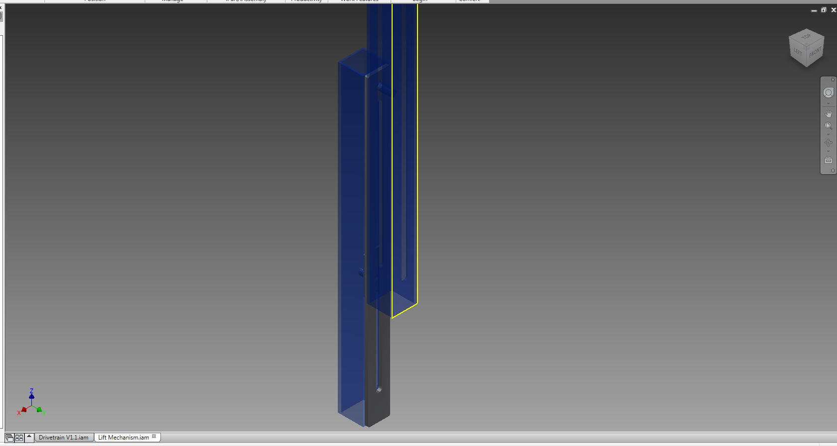
Figure 57 - Aluminum slider
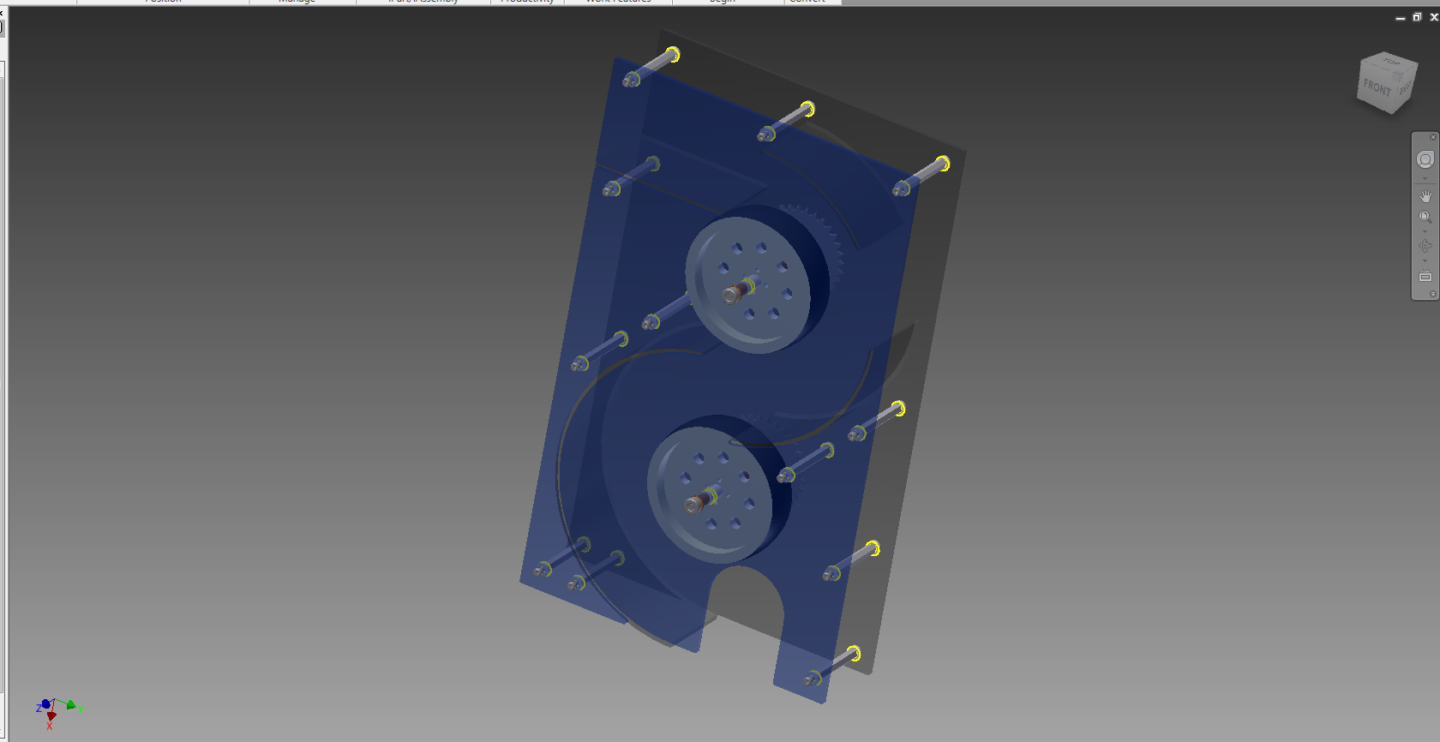
Figure 58 - Collecting Mechanism

We plan to use the manual milling machine to fabricate the aluminum bars however as for the covers for the plastic since there are curves, it will be extremely hard to fabricate manually. We will try to get the CNC mill in the lab working to see if it’s possible to fabricate it on it.
CNC machines operate on G-Code however there usually is translation software that allows a DWG file, which can be made in any CAD software, to be translated in to G-Code. Otherwise we will have to write and enter the code in line by line.
Erik made some new flat circular idlers for the drivetrain. He put them on the axle between the rear wheels and also drilled a new hole for the axle to go through where the plastic holder tensioners were. They looked much better and sturdier. We will put them to test very soon.

-CAD
Erik and Henry continued to work on the model and they started working on the collecting mechanism. Turns out after the collecting mechanism is put into place, there isn’t much room (roughly 1 in. at most 2 in.) on both sides for mounting especially if we are going to use tank treads. We discussed possibly of just having a funnel but it’s a passive device and it won’t be efficient. However, they did decide to have a CR servo mounted on sheet aluminum on standoffs off the front cover of the collecting mechanism. The flexibility of the aluminum will give us a wider range and versatility and it will be able to suck the balls in efficiently.
Henry found this video of FTC team 1902 Exploding Bacon from the Hotshot! season and they used surgical tubing as conveyor belt for the balls. Maybe we can use that instead of tank treads to save space.
Also, while they were designing, Erik noticed the front wheels might be stuck on the balls because it didn’t have a wheel guard so we can drive off the cliff. The simple solution he came up with is we will put a polycarbonate piece around the front so it will deflect the balls. And since polycarbonate (also LEXAN) is extremely flexible and non-brittle, it will be able to take hits without breaking off.
Henry also found the models of the field on the PTC site and he downloaded for the crate to see the dimensions and to see where the lips are to work on the collecting mechanism for the crate. However, the same problem with the collecting mechanism for the racquetball was present because there wasn’t really much space for the tank treads since they are too big (roughly 1 1/2 in.).
Henry found a video that teaches how to CAD a chain like part that’s not industrial regular chains. The chains used in FTC are industrial however, as for the tank treads, it’s a different scenario since they are not industrialized and Autodesk Inventor doesn’t have a build-in function for it. The video consisted of drawing the route, then using a rectangular adaptive pattern on the link then linking the elements together.
Link: http://www.metacafe.com/watch/5726125/chain_inventor_studio_video_tutorial_autodesk_inventor_2010/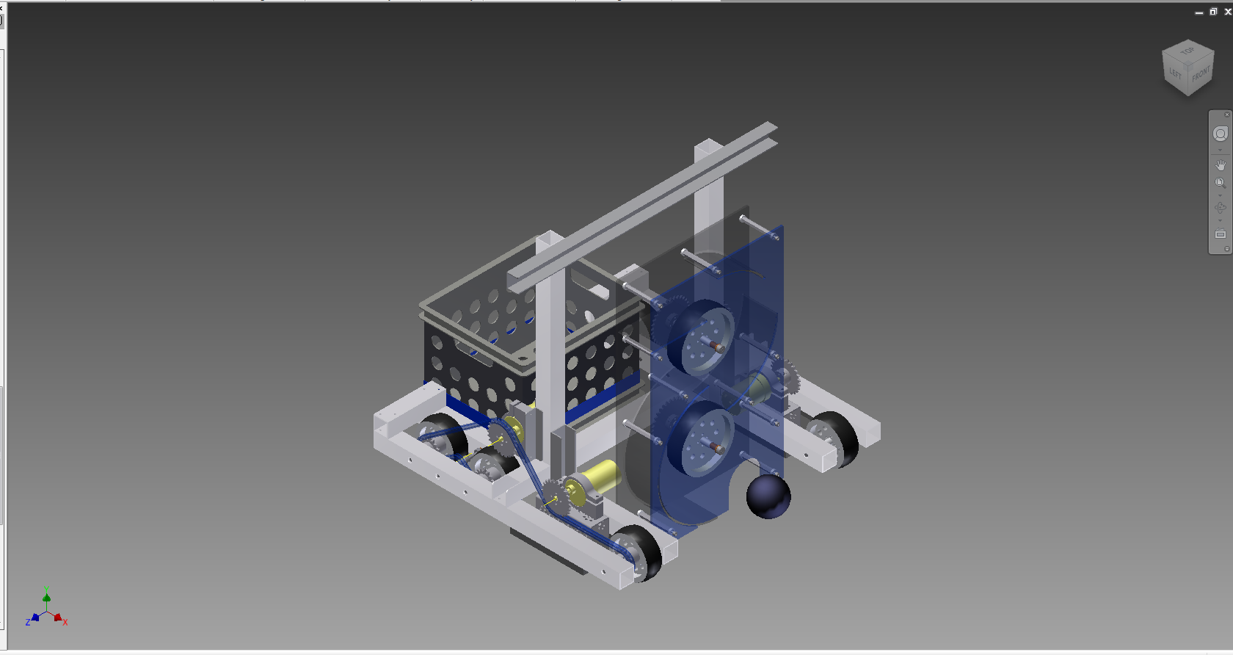
Figure 59- Robot with Collecting Mechanism & Crate
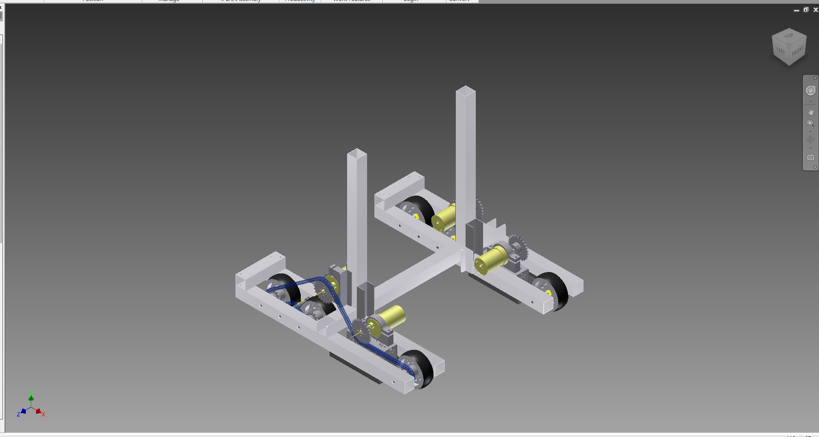
Figure 60 - Robot Chassis

-Mentoring
Henry mentored the FLL team that meets at the lab every Friday. The team was break into two groups and their objectives were complete a similar difficulty challenge to get them familiar with programming. One of the groups’ tasks was knocking the yellow ball off the ring and the other one is push the tractor so the corns would fall off.
One of the groups used timing and mapped the route quite simply and was able to reach the yellow ball. They used consecutive common blocks and they grasped the essentials without much problem.
The other group decided to use the light sensor to tackle the problem. However, they didn’t quite fully understand the programming and Henry taught them how to get the threshold value (total of black and white divided by two), and how to use a loop to accomplish the task. They were successful in making the robot stop when it hits a black line. Next time they will continue and try to follow the line.
The kids still seemed enthusiastic even though neither group accomplish the task (robot has to come back to base). They will continue next time and they will decide which missions they are interested in and go from there.

Meeting 10/25/2011
Task List:
-Update
-Milling Machine

-Update
The new parts came in!!! Henry picked up the order for the club and we got batteries, new wheels, and chains mostly. Henry also ordered some of the new delrin bearings and the bevel gears so they were in the order also.
The first impression of the bevel gears is “they are huge”! The gears are even thicker than normal spur gears and the size is in between a medium to a big spur gear. The size reference on the picture from the LEGO education site was very misleading. We thought it’d be the size of a small gear but obviously this isn’t the case. We will have to change our current plans of using them on the collecting mechanism and work around it.
Also, Kim is going to print out the flyer the bowling alley personnel made to have them posted in the school building.
Henry also contacted everyone on the team (Emanuel included) to have a meeting the 2nd week of November. By then Emanuel will be done with crosscountry and he will be able to come in and help. In the meeting we will discuss about schedule, and revisit goals we set in the season.

-Milling Machine
The teacher from McNary High School came and showed us how to use the milling machine. The procedure of operating the machine is as follow:
-Inserting the bit into the right size collet
-Insert the collet into the milling machine (some machines are keyed while some are not, it doesn’t matter much since it’s the taper at the end of the collet that’s holding it tight)
-Tighten the bolt that’s on top of the machine that will be raised up when the collet is pushed up (there’s a brake that can be held down so the whole machine doesn’t spin)
-Lower the mill and move the mill to the end just pressing the material that’s on the vice
-Raise the mill and move the mill half of the drill bit size and then the mill is zeroed on that particular axis
-Move the mill to the desired starting drilling place
-Start the mill (forward), slowly lower the drill to the desired depth, then lock it in place
-Mill the piece
Since it was the first time milling the piece, we had a few issues. The teacher told us aluminum is very soft and it usually “wraps” around the drill bit as the milling process goes and it’s good to have lubricant on it. He also explained how to get a good speed for milling material. If the drill bit is bigger, than it should be spinning at a slower rate and vice versa. For aluminum it can be fairly fast since aluminum is very soft.
The beginning of the first cut was very nice but then for some reason it drifted to one side. We stopped the machine and found out the “top” of the milling machine is also moveable and must be locked down. The teacher also told us other accessories of the machine such as tilting the head to mill angled slots and the slots at the end of the runway are for tool holding so the tools don’t mess up the runway.
After tightening down the mill further, we continued to make the slot but the cut was getting messier. That has something to do with feed rate and the spindle speed. This will be research and experiment more in the future. Henry and Erik are very excited for the new tool.
The teacher also explained how to use the lathe and told us the CNC mill in the lab is capable of doing the aluminum slot and the manual one is very heavy duty.

Meeting 10/26/2011
Task List:
-Milling Machine
-CAD

-Milling Machine
Today Erik and Henry demonstrated to John, Art and Katie how to operate the milling machine. The team cut a new slot and due to yesterday’s experience, Erik lowered the spindle speed and got a cleaner cut. However, the edges were very rough. After the 2nd cut, Erik used the grinding wheel to smooth out all the cuts that were made yesterday.
The third cut on the slot (2nd for the day) was much better. Henry suggested Erik to turn the spindle speed up and feed the tube slower into the machine. Erik turned the speed up to roughly 1900 rpm and Katie fed it at a much slower rate with John and Art sweeping away the chips and lubricating it the whole way. The result was much better and even the inside edges were smooth.

-CAD
Henry and Erik worked on the lift on Inventor today. The distance between the two towers was 9.875 in. but however the motors are roughly 1 in. out both ways so that would limit the stages of the lift. However, since we won’t be using that much stages (8 to reach the other side with 1/8 in. sliders with 1 in. square tubes), it’s not a big issue.
The number of stages for the lift will be added on after we get the first stage working however there are more issues that need to be figured out. We decided to mount the mounting holes for the bronze bushing for the sprockets or rollers at 1/4 in. into the tube. This is very pushing the limit of the bar but it was the most viable option with where the bolt is mounted and the length of the slots. We might have to tweak the dimensions a bit later in the future.
Also, another issue is we realized we didn’t have enough sprockets to use as idlers. Erik and Henry decided to use the 1/8 in. plastic to make idlers like how they are for the drivetrain except it will have outside guards with a middle ridge that’s raised up. It will have mounting holes just like the sprockets so it can be mounted on an axle collar.
In the end of the meeting Erik determined a good goal for the lift would be 4 stages with the current configuration and setup of the lift (length of travel = slot length = 10 in.). This would raise the crates 40 in. in the air up theoretically with 6 crates at most and the top one being at roughly 76 in. Henry did a few calculations and he determined the maximum possible score from the crate stack alone would add up to 570! This is very exciting and we will continue to work out the details for the lift next meeting.

Meeting 10/28/2011
Task List:
-CNC Mill
-Mentoring

-CNC Mill
Today Henry went through the “training” book for the CNC Mill that’s in the lab. He learned the basic commands for G Code and learned how to operate the mill. He took notes so everyone can review the notes and catch on fairly fast.

E Button
Tool Holder
Spindle Head
SafetyShield

Machine Reference Zero pg. 35 - 40
Software - Top tool bar - Machine - Manual
rapid fastest cut slowest
record Z
after that move bit up at leaset 5 mm than the vice
record x y
G50
*****REMOVE MINUS SIGN THEN SUBTRAT 10 FROM THE Z VALUE, NOT FOR X Y
Dryrun
Software - Top tool bar - Machine - Cycle Mode - From Start - Cycle Strat - RUN - Okay
Add the 10 back onto Z
Samething as dryrun
Home CNC Mill
Machine - Manual - Home - Off

CNC Program Block
N-word | G / M - Code | Auxiliary words

Startup blocks
Tool Path
Shutdown blocks

G00
Rapid Traverse
G00 X... Y... Z...
*****NEVER USE FOR CUTTING

G01
Linear Interpolation Command; for moving while cutting
G01 x... Y... Z... F...
F = feedrate
Automatic store value (if not entered same value as last G01
G70
English Units Commands (Inches)
G70
G71
Metric
G71
M03
Clockwise
M03 S...
S = RPM
M04
CounterClockwise
M04 S...
S = RPM
M05
Stop
M05
M02 / M30
End of Program
M02 / M30
G90
Absolute Positioning
G90
G91
Relative Positioning
G91
G50
Offsets
G50 X... Y... Z...
G02
Clockwise interpolation
G02 X... Y... I... J... F...
X Y = endpoint of arc
I J = center of arc relative to cutter position
*****ALWAYS RELATIVE
If endpoint not specify = circle
Or
G02 X... Y... R... F...
R= radius
If radius positive cut shorter arc, vice versa
G03
Counterclockwise Interpolation
G03 X... Y... I... J... F...
X Y = Endpoint
I J = center of arc relative to cutter position
*****ALWAYS RELATIVE
If endpoint not specify = circle
Or
G02 X... Y... R... F...
R= radius
If radius positive cut shorter arc, vice versa
G04
Pause
G04 X...
G04 P...
X = second
P = millisecond 1/1000
*****DO NOT USE FOR MANUAL INTERVENE
M00
Program STOP
M00
****DOES NOT STOP SPINDLE
USE M05 FOR TOOL CHANGE

Startup Block
N10 Measurement system (G71 / G70)
N20 G90 (absolute positioning)
N30 T01 M6 (tool selection)
N40 G50 (offsets)
N50 M3 (start spindle)
N60 G0 Z15 (lift spindle up to safe distance)

End Block
N.. M05 (Stop Spindle)
N.. M02 (Finish Program)

pg.69
Aluminum 2mm 2000 rpm 100 mm.min
Plastic 2mm 2400 rpm 200 mm/min

Henry wrote a program to mill a smiley face (it has straight and curve lines to practice all the commands) and he was successful eventually but one problem he encountered was the fact there’s a software limit for the axis and it requires a password to change the limit. The original plastic stock is too thin and Henry fixed it by changing to a thicker wood stock.
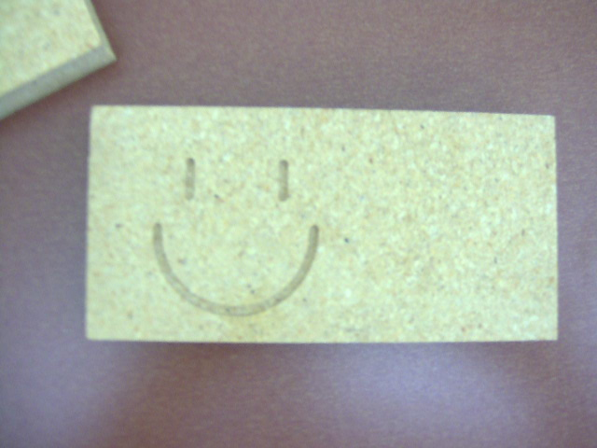
Figure 61 - Smiley Face

Henry used the bit that was on the mill however there’s a way to setup a library so the tool can be updated in the simulation of the milled piece in the software. There might also be a way to draw the design in the software and have it translate it into G Code automatically. These will be further looked into in the future.
At the end Henry also milled this piece out:
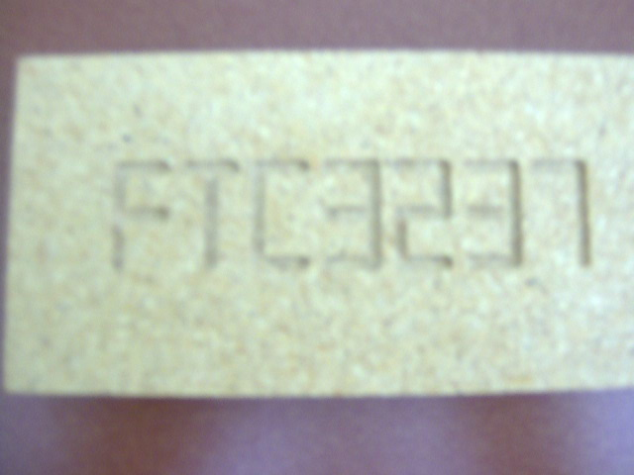
Figure 62 - FTC 3237

-Mentoring
Both groups were able to accomplish their missions (remove yellow & blue ball) and they are looking for ways to make them more consistent. The mission by the tractor is a bit more difficult since there are more objects around it. The robot was moving inconsistently. Henry gave the team the advice of putting more weight on top of the drive wheels so it doesn’t slip as much and thus making the program more consistent.

Meeting 11/2/2011
Task List:
-Structure
-Custom fabrication

-Structure
Erik’s finally back from getting all of his wisdom teeth removed!!! Today he finished putting the towers onto the robot along with the horizontal bar. Henry and Erik used the manual mill to cut a slot in the Kydex mounting sheet below the chassis so they can gain assess to the nuts underneath and for quick access during competition.

-Custom Fabrication
As it turns out the CNC mill isn’t big enough to cut the slots for the plastic. Instead we will have to figure some other ways to cut the arcs. After going to a local plastic supplier to get a quote from them, they informed us it’s possible to cut the arc manually on the manual mill.
Henry also found this series video that’s made by Glacern Machining Tools on YouTube that explained a lot of things about mills.
Katie had learned how to program the CNC mill and had drawn an umbrella for practice and she will be making name tags for everyone on the team.

Meeting 11/7/2011
Task List:
-T-Shirt Update
-Structure
-Crate Collecting
-Programming

-T-Shirt Update
Katie had finished the design for the T-shirt and had gave the PDF files to Coach Smith. Coach Smith will order the T-shirts for the club soon.

-Structure
Erik put angles on the robot to prevent the towers from tilting forward / backward. The chassis is much sturdier. We mounted them on aluminum angles that are riveted onto the chassis so the mounting angles can also be used to mount the collecting mechanism.
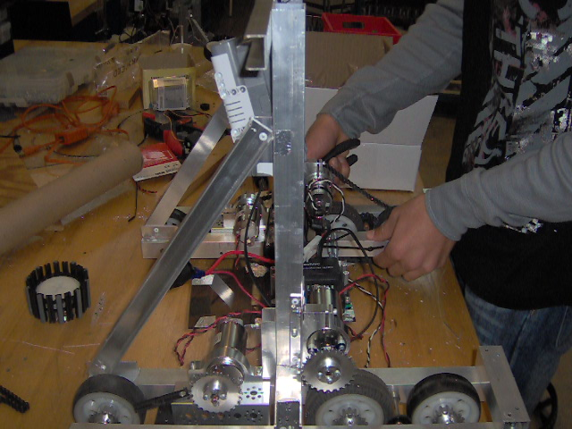
Figure 63 - Angle Structure

-Crate Collecting
Erik and Henry put together a collecting wheel that’s made out of tank tread sprocket and tank treads with rubber inserts. They are going to go to the inside corner of the chassis. Erik cut a slot out of the square tubes and mounted them on vertically so the servos can be mounted on there to power the collecting wheels.
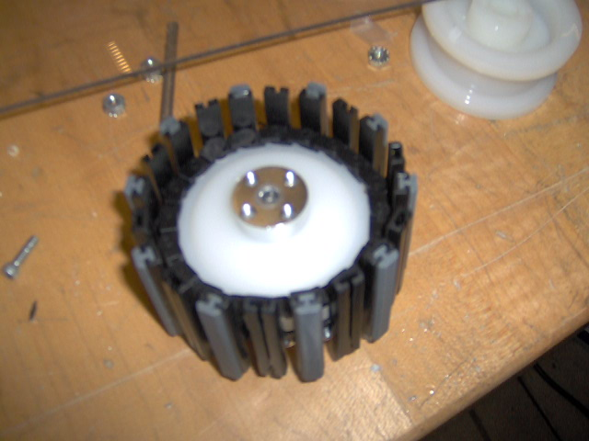
Figure 64 - Collecting Wheel

A small Tetrix C-Channel was mounted onto the 4 in. horizontal bars on both sides of the chassis for the axle of the collecting wheels. However, after putting all the things together, Erik & Emanuel (finally done with crosscountry) realized the wheels will catch onto the lower lips of the crate, preventing it from lifting up. This is a problem we didn’t think of and seems like the current design for the collecting wheel isn’t going to work. Emanuel also pointed out how the collecting wheels don’t extend outside of the chassis and they won’t be able to contribute much with grabbing onto the crate to line them up. He drove the robot on the field to test and it’s fairly easy to line the crate into the chassis without much problem.
Then the team headed a new direction and decided to try zip-ties. The zip-ties will be able to flop up and down while extending out to possibly have a further reach than the tank tread and it won’t catch the lip of the crate.
Henry then milled out a circular piece that had the diameter of 1.5 in. out of Kydex which will have the zip-ties mounted on it. The circular piece also had the mounting holes for an axle drilled out and the mounting holes for the axle collar. Henry made the depth to be 3.5 mm even though the plastic was only 3 mm. However, the spindle still didn’t go all the way through the plastic due to its flexibility. Fortunately the cut for the outline of the circle was deep enough. However due to the flexing of the plastic and the fact the circular piece “tilts”, the piece wasn’t prefect circular. This will be fixed probably with a wood block beneath it preventing it from bending in the future.
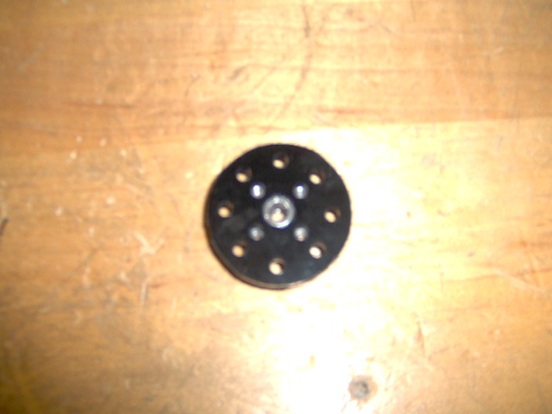
Figure 65 - Prototype Collecting Wheel

The mounting holes were perfectly lined up with 8 spots around the piece for putting on zip-ties.

-Programming
Henry and Katie worked out the pseudo-code for autonomous. Here’s the layout:
-Determine Blue / Red (Switch with breadboard) with if / else statement
-Determine Position (Switch with breadboard) with if / else statement
-Determine Routine (Potentiometer with breadboard) with switch statement
There will be a background task to take poll of all the values from sensors. Henry and Katie also wrote out a generic Move function to move the robot using encoders. The generic move function will include forward, backward, zero-point-left, zero-point-right, forward-left, forward-right, backward-right, backward-left. There’s 8 total and that makes sense because there’s three possible options for each side which makes up a 3 x 3 = 9 with one of them being neither of them are moving. The move function also has a time out on there so it won’t go pass the time out in case of disturbance. Henry also wrote out the pseudo-code for moving using timer (for going off the cliff), lining up with the IR beacon, and moving with PID. Moving with PID will substitute the generic move function since it’s simpler to use (not to program) and it’s more effective.
Henry also started on the pseudo-code for tele-op, mainly for driving since the chassis has a tendency to “curve” due to whatever reason, mostly because of the motors are uneven. Henry will take the ratio of the joystick, or desired value and adjust the motor power by checking it with motor speed, which can be found using an encoder. He will also implement the brake function so it can be in brake mode and no robot can push us, assuming the wheels doesn’t slip front / back or it’s not pushed sideways.

Meeting 11/8/2011
Task List:
-Crate Collecting
-Lifting Forks
-CAD
-Research

-Crate Collecting
Erik and Henry put the zip-ties onto the circular piece and tested it out. Turns out we needed to put two of them back to back so it fits into the both the axle collar and the hub spacer. We had to fabricate two more of them and the new ones are more circular since Erik put a wooden block right beneath the plastic to prevent it from bending.
However, when we put it together and tested it, we realized there was the exact same problem – collector hitting the crate’s lower lip. But this time it was the medium gear that was mounted on there that’s hitting.
The conclusion from the prototype is there’s no way we can put a medium gear on the collecting mechanism. We must either use a small gear, which is less flexible in where to mount the servo, or a sprocket. The sprockets will be our backup plan. However since we don’t have any small sprockets this will be delayed.
There were also some other ideas that Emanuel and Erik came up with. We can implement a “V” shape funnel that drops down in the beginning of the match to help funnel the crates in. This might work better since it will extend out of the chassis, unlike the prototypes we tried before. And the two sides of the “V” can be powered by servos to pinch the crate to prevent it from moving.

-Lifting Forks
Erik started building a prototype for the lifter forks. He used a piece of scrap plastic as the horizontal bar that held two pieces of TETRIX angles together by zip-ties. The zip-ties allow some degree of rotation and expansion so when the prototype pushes down onto the crate it opens up and catches the top lip of the bottom crate. The idea looks promising and fairly simple as of right now.
However, one problem we notice was the necessity of lining the crates PERFECTLY in order to form a decently stable stack. A stable stack is defined as a stack that can be in the robot while driving around and won’t fall over. We might need to make the mechanism to be dead on and precise.

-CAD
Henry continued to work on the CAD design of the other parts of the robot. He updated the CAD model and put the new towers and diagonals on there, as well as the mounting pieces for the crate collector. He and Erik also determined how to mount the racquetball collector. It will be mounted on the top, middle and the bottom. There will be square tubes that attaches from the diagonal from both sides that will mount to the center of the mechanism; the top will be mounted on a square tube which will replace the horizontal channel, there will be two 1 in. square tubes in between and there will be an angle to ensure its stable; and the bottom will be mounted by also two 1 in. square tubes that will be mounted on an angle across where the riveted pieces of plastic is.
They also determined how to chain the collector so the wheels will spin the correct direction:

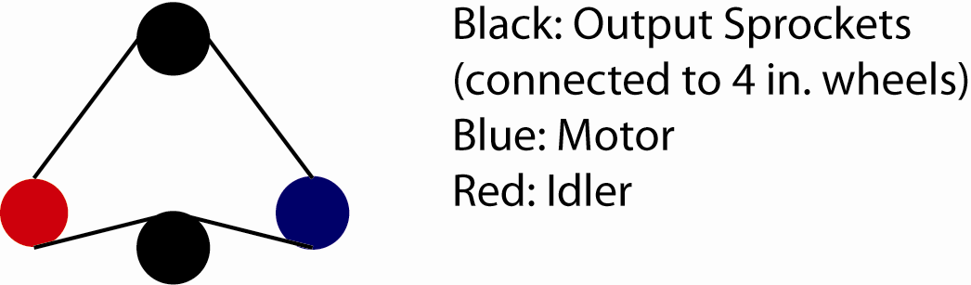
Figure 66 - Chain Route

Currently the sprockets on the models are large sprockets but that might change depending on what speed we want.
Erik also designed an add-on wheel that’s linked to the mechanism which will bring the racquetballs to the “door” of the mechanism. On the left side there will be a rounded piece of aluminum which will guide the racquetballs into the door; on the right side there will be a powered 4 in. wheel that’s linked to the lower wheel inside the mechanism, geared for 1:3 (for speed) that will push the racquetballs to the left. Since we will be driving forward when we collect the balls this will be sufficient enough to bring the balls in and we will add the servo with LEGO tires on it to bring it into the mechanism if necessary. We can also put something else onto the wheel to make it rubbery so it catches the balls better. Henry put the system on the model and mounted it on in CAD.
At the end of the CAD session Henry and Erik briefly discussed about the magnetic ball holder. Since the scoring place can only storage 4, there’s no point in capable of storing more than that. The scoring place is 5 in. from the ramp height wise and the release point of the magnetic balls are at 10 in. We will have a bin to store the balls, which will have a tilted base (toward the goal) and the front piece will be a half PVC that’s powered by a servo so there will be little to no funneling and it’s less likely to jam.
Erik’s dad, Keith Meyer, also one of our mentors looked through the model and pointed out the arcs for the ramps that are in the front & back pieces of plastic will significantly decrease the structural integrity of the piece. His suggestion was instead of cutting out whole arcs, only cut slots out on the plastic and the ramp so it goes together like LEGO, which will make it stronger and sturdier.

-Research
Erik mentioned some of the plastics his family’s farm uses that might be able to substitute the current Kydex / polycarbonate and be more suitable for the sliders for the elevator since it’s slipperier. He thought it was Teflon but later corrected by his dad that it was actually UHMW (Ultra-High-Molecular-Weight) polyethylene. After further research, we found out Teflon actually has an even smaller coefficient of friction. We will contact the local plastic vendor and ask whether UHMW is a non-reinforced polymer based plastic, which is legal for competition. The reason behind it is since it’s cheaper.
Keith also brought up the question of how the referee judge whether a robot is in the process of stacking since it can’t be interrupt if it’s in the protected area. The ramp and raised platform are also counted as a protected area and it will benefit us since we can drop the crates off and stack them till the end of the match.

Meeting 11/14/2011
Task List:
-Coding
-Crate Collecting
-Collecting Mechanism

-Coding
Henry started to code the PID function for traversing during autonomous. Here’s the code below:

float Error_Cap = 1920;
float Left_Error = 0;
float Right_Error = 0;
float Left_Derivative = 0;
float Right_Derivative = 0;
float Left_Integral = 0;
float Right_Integral = 0;
float Integral_Cap = 1920;
float Left_Last_Error = 0;
float Right_Last_Error = 0;
float Integral_Scale = Error_Cap / 3;
float Left_Kp = Error_Cap / 100;
float Right_Kp = Error_Cap / 100;
float Left_Kd = 10;
float Right_Kd = 10;
float Left_Ki = .75;
float Right_Ki = .75;
int Bound = 80;
int Left_Power;
int Right_Power;

void Reset_Encoder()
{
nMotorEncoder[Left_Drive] = 0;
nMotorEncoder[Right_Drive] = 0;
}

float Convert(float Distance)
{
float Constant;
return Distance * Constant;
}

void PID_Move(int Left_Target, int Right_Target, float Time_Out)
{
ClearTimer(T1);
while (((Left_Encoder < (Left_Target - Bound)) || (Left_Encoder > (Left_Target + Bound)))||((Right_Encoder < (Right_Target - Bound)) || (Right_Encoder > (Right_Target + Bound))))
{
if (time1[T1] > (Time_Out * 1000))
break;
Left_Error = Left_Target - Left_Encoder;
Right_Error = Right_Target - Right_Encoder;
if (Left_Error > Error_Cap)
Left_Error = Error_Cap;
if (Left_Error < -Error_Cap)
Left_Error = -Error_Cap;
if (Right_Error > Error_Cap)
Right_Error = Error_Cap;
if (Right_Error < -Error_Cap)
Right_Error = -Error_Cap;
Left_Derivative = Left_Error - Left_Last_Error;
Right_Derivative = Right_Error - Right_Last_Error;
if ((Left_Error == Error_Cap) || (Left_Error == -Error_Cap))
Left_Integral = 0;
else
if (Left_Integral < -Integral_Cap)
Left_Integral = -Integral_Cap;
else
if (Left_Integral > Integral_Cap)
Left_Integral = Integral_Cap;
else
Left_Integral += (Left_Error / Integral_Scale);
if ((Right_Error == Error_Cap) || (Right_Error == -Error_Cap))
Right_Integral = 0;
else
if (Right_Integral < -Integral_Cap)
Right_Integral = -Integral_Cap;
else
if (Right_Integral > Integral_Cap)
Right_Integral = Integral_Cap;
else
Right_Integral += (Right_Error / Integral_Scale);
Left_Power = Left_Error / Left_Kp + Left_Integral / Left_Ki + Left_Derivative / Left_Kd;
Right_Power = Right_Error / Right_Kp + Right_Integral / Right_Ki + Right_Derivative / Right_Kd;
motor[Left_Drive] = Left_Power;
motor[Right_Drive] = Right_Power;
Left_Last_Error = Left_Error;
Right_Last_Error = Right_Error;
wait10Msec(10);
}
}

The variables for the function were originally inside the function (local) however it was moved out to become global due to debugging purposes. The RobotC debugger only polls the global variables.
The PID worked quite well except it didn’t fix the problem of the robot steering one way. After further speculation, Henry thinks since the motors are from different years, there’s a significant amount of difference, especially when it’s running at lower power. This is an issue that has to be addressed since PID only works if the motors perform as they should during lower power levels. “Twitching” or “gliding” unpredictably is going to significantly lower the accuracy of motors. Erik is going to swap out a pair of the motors see if there’s a difference.

-Crate Collecting
Erik and Katie made a better prototype of the grabber to collect the crates. This newer prototype is powered by two servos instead of stationary to help aligning & straightening out the crates. The robot will be able to drive into a non-straight crate and will be able to straighten it by closing the arms. The plastic on both sides allow the mechanism to slide down (hence the bend) and the upright edge on top will allow it to raise the crates.
Henry wasn’t able to test it electronically since he was programming autonomous but this will be tested in the next meeting.
One future problem of implementing the mechanism would be due to the size restrictions the arm wouldn’t be actually the length of the TETRIX angles but much shorter. This will decrease its effectiveness.
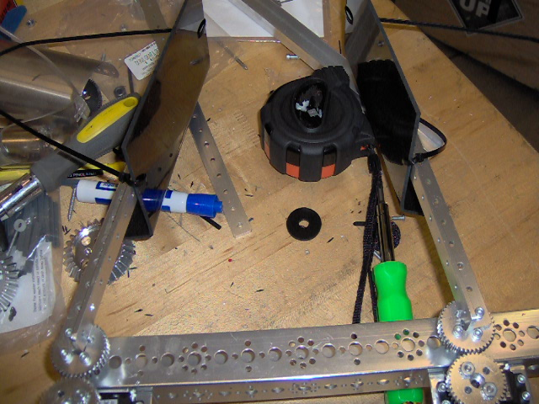
Figure 67 - Crate Collecting Mechanism

-Collecting Mechanism
Erik brought the blueprint for the curves out and Henry calculated the degrees for the notches on the blueprint.
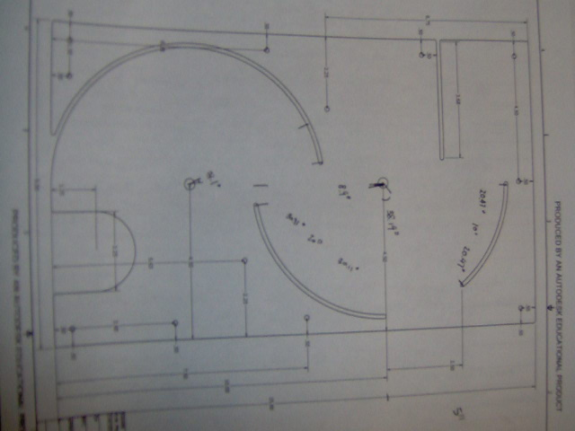
Figure 68 – Blueprint

The next step Henry had to do was to translate the degrees into actual coordinates. Henry was able to accomplish that by graphing the equation (sin(theta)^2 + cos(theta)^2) * 4 into the graphing calculator, which produces a graph of a circle with radius 4, and Henry was able to punch in the degree of the coordinate and find out the x and y.
Erik mounted the “scratch” plastic onto a 2 by 4 by screws. The wood block was small enough to fit in the vise of the CNC mill and thus we were able to use the CNC mill to cut out the arcs. However, the first mounting spot was insufficient (the holes were in the center) due to the software limit of the axes on the CNC mill was hit. We have no way of changing the limit since we do not know the password that requires. Henry shifted the y-offset and cut the arcs onto the plastic to see whether it’s a viable option for the team. Then Erik took the plastic off and made mounting holes both ways (for the top & the bottom arc) since the design can’t be cut in one session due to the software limits.
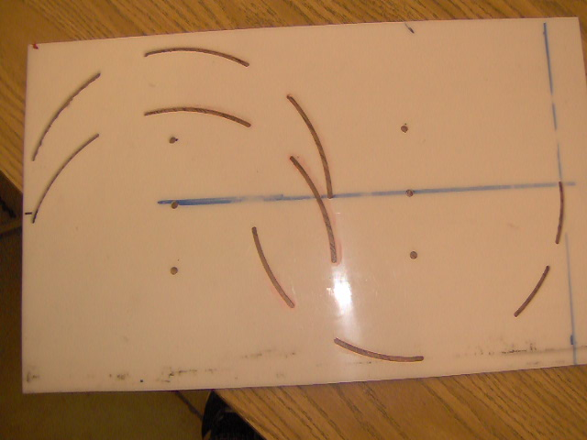
Figure 69 – Arcs

The left arcs (bottom arcs) were a bit too long towards the center since Henry programmed the curves estimating the degrees. It will be fixed in the next try. Also, the slot for the magnetic balls is just big enough for the ball to go through.
Meeting 12/12/2011
Task List:
-Lifting Bars

-Lifting Bars
The team finally fabricated the slots for the lifting bars. The first slot was machined using the manual mill and it didn’t turn out so good. The bit started making “waves” and Erik and Coach Smith suspected it’s because the bit is heating up and melting the aluminum bar.
We are using threaded rod and compatible locknuts to put the lifting mechanism together and have UHMW where metal is rubbing against metal. That decreased the friction tremendously.
Henry made a program to machine the slot in the CNC and for some reason it turned out better than the one that was manufactured in the manual mill.
As for the rollers / sprockets, since we don’t have any extra sprockets, we settled on having bronze bushing with axles for the rollers.
Another problem we faced was when the second slot is being machined, it needs to be in a vice and the vice squeezes the first slot. Erik had to put a piece of plastic in between the slots to secure it.
Erik and Henry made two 1 in. bars and a third one that’s 3/4. They were very happy with the results.
In the next meeting we will put the whole structure together and test what kind of motor and gear combination we need for the lift.
Meeting 1/3/2012
Task List:
-Collecting Mechanism
-Setting Goals
-Schedule / Scouting

-Collecting Mechanism
Erik cutout the real polycarbonate and Henry cut the sample one on the mill to make sure the curves are correct. The curves are 1/16 in. instead of 1/8 because Erik was concerned whether the ramps will bend or not.
If this mechanism doesn’t work, we will have to put together a simple single action (versus continuous) mechanism to gather the balls. It’s easier and it will give us more options and have time to focus on other things.

-Setting Goals
There’s less than a month till competition and currently we only have a drivetrain. We have revised our plan down to having the elevator, which we will follow a design of a team from Washington, 417, from Exothermic Robotics Club. The stacker is prototyped and ready to make the last copy to be put on when the elevator is done. Erik and Henry will fabricate the crate flipper as soon as they determine the simplest way they can think of.

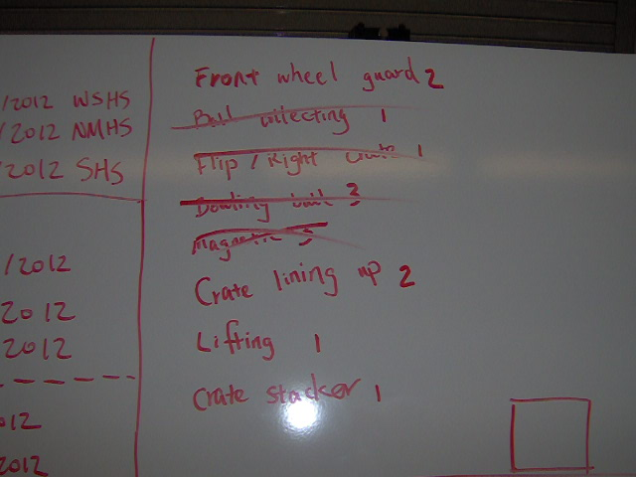
Figure 70 - Goal Setting

-Schedule / Scouting
Oh my goodness. Fortunately our team was the 1st on time stamp so we got our 1st pick but not our 2nd (OSU was filled up already) and our 3rd pick. We have the option to participate in the 2nd of the 2 Tigard qualifiers and the St. Helens qualifier if we choose to. However, the bad news is we will be competing with STRONG teams such as Short Circuits (if they decide to participate in 2nd Tigard), Amity, Banks, Hood River, and our fellow RAD team from West Salem. This makes it nearly impossible for both West Salem team to qualify for state from the tournament because there’s only one automatic performance slot. As for St. Helens, essentially all the same teams are going to be there and our rookie FTC team is going to be there also! Henry will do a more extensively analysis before and after the scrimmage on the 7th and possibly the 14th.

Meeting 1/4/2012
Task List:
-Scout
-Ramp
-Scrimmage Preparation

-Scout
Henry compiled the 28th and 29th Tigard events to see what they are going to be like. On the 28th the key teams will be consist of 3531 Short Circuits, the Banks team, and the Batteries in Black, a rookie team. On 29th the keys will again be Short Circuits, unless they opt out, the other Banks team, the Amity and the Hood River teams. Hood River is bringing 4 teams down to the event and they were title contenders last year. Henry will look more into them in the next few meetings / as things clear up.

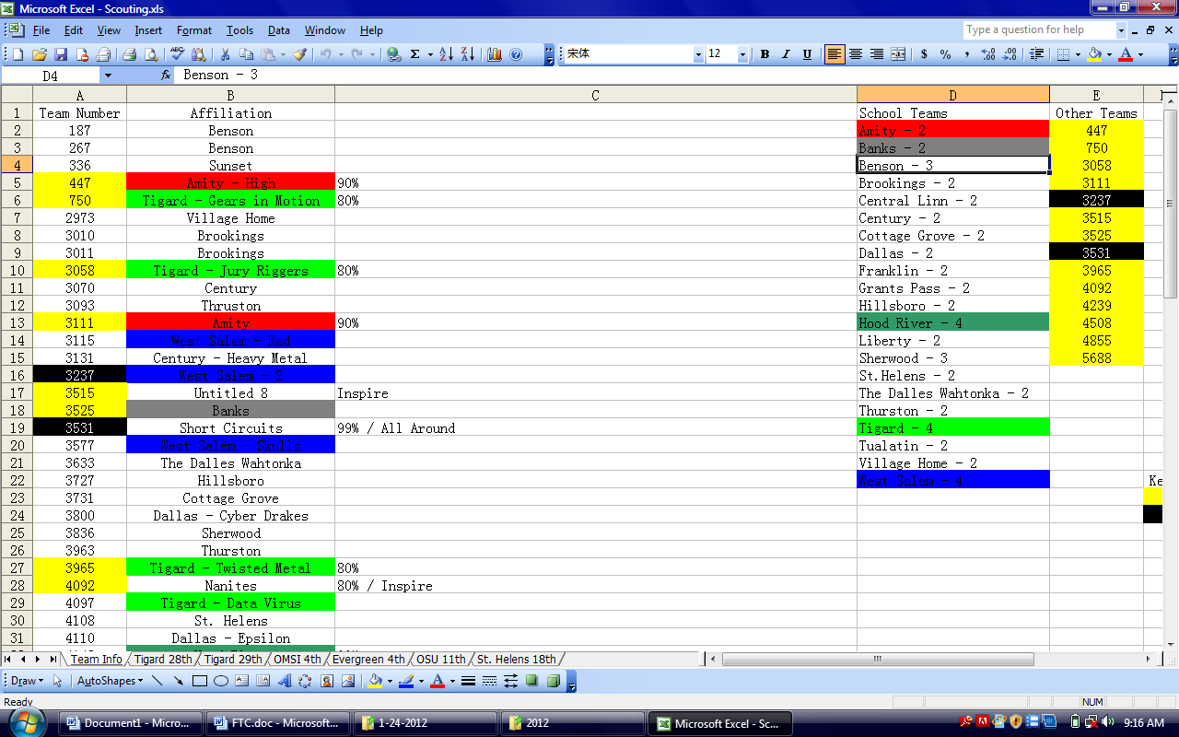
Figure 71 - Scouting Sheet

-Ramp
Erik, Art, John and Henry fabricated the 1st piece of ramp. They cutout the sections for the slots on the mill by standing the polycarbonate piece on its side. It fitted fine and stability shouldn’t be a problem when there’s two sides on it.

-Scrimmage
Henry tested the robot drivetrain to make sure it drove fine and put together 1 autonomous for it to go to the back corner for the blue as time ran out. He will finish a few more for tomorrow’s scrimmage after school. He wanted to have the robot just drive off the cliff but due to center of gravity reason it fell over so he didn’t attempt it anymore.

Meeting 1/5/2012
Task List:
-Bowling Ball Arm
-Collector
-Scrimmage

-Bowling Ball Arm
For the scrimmages today and tomorrow, Henry decided to mount LEGO motors to a “U” that goes over the bowling balls and control it.

-Collector
ALL THE SLOTS ARE FABRICATED!!! Erik also made the ramps and it fitted perfectly! It was able to hold together without any fasteners holding it in. Tomorrow Henry will mill out the mounting holes, the trap door and the motor hole.

-Scrimmage
The robot played in 2 scrimmage matches and here are few observations:
-Two minutes go by FAST (we expected it but driving again just brought reality back to us.
-Racquetball is annoying (our drivetrain most of the time were good at handling the racquetballs since they don’t get stuck easily but it still causes problems.
-Pushing the whole tub of racquetballs to the protective zone is very good strategy.
-Our robot was able to stand its own against others in terms of robustness and defense.
-The bowling ball was easy to collect, maybe due to the fact we only used basketballs.
-There is a lot of stuff on the field.
-It’s going to be really easy to be penalized – need to be careful since it can make or break a match.
The robot performed well even without any actual mechanisms that we planned, which is probably a realistic view of how the robots are going to be like. Most robots will think bowling balls as “bonus” and try to focus on racquetballs – which is much harder. The average teams probably can do both barely and the just above average teams will win most of their matches by the bowling ball. Driving will be important.

Meeting 1/6/2012
Task List:
-Collecting Mechanism
-Scrimmage

-Collecting Mechanism
IT’S DONE! Instead of drilling out the mounting holes on the CNC, Henry and Erik used the manual mill. The manual mill has a distance knob that has 200 clicks per turn, and 1 click stands for 1/1000 in. This saved us a lot of the time and the holes turned out a lot better.
The most surprising thing was everything fitted together like it’s supposed to on the CAD drawings. Erik riveted on the 1/2 in. square tubing to mount the motor and powered the whole thing by chain as it was planned.
The balls went up the ramp smoothly. One observation was when the ball first enters the opening, it doesn’t immediate get “sucked” into and this is going to be fixed either by an angle inside that pushes it towards the wheel and we will probably move the door a bit closer to the wheel.
The collecting mechanism currently holds 8 balls which mean we have 7 for the ramp if we decide to have the open / close mechanism at the end. However, if we do not have the mechanism, by the rules the racquetballs won’t count since they are not in control because the racquetballs will fall off. However, if we still don’t pass inspection due to whatever reason, we will have a backup mechanism where the ramp will simply go straight to the side and we have to score the racquetballs on the side of our robot, instead of having a crate in, which requires one more step but would definitely pass inspection.
We will make a backup one in case the one we have fails.

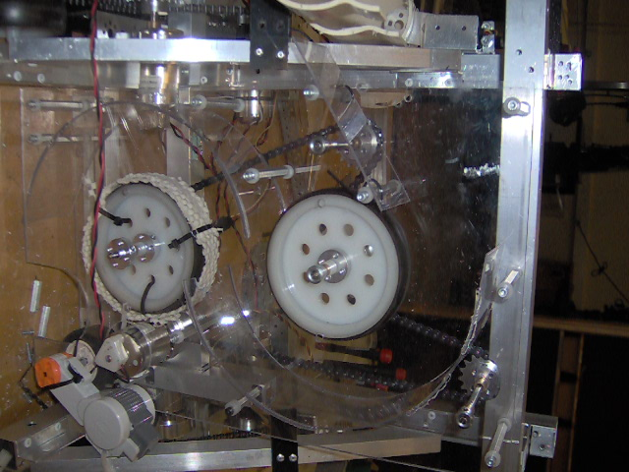
Figure 72 - Collecting Mechanism

-Scrimmage
We only played in one more match against the rookie team today because the other teams were busy preparing their robots. We finished the scrimmage with a 3-0 undefeated record and won the t-shirts! However, the racquetballs were acting up again and we will have to fix that.

Meeting 1/10/2012
Task List:
-Collector
-Bowling ball

-Collector
Today we mounted the collector on. Henry printed out the CAD drawings so John, Art, Erik and Emanuel can put it together. We forgot to put the idler sprocket on the CAD model and we had to cut a slot on the top horizontal square tube to compensate for that. Otherwise everything went together perfectly.
During the testing it turns out the wheel doesn’t grab the ball when it’s on the ground. At the end we had to put anti-slip pad onto the wheel so it grabs. However, there’s still a lot of “slack” in where the wheel doesn’t grab the ball and where it does. We will have to fix that later.
Once the parts come in, we will also put rollers so the balls roll into the gate.
However, as soon as the wheel grabs the ball, it went up the collector smoothly.

-Bowling Ball
Coach Smith got two bowling balls off Craigslist from an out of business alley and we got to try to push the bowling ball up the ramp. We had some traction issues but we were still able to push the bowling ball up. Now we have a full field setup!

Meeting 1/11/2012
Task List:
-Racquetball Mechanism
-Lift

-Racquetball Mechanism
John worked on the ramp that transfers the racquetball from the top of the arc to outside of the collecting mechanism while Erik used a PVC pipe and cut it so it “wraps” around the center structure. All the pieces are riveted on and will be strengthened later with actual parts but for now we can successfully deliver a ball to a crate.

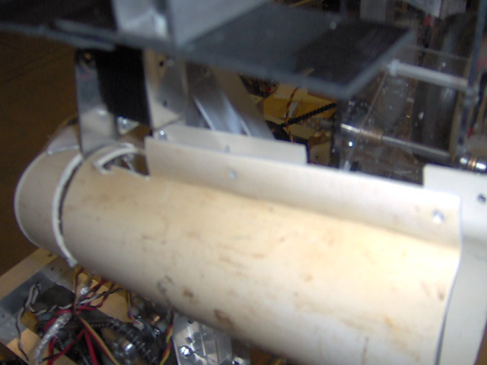
Figure 73 - PVC Pipe

-Lift
Erik cut the slotted square tubes into the height he wanted and he will start assembling the lift tomorrow when the sprockets come in.
We will need the countersunk bolts to put everything together but before then we will need to cut out the plastic and everything else.

Meeting 1/17/2012
Task List:
-Racquetball Mechanism
-Crate Flipper

-Racquetball Mechanism
John and Art started working on how to deliver the racquetball more efficiently from the ground to the PVC pipe. John is in charged of installing a funnel outside of the polycarbonate structure while Art is in charged of finding a way to push the ball so the 4 in. wheels grab it to push it up the ramp.
John put spacers on cut threaded rod and will mount it on a strip of plastic that will be mounted on a “V” shape of the robot so the balls will roll toward the trap door.
Art put a wheel at the end of a LEGO motor and mounted it onto the robot however it didn’t work because the wheel wasn’t touching the racquetballs when they go across the door. He will install flaps or zip-ties next meeting to see if that works or not.

-Crate Flipper
Henry made a crate flipper out of custom aluminum parts with a ledge on the end and mounted it on the robot. It’s powered by a servo and surprisingly it works really well. It takes less time to line up than most of the mechanisms (grabbing type) but the disadvantage is we have to realign ourselves for the crate after it’s flipped.

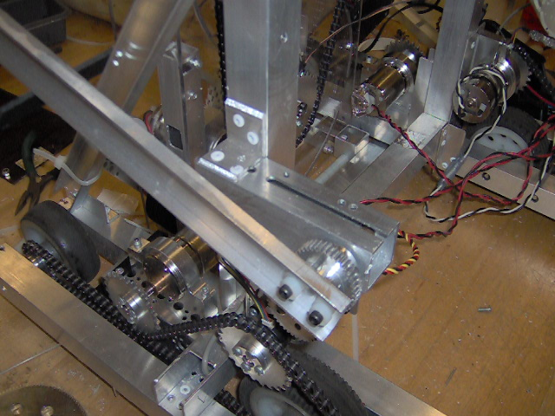
Figure 74 - Crate Flipper

Meeting 1/19/2012
Task List:
-Lift mechanism
-Rollers
-Racquetball Mechanism

-Lift Mechanism
Henry and Erik started cutting the plastic for the lift mechanism however it turned out to be much more difficult. They ended up having to design the model in Autodesk. We used two pieces of 1/8 in. and one piece of 1/16 in. of polycarbonate that’s 1 in. by 3/4 in. along with 1 piece of 3/8 in. by 1 in. UHMW and one piece of 1/2 in. by 1 in. UHMW for the sliding surfaces. We finished one assembly and we will work on more of them.

-Rollers
Erik put nylon spacers on the threaded rods in front and back of the wheels to prevent the racquetballs from getting stuck underneath the robot. He also added rollers on the bottom so the polycarbonate collector won’t be able to hit the field.

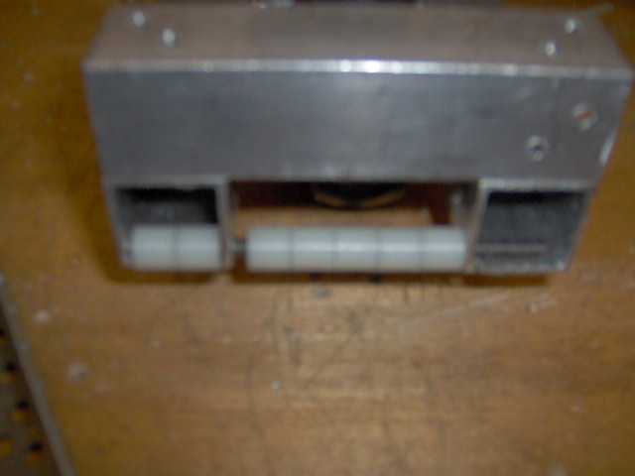
Figure 75 - Back Rollers

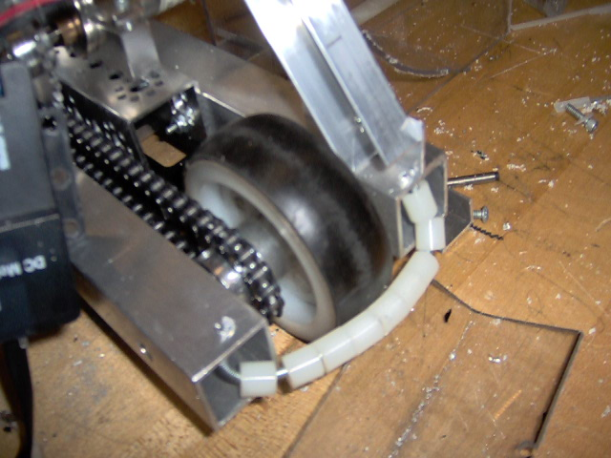
Figure 76 - Front Roller

-Racquetball Mechanism
Emanuel cut a slot out of the PVC pipe and installed a servo to control the flow of racquetballs coming out of the pipe. He also put a piece of plastic underneath the PVC so it doesn’t tilt (it was meant to be a prototype and it only had one rivet so it pivots) and a stand off at the end so the racquetballs doesn’t come out from the other end.

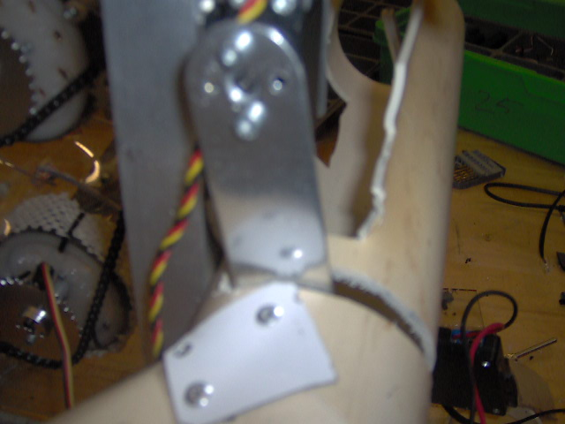
Figure 77 - Servo Opener

Meeting 1/23/2012
Task List:
-Racquetball Mechanism
-Crate Stacker
-Minor Tasks

-Racquetball Mechanism
Art put zip-ties on the LEGO tire and it successfully pushed the racquetballs up the arcs to the PVC.

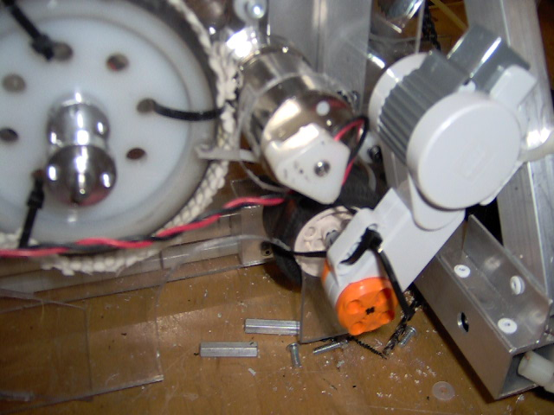
Figure 78 – Accelerator

-Crate Stacker
Emanuel worked on the crate stacker and instead of having a pivot that’s tensioned by tubing, we are going to have one side of the stacker sliding horizontally and the other side stationary. He didn’t finish it because of the sizing constraints and it will be worked on tomorrow.

-Minor Tasks
Art put a plastic strip as a physical stop for the servo to prevent it from going back to far. Erik made 3 more of the lifting assemblies. It took him 30 minutes for each one. Henry took off the electronics and started to find a place more permanently since they are taking up the spot for the lift. We will put the battery on top of the rear driving wheels and we will put weight on the other side to balance the weight out.
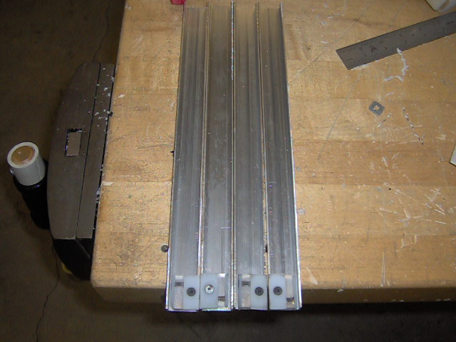
Figure 79 - Lift Assemblies

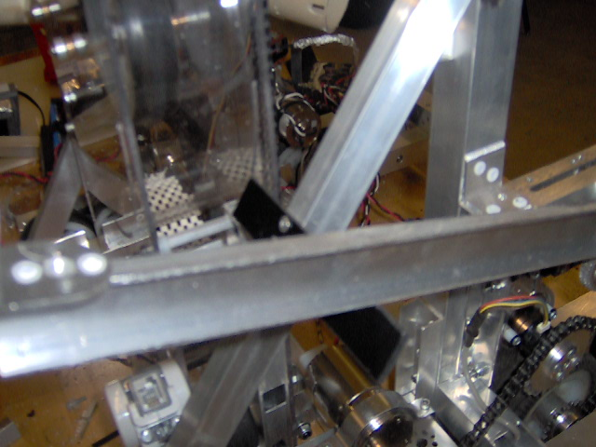
Figure 80 - Flipper Stopper

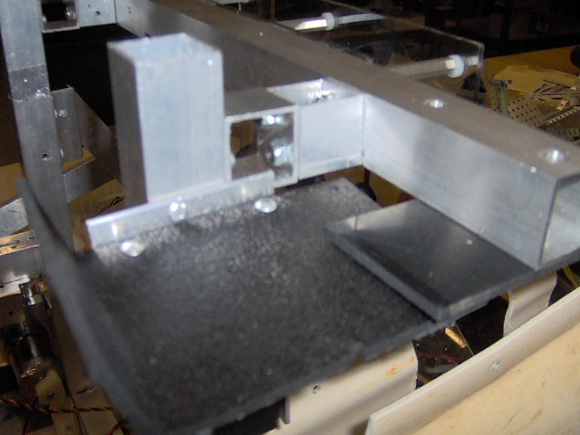
Figure 81 - NXT Platform

Meeting 1/26/2012
Task List:
-Stacking Mechanism
-Lifting assembly

-Stacking Mechanism
Emanuel made the slot wider and put bushing with axles in it to slide and it slides much better. He also made a new channel to mount them on so instead of one side being stationary both sides are able to slide. One last problem with the mechanism is its upper edge gets caught even after Emanuel put rollers on them. This will be looked at more and needs to be fixed before the competition.

-Lifting Assembly
Erik finished assembling the 2 stages we will have for the qualifier and mounted all the sprockets and the motor. However, during the first testing it didn’t work because Henry forgot to put an extra idler that’s needed due to the placement of the motor in the diagram. It will be put on tomorrow and then the lift will be done.

Meeting 1/27/2012
Task List:
-Lifting Mechanism
-Stacking Mechanism
-Ready for competition

-Lifting Mechanism
Erik put the tensioner on the lift by the motor but the lift still didn’t work because of the tension on the other side (the long chain that comes straight down). He ended up mounting the 1st tensioner stationery making it an idler and mounted another one on the other side.
Then the lift worked fine and he put two brackets on there to mount the stacker on. The lift worked pretty smoothly and there’s no problem with load.

-Stacking Mechanism
Emanuel changed the stacker to stationery for both sides and put tubing in between the aluminum and the black plastic. Now the stacker flexes rotationally to open and close and is much sturdier.
The stacker had no problem stacking all six crates but had a problem with them tipping over in the front. If we have time we will put a top to prevent it from happening.
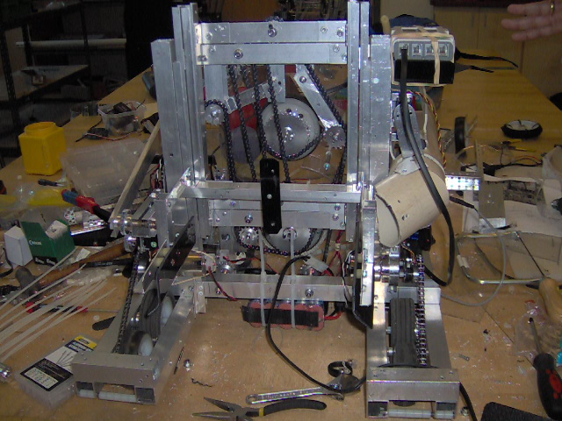
Figure 82 - Back of robot (Stacker & Lifter)

-Ready for Competition
Henry riveted the numbers Katie printed out with plastic on both sides preventing it from damaging.
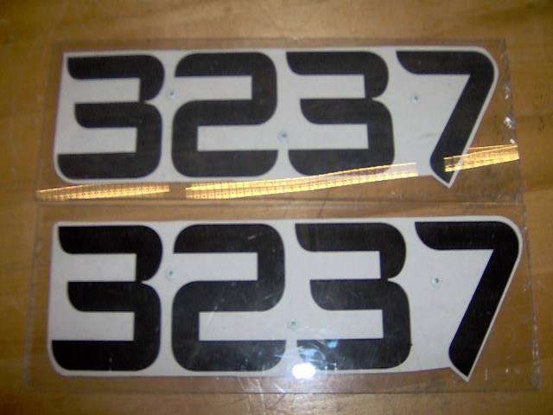
Figure 83 – Numbers

He also put the electrical board together and put plastic as cover.
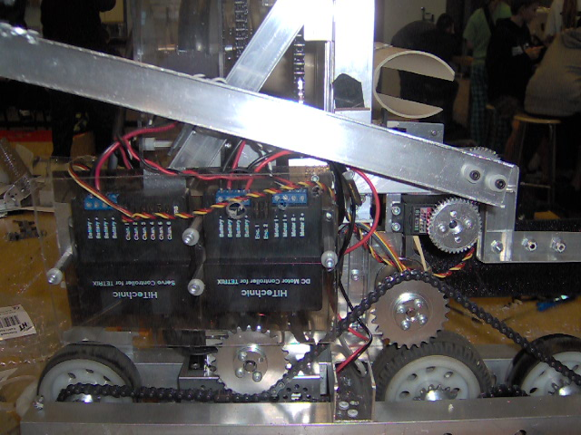
Figure 84 - Electrical Board

Erik also mounted a new end for the PVC on there so it doesn’t hit the lift when it goes up:
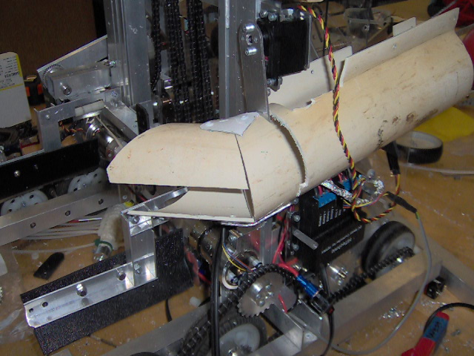
Figure 85 - PVC Pipe

Henry will finish mounting the Samantha, the engineering notebook and go through the checklist before they leave the lab.

Henry will go up on Saturday for the competition to scout and do some touchups on the robot and to test out the robot.
Competition on Sunday!

