Activity 4.1g Model Creation Name:________________________________

Demonstrate the part to Smith to have it signed off

- ____________(inches) 2) ___________________(mm)
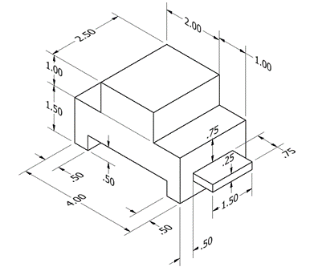
____________ Dimensioned ____________ Dimensioned
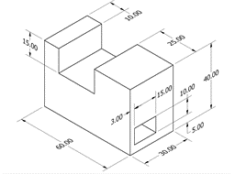

- ____________(inches) 4) ___________________(inches)
____________ Dimensioned ____________ Dimensioned
