Activity 7.1 More Dimensioning

Introduction
The basic standard dimensioning method established by the American National Standards Institute and the American Society of Mechanical Engineers (ANSI or ASME) is used to apply measurement to parts to enable clear communication. In order to communicate effectively, a person needs to understand the rules of the language and to follow the standards set down so that anyone who reads a dimensioned drawing will understand the intent and then be able to manufacture the part correctly.

In Unit 3 you were introduced to dimensioning and practiced putting dimensions on your puzzle cube. In this activity you will continue your practice by applying the appropriate dimensions and learning to understand the thought process that is used to create a clear and concise message regarding the size and shape of an object or a product.

Equipment
- Engineering notebook
- Pencil
- Computer with 3-D CAD solid modeling program
- Dimensioning guidelines

Procedure
In this activity you will create part drawings of various parts that you have previously created. Your drawings should clearly document the parts such that a manufacturer can accurately create the parts.

- Create a multi-view CAD part drawing of the following part that you modeled during Activity 5.6 Mass Property Analysis. The grid spacing is 0.25 inch. Use datum dimensioning and aligned dimensioning. Save the file and document its name and location below.
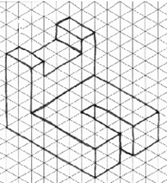

Part file name: |  | Part file location:

Note: To change the dimensioning style of a particular dimension, right click on the dimension, choose New Dimension Style, and then select the Text tab. In the Orientation area under Linear, select the Inline-Aligned choice in the angled and vertical dimension drop-down menus. Then depress the OK button. This will create a new dimensioning style (Default (ANSI)-01) and change the selected dimension style. To change the style for the other vertical dimensions, you must change the format for each dimension. To change the style for a dimension once you have created a new style, select the dimension to change. Open the Annotate tab in the ribbon. In the Format panel, change the Dimension style from the default to your new style. Note that if you create a new dimension style for every vertical dimension, you will add multiple styles to the styles library.

- Create a multi-view CAD part drawing of the following part that you modeled as part of Activity 5.6 Mass Property Analysis. The grid spacing is 0.25 inch. Use chain dimensioning and unidirectional dimensioning. Save the file and document its name and location below.
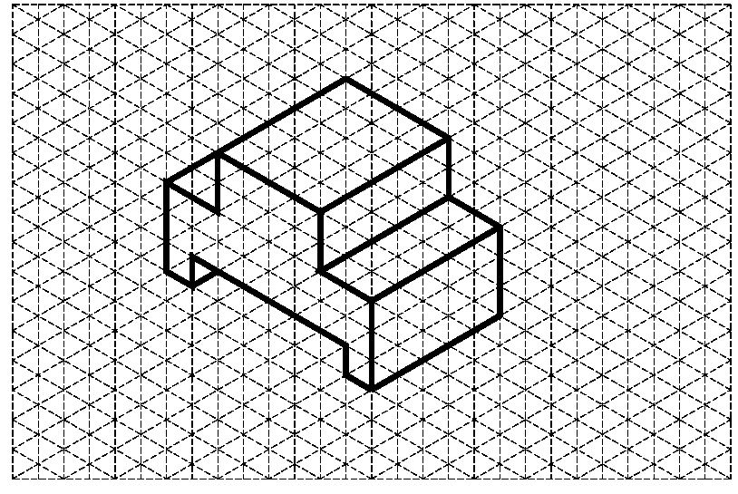

Part file name: |  | Part file location:

- Create a multi-view CAD part drawing of the following part that you modeled as part of Activity 5.6 Mass Property Analysis. The grid spacing is 1 centimeter. Dimension the part drawing using the coordinate method for dimensioning angles and datum dimensioning. Save the drawing file and document its name and location below.

Part file name: |  | Part file location:

- Create a computer model of the part shown below using 3D solid modeling software. The grid spacing for the part is 0.25 inches. Then create a fully dimensioned part drawing to represent the part using the angular method to dimension the angles. Use the least number of views necessary to adequately detail the part for manufacturing. Save the part and the drawing files and document the file names and locations below.
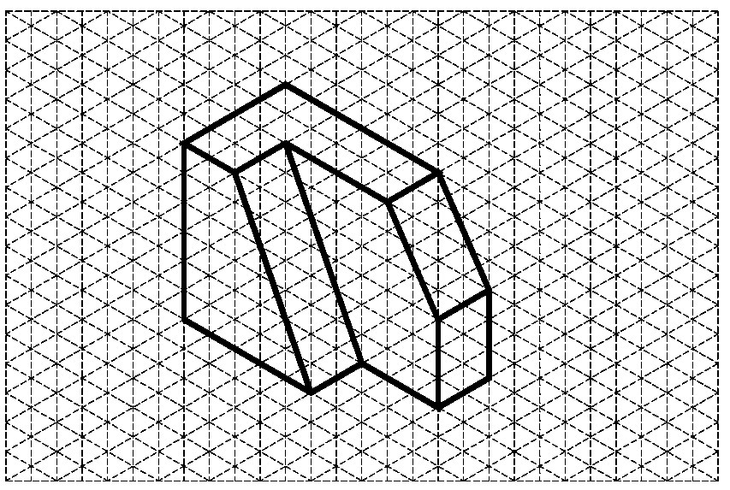

Part file name: |  | Part file location:
Dwg file name: |  | Dwg file location:

- Create a computer model of the part shown below using 3D solid modeling software. The grid spacing for the part is 0.25 inches. Then create a fully dimensioned part drawing to represent the part using the appropriate dimensioning techniques for circles and arcs. Use reference dimensions (to indicate multiple occurrences) when circles or arcs are repeated. Assume that all holes cut completely through the part. Indicate this by adding the word “Thru” after the hole diameter in the dimension note. Save the part and the drawing files and document the file names and locations below.

Part file name: |  | Part file location:
Dwg file name: |  | Dwg file location:

- Print a copy of the part drawing created for the part in number 5 above. Exchange your drawing with another student. Using the Dimensioning Guidelines as a guide, make corrections to your partner’s drawing using a red pen or pencil. Be sure to document which guideline is violated for each correction. Return the mark-up to your partner.
- Based on the marked up drawing, make appropriate corrections to your part drawing created for the part in number 5 above. Save your files. Print a copy of your revised drawing. Next to each dimension, indicate whether the dimension is a size dimension (by writing the letter “S) or a location dimension (by writing the letter “L”).

- Create a computer model of the part shown below using 3D solid modeling software. Then create a fully dimensioned part drawing to represent the part using the appropriate dimensioning techniques. Dimension the cylindrical features on a view in which they do not appear as a circle (presented in the Dimensioning Standards.ppt). Note that TYP means “typical” and indicates that the dimension is typical for all similar features. However, in this case use a reference dimension that indicates the exact number of occurrences (using the “X” symbol) for each repeated feature. Assume that all holes cut completely through the part. Indicate this by adding the word “Thru” after the hole diameter in the dimension note. Save the part and the drawing files and document the file names and locations below.
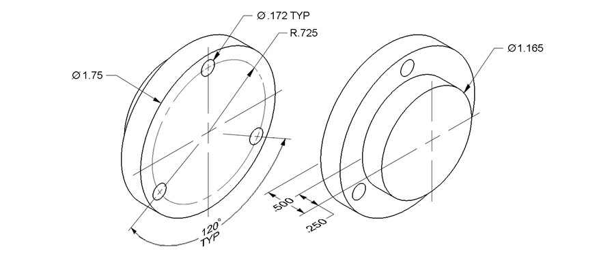
Part file name: |  | Part file location:
Dwg file name: |  | Dwg file location:

Conclusion
- Why is it important to have your drawing dimensioned completely?

- What is the difference between size dimensions and location dimensions?

- What is the difference between chain dimensioning and datum dimensioning? Which method generally results in smaller dimensional deviation in manufactured parts?

- What are the similarities and differences between communicating about an object or product part through a dimensioned drawing and through a written description?

