Activity 6.1 Visual Design Principles and Elements Identification

Introduction
Following the steps in the design process and applying visual design principles and elements are key ingredients leading to the overall effectiveness and tastefulness of a design.

As you learned in previous lessons, the design process is a very important step-by-step framework that needs to be followed and revisited during a person’s attempt at product design. Following this process by itself does not guarantee an awe-inspiring solution. Using the right blend of visual design principles and elements can greatly enhance your product’s functionality, appearance, feel, and overall effectiveness. Selecting this proper combination is a difficult skill to develop, but can be achieved by immersing yourself in the design process throughout the year, tackling problem after problem, and letting your imagination run wild.

When you look at a product that you really like, what, besides its function, do you like? Is it the color? Is it the form or shape of the case? Maybe it’s the rhythm in its appearance. Maybe it’s the product’s proportion. Then again, maybe it’s the formal balance of its design that grabs your attention. With some insight into the visual design principles and elements, you will be able to create products that capture the attention and imagination of the viewer. Artists, graphic designers, architects, and industrial designers make up only a handful of the professionals that utilize the vocabulary of visual design principles and elements on a daily basis.

Equipment
- Pencil
- 3.5 index cards
- Computer
- Digital camera
- (Optional) Activity 6.1a Visual Design Principles and Elements Matrix

Procedure
The purpose of this activity is to identify the visual design elements that appear in your environment and then identify the visual design principles by which they were arranged.

- Locate five man-made items at home, school, internet or elsewhere in your environment that are visually interesting. Take a photograph or screen capture of each item. If it is not possible to take a photograph, sketch the item and shade it with colored pencils to closely represent the object.
- Document your visual analysis in a PowerPoint using one slide for each item evaluated.
  - The first slide in the PowerPoint must include ‘6.1 Visual properties Identification’ and your name. You can use the Activity 6.1a Visual Design Principles and Elements Matrix or write out a summary.
  - One slide for each object that includes your image, the matrix or summary and the name of the product, and identify the visual design principles and elements that are evident in that product. [Also note and explain any obvious disregard for a principle of design. For example, if a design appears chaotic and lacks unity, note this and explain why.]
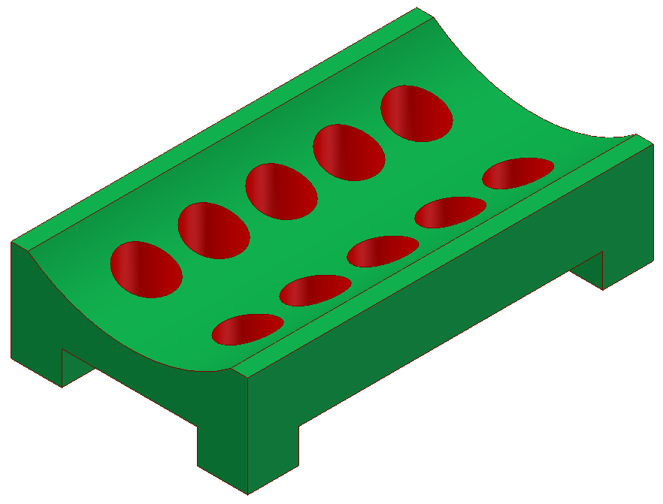
Soap Dish
Elements: bright red and green colors, curved and straight lines, rectangular and circular shapes, geometric forms, smooth texture
Principles:
Emphasis - red color against green background.
Contrast – straight lines contrast curved edges, red and green colors contrast.
Formal balance – created by symmetry of shapes, forms and space.
Regular Rhythm – created by repeated use of circular holes.
Proportion – All elements seem proportional and of an appropriate size for function.
Unity – created by consistent use of geometric shapes, color, and smooth texture.
Economy – Simple lines and shapes. No extraneous elements.
Example

Example Matrix
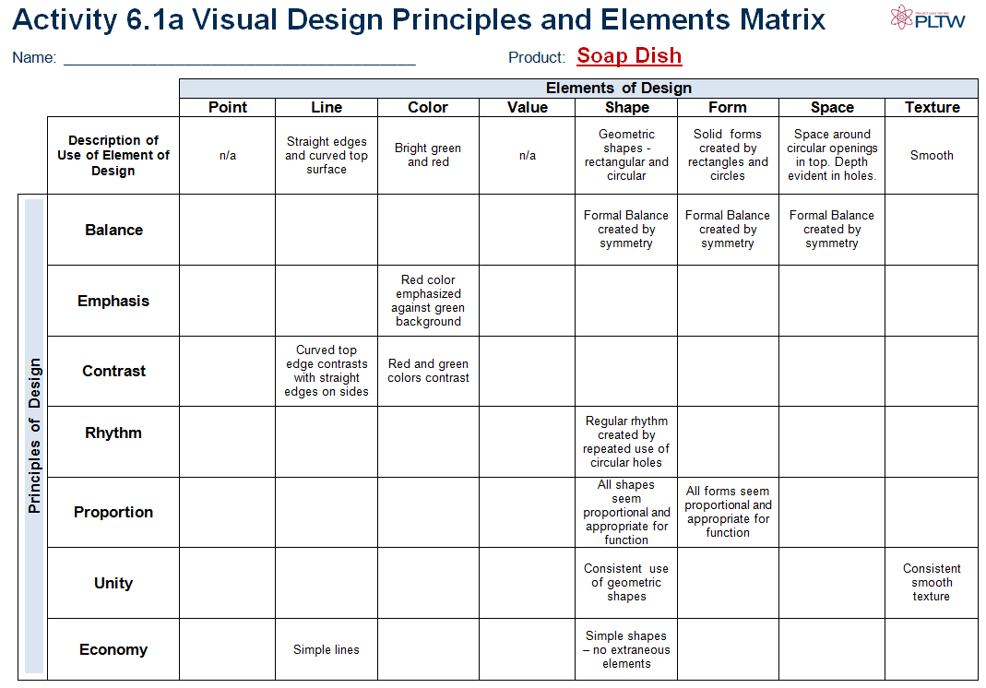

- (Extra Credit) Create a brochure in Publisher to summarize your five objects. Include a photographic image and a text box containing your description of the visual elements and principles of design displayed for each object.
- Be prepared to present the PowerPoint from part 2) on each object and its visual design principles and elements.
Conclusion (Include on your last slide)
- How are visual design principles and elements utilized in a design?

- Identify a product that you feel is aesthetically pleasing. What is it about the product that you find appealing?

- Identify a product that you don’t like the appearance of and identify the visual design principles and elements that lead to this feeling.

- Identify the visual design principles and elements that were not used appropriately in some of the products shown.

