Name:____________________________

Activity 5.1 Calculating Properties of Shapes

- Use the sketch below to calculate the area of the square. Add all linear dimensions to the sketch that were used in the calculations. Note: each grid unit = 1 inch.
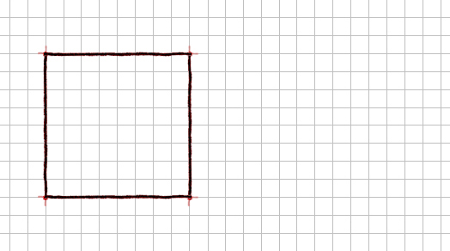
- If the area of the square represented above is revised to be 90.25 in.². (Note that the original grid spacing no longer applies.)
  - What is the side length of the square?

  - Using this length, what is the corresponding grid spacing for the sketch?

- Sketch a rectangle with an area of 2.25 in.². Prove the geometry by dimensioning the sketch and showing the area calculation. Show only those dimensions needed for the area calculation. Note: each grid unit = .25 inch.

- Use the sketch below to calculate the area of the rhomboid. Add linear dimensions to the sketch that were used in the area calculation. Note: each grid unit = 1 inch.
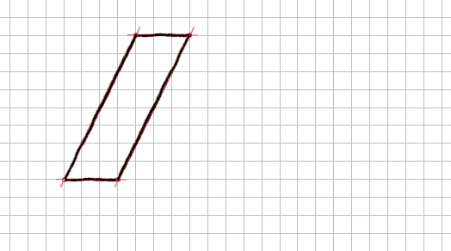
- Complete the sketch of the obtuse triangle. It must have an area of 1.75 in.². Prove the geometry by dimensioning the sketch and showing the area calculation. Show only those dimensions needed for the area calculation. Note: each grid unit = .25 inch.
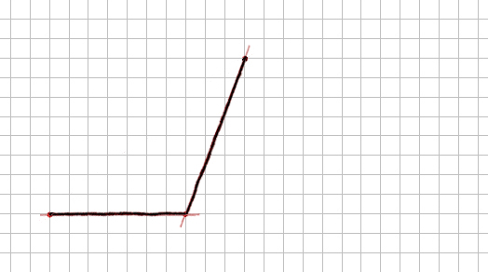
- Use the sketch below to calculate the area of the circle. Add any dimensions to the sketch that were used to calculate the area. Note: each grid unit = .25 inch.
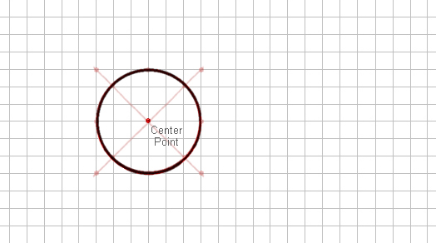
- The area of the circle represented above is revised to be 15.90 in.². Note that the original grid spacing no longer applies.
  - What is the radius of the circle?

  - Using this length, what is the corresponding grid spacing for the sketch?
- An ellipse has an area of 4.71 in.² and a minor axis that is 2 in. long. Solve for the major axis, and then sketch the ellipse using that dimension. Show only those dimensions needed for the area calculation. Note: each grid unit = .25 inch.
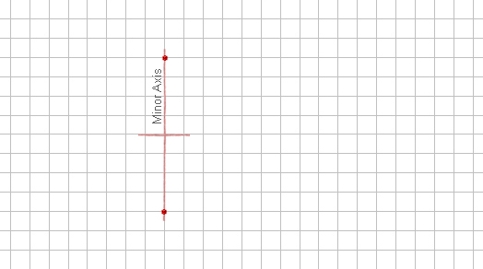

- A regular octagon has sides that measure 4 in. Sketch the octagon on the grid below assuming a grid spacing of 1 in., and calculate the area. Check the reasonableness of your answer by estimating the area - count the number of one square inch square units enclosed by the shape.

Extending your Learning (1pt E.C.)
- The sketch shown below is for a commercial sign. It was drawn to 1/10 of its true size. What is the area of the actual sign? Prove your answer by showing all calculations. Note: each grid unit = 1 inch.
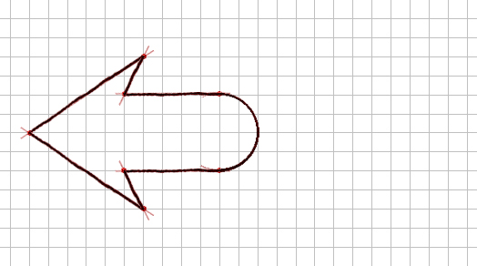

Conclusion
- What is the difference between a circle and an ellipse?

- What is the difference between an inscribed and a circumscribed shape?

- Why is it impossible for a triangle to contain a 180° angle?

- How is a rhombus similar to a square?

- What is the difference between a right, acute, and obtuse triangle?

