Name: ___________________________

Activity 3.1a Linear Measurement with Metric and US Units

Procedure
Record the length of the rectangles shown in the following figure using SI units and the correct number of significant figures. Include the units in your answers.
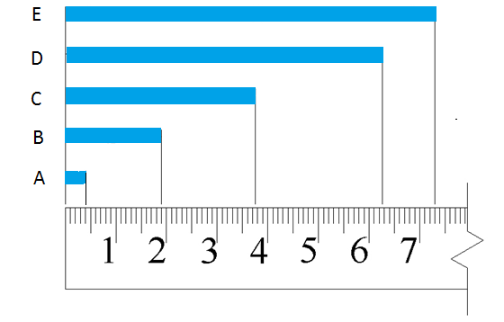

 | Distance | Measurement
1. | A
2. | B
3. | C
4. | D
5. | E

Calculate each of the following lengths and record the answer using appropriate significant digits and the correct units. Show all calculations.

- What is the difference in the length of rectangles A and C?

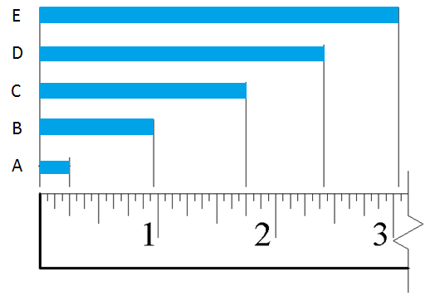
- What is the difference in the length of rectangles B and E?

 | Distance | Measurement (Fraction) | Measurement (Decimal)
8. | A
9. | B
10. | C
11. | D
12. | E

- What is the difference in length between rectangles A and C?

- What is the difference in length between rectangles B and E?

- Using a metric/US ruler, measure the missing lengths in the figure below and enter the dimensions in the boxes. Be sure to use the correct number of significant digits and include units. Use one box for SI and the other of US units.
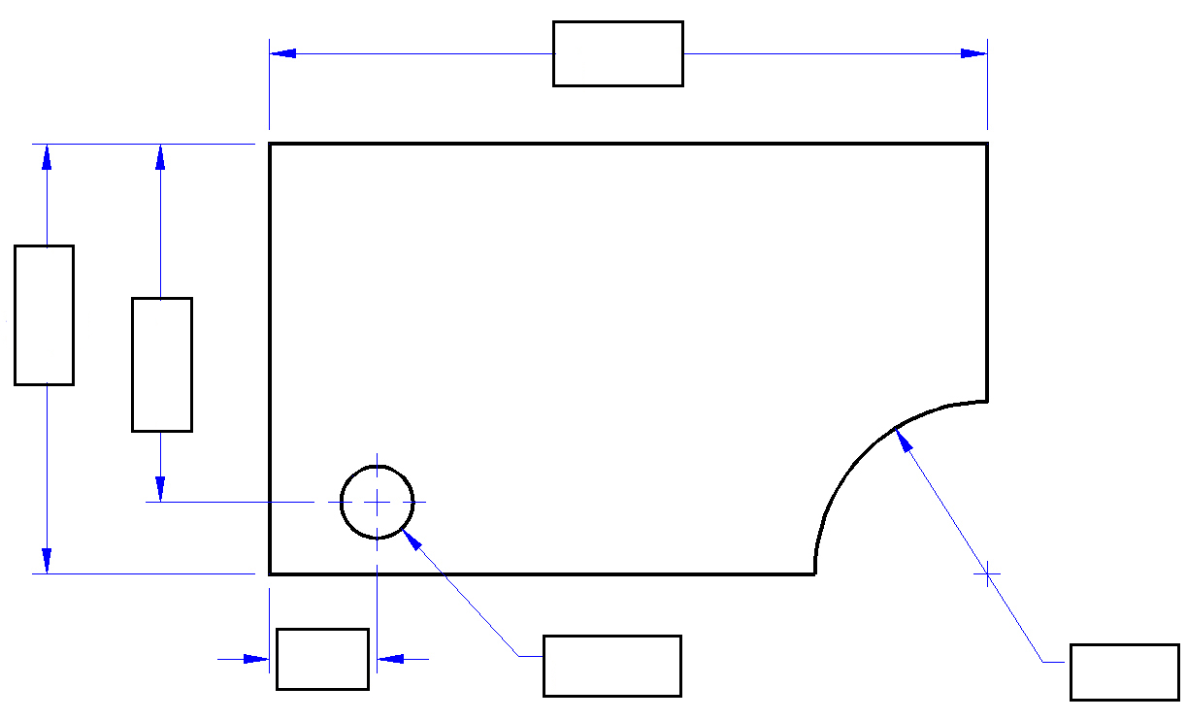
ø
R
ø
R

Conclusion
- Explain the meaning of significant digits (or significant figures) in measurement.

- Why is the metric system used instead of the US customary system, and vice versa, in various parts of the world?

