

|  |
| --- |
| **Activity 2.1 Isometric Sketching** |

Reproduce the isometric view shown below to the left by completing the isometric pictorial of the object on the right. Use points and construction lines to lay out the isometric sketches. DO NOT ERASE YOUR POINTS AND CONSTRUCTION LINES.

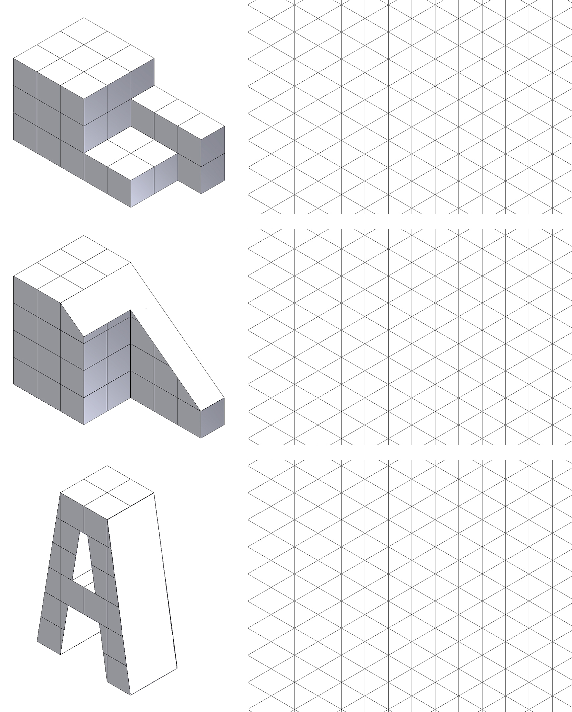

|  |  |
| --- | --- |
| isometrics11e | isometrics11c  Top, Front, Right Side View |

1.

2.



3.



Study the isometric views below. Using the back side of grid paper, your engineering notebook, or graph paper (as indicated by your instructor) recreate the two isometric views for practice. Using the back side of the printed grid paper will allow more contrast between your object lines and the grid lines.

|  |  |
| --- | --- |
| 4. | 5. |
|  |  |

1. Create an isometric sketch of one of the following objects. You do not need to measure the object, but try to represent the object at an appropriate scale to fill a quarter of a sheet of graph paper using correct proportions.

|  |  |  |
| --- | --- | --- |
|  | * Toothbrush * Clothes pin * Flash drive * Flashlight * Monitor | * Chair * Surge protector * Cell phone * Remote control device * Other instructor approved object |

Conclusion (3+ Sentences each answer. Put answers on back)

1. What are the advantages and disadvantages to using an isometric pictorial compared to using an oblique pictorial in technical drawings?
2. What is the difference between a two-dimensional sketch and an isometric sketch?
3. Why do designers use tonal shading?